Use of airborne remote sensing to detect riverside Brassica rapa to aid in risk assessment of
transgenic crops
Luisa M. Elliott,ª David C. Mason,ª Joel Allainguillaume,^{b*} Mike J. Wilkinson^{b}
ªNERC Environmental Systems Science Centre, The University of Reading, Reading RG6 6AL, UK.
dcm@mail.nerc-essc.ac.uk
^{b}Plant Sciences Laboratory, School of Biological Sciences, The University of Reading, Reading RG6 6AS, UK.
m.j.wilkinson@reading.ac.uk

Abstract. High resolution descriptions of plant distribution have utility for many ecological applications but are especially useful for predictive modelling of gene flow from transgenic crops. Difficulty lies in the extrapolation errors that occur when limited ground survey data are scaled up to the landscape or national level. This problem is epitomized by the wide confidence limits generated in a previous attempt to describe the national abundance of riverside Brassica rapa (a wild relative of cultivated rapeseed) across the United Kingdom. Here, we assess the value of airborne remote sensing to locate B. rapa over large areas and so reduce the need for extrapolation. We describe results from flights over the river Nene in England acquired using Airborne Thematic Mapper (ATM) and Compact Airborne Spectrographic Imager (CASI) imagery, together with ground truth data. It proved possible to detect 97% of flowering B. rapa on the basis of spectral profiles. This included all stands of plants that occupied >2m square (>5 plants), which were detected using single-pixel classification. It also included very small populations (<5 flowering plants, 1-2m square) that generated mixed pixels, which were detected using spectral unmixing. The high detection accuracy for flowering B. rapa was coupled with a rather large false positive rate (43%). The latter could be reduced by using the image detections to target fieldwork to confirm species identity, or by acquiring additional remote sensing data such as laser altimetry or multitemporal imagery.

Keywords: agriculture, classification, ecology, sub-pixel.

1. INTRODUCTION

Legislative decisions over consent to cultivate Genetically Modified (GM) crops are taken at the national or regional scale. Ideally, estimates of gene flow and of any associated ecological risks should also be assembled at this level. Ecological consequences caused by gene flow from any transgenic crop start with first-generation (F₁) hybrid formation, followed by introgression and secondary spread to other populations of the crop relative. The capacity of a transgene to cause widespread ecological harm is partly a function of the extent to which transgenes are able to reach other wild relative populations by intraspecific gene flow. This is heavily dependent upon the dispersal characteristics of the recipient species and the pattern of distribution of populations across the landscape. In order to adequately predict the pattern, speed and extent of transgene spread for any given frequency and distribution of F₁ hybrids, it is therefore desirable to develop methods that accurately describe the distribution of crop relatives across the target landscape.
When spectral diagnosis of species is possible, direct use of remote sensing technology to infer distributions is clearly preferable to indirect systems based on community associations (see [1]). Whilst fields of crops can often be located by remote sensing (e.g. [2,3,4]), natural populations of crop relatives are more difficult to identify. In the context of predicting gene spread between populations, it is necessary to recognize the potential importance of small stands of plants since these could act as ‘genetic bridges’ between the more substantial populations. Reference to local or national Floras provides little guidance on the relative positions of even large populations since it is typical for information to be provided on a simple presence or absence basis over areas exceeding 1km². Targeted surveys provide an alternative source of information on population sizes and distributions over small areas but are extremely time-consuming to perform and almost inevitably lack comprehensive coverage. Whilst modelling approaches can be used to extrapolate the results of direct surveys to wider areas [5], this strategy unavoidably introduces uncertainty into the final estimate. In order for error ranges generated by extrapolative modelling to be reduced, there is need for additional ‘bridging’ distribution data for the crop relative that is collected at an intermediate scale, albeit at reduced resolution.
Rapeseed (Brassica napus) is one of four transgenic crops grown extensively across the world [6]. In terms of gene flow, most attention has focused on wild Brassica rapa as a potential recipient of transgenes [7,8], with reference [5] providing the first national scale estimate of F₁ hybrid formation between these species in the United Kingdom (UK). B. rapa grows on the banks of rivers in the UK as a truly wild plant. Pollen dispersal [9] and hybrid formation between the two declines rapidly with distance and so most hybrids are expected where rapeseed fields are planted next to riverside populations of B. rapa [5]. For this reason, it is important to describe the incidence of co-occurrence (sympatry), where rapeseed grows next to waterside B. rapa. This has now been estimated on a national scale for the UK at a 2km square resolution, as has the distribution of rapeseed fields at greater distances from waterside populations and the frequency of weedy B. rapa infestations [5,10]. On the basis of such data, the number of B. rapa hybrids formed across the whole of the UK each year was estimated as 48,000 ± 27,000 hybrids [5]. Although GM rapeseed is not currently grown in the UK, these findings represent the first step towards quantitative risk assessment on a national scale if the rapeseed grown was GM. They set targets for strategies to eliminate hybridization through the use of biocontainment methods such as male sterility [11,12] or transplastomic transformation (e.g. [13]). However, the large size of the error term indicates that the number of hybrids per annum can currently only be estimated to the nearest order of magnitude. Robust descriptions of recipient population size and distribution are now required to generate spatially explicit models describing the speed and extent of transgenes spread from these initial hybridization sites.
Reference [5] initially described the crude distribution of B. rapa using data from herbarium specimens and literature surveys. This distribution was necessarily at a coarse resolution (10km grid square) but served to identify river systems containing wild B. rapa. Variation in population size and distribution within rivers containing B. rapa was described using surveys along 310km of waterways. Extrapolative modelling from these data sets provided the distribution of riverside B. rapa across the UK, but inevitably introduced most of the uncertainty reported in the final estimate of hybrid numbers. Furthermore, legal land access restrictions in the UK meant that the waterways surveys were almost entirely composed of navigable waterways providing free public access. Thus, the survey data under-represented minor tributaries that predominate in the UK landscape and so the extrapolations were based on the assumption that B. rapa distribution on minor tributaries is similar to that seen in navigable water courses. In order to validate this assumption or to correct for any disparity, it is important to survey extensively over all riverbank types.
Airborne remote sensing provides the potential for rapidly identifying inaccessible B. rapa populations over large areas. Riverbank B. rapa populations typically occupy strips of land 1-5m from the riverbank, 5-50m long and 2-4m wide. The distinct spectral profile of Brassica when it is in flower [2,3,4], means there is a realistic prospect that populations could be resolved using Airborne Thematic Mapper (ATM) or Compact Airborne Spectrographic Imager (CASI) imagery. Whilst it would be impractical to survey all UK rivers by aircraft, such data relate to an intermediate scale of data and so would reduce error from extrapolation. The approach also provides a useful means of generating information from areas that are inaccessible for fieldwork and so has potential for other ecological problems (e.g. invasions).
The primary objective of this study was to develop a method to detect B. rapa stands using remote sensing images collected from aircraft. Because it was not always possible to obtain ground reference data from an image, a method was developed for classifying such images by obtaining data from a contemporaneously-acquired image for which ground reference data were available, and using these as training data.

2. DATA ACQUISITION AND GROUND SURVEY

The Airborne Remote Sensing Facility (ARSF) of the U.K. Natural Environment Research Council (NERC) carried out feasibility flights on 30th May 2003. The date of the flights was selected so that cultivated rapeseed had largely completed flowering whereas wild B. rapa was still in full flower. This was done partly to reduce the number of false positives attributable to rapeseed. Airborne remote sensing data were acquired in two flight paths over a section of about 28km of the river Nene (Northamptonshire, England), covering a swathe 1.2km wide for the ATM (Fig. 1) and 0.6km wide for the CASI-2. B. rapa is present at several sites along this section. The winding course of the river meant that although both riverbanks featured throughout, it was not possible to ensure central positioning of the river within the image, particularly for images acquired using CASI-2. The time of the overflight was approximately mid-day to avoid shadowing problems with low sun angles. Both ATM and CASI-2 images were acquired, allowing a comparison of spectral versus spatial resolution to be performed. The CASI-2 data had a 1m pixel size and fifteen spectral bands in the range 0.4 – 0.95μm, whereas the ATM had a 1.2m pixel size and ten spectral bands in the range 0.4 – 2.3μm (Table 1). This meant that, while the ATM had slightly lower spatial resolution, it had the advantage of additional bands in the near- and short-wave infrared. The images were geo-registered to British National Grid coordinates using ARSF software for direct geo-referencing, whereby the aircraft’s precise 3D navigation information (position, pitch, roll and heading) was used, without the need for any ground control points. Using this method, a geo-registration accuracy of a few metres was achieved [14].
Ground survey was performed at the time of the overflight to detect B. rapa within around 8km of riverbank indicated by the red (3 x 1km) and green (3 x 3km) rectangles of Fig. 1a. B. rapa was abundant in populations of varying sizes. GPS location, numbers of plants and approximate polygon area, length and width occupied was recorded for each flowering B. rapa population and for those of phenotypically similar species (e.g. Sinapis arvensis). Considering surveyed populations larger than 1m square, there were 7291 B. rapa plants in the red rectangle and 11500 in the green one, with an average plant density of 3.9 plants/m². The B. rapa plants have modest stature (rarely exceeding 1m in height and diameter) and although they can form large stands without apparent competition, often co-occur with other herbaceous species in mixed stands. Fig. 2 shows the dimensions of the waterside B. rapa populations found during the fieldwork. Table 2 gives a profile of population sizes and plant numbers within the green and red rectangles of Fig. 1a. Populations margins were set when there was at least 10m separation from conspecifics. The locations of the B. rapa and other
species found were overlaid onto the ATM (Fig. 1b) and CASI-2 images. There were several rapeseed fields containing plants in fruit or in the final stages of flowering in the image shown in Fig. 1b.

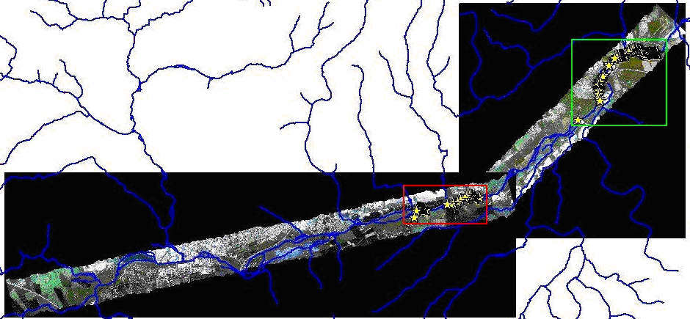

(a)

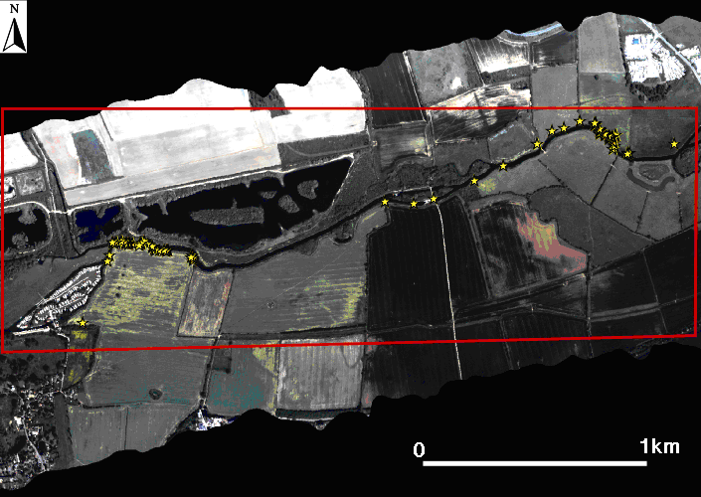
A

(b)

Fig. 1. (a) ATM image of the river Nene (GPS locations of ground reference sites for various vegetation cover types are highlighted with yellow stars), (b) an expanded version of the red rectangle.
Table 1. Selected ATM and CASI-2 bands and wavelengths.

Band Number | ATM  wavelength (μm) | CASI-2  wavelength (μm)
1 | 0.42 - 0.45 | 0.41 – 0.43
2 | 0.45 – 0.52 | 0.44 – 0.46
3 | 0.52 – 0.60 | 0.48 – 0.50
4 | 0.60 – 0.62 | 0.52 – 0.54
5 | 0.63 – 0.69 | 0.57 – 0.58
6 | 0.69 – 0.75 | 0.61 – 0.62
7 | 0.76 – 0.90 | 0.64 – 0.65
8 | 0.91 – 1.05 | 0.67 – 0.68
9 | 1.55 – 1.75 | 0.72 – 0.73
10 | 2.08 – 2.35 | 0.75 – 0.76
11 |  | 0.78 – 0.79
12 |  | 0.82 – 0.83
13 |  | 0.85 – 0.86
14 |  | 0.89 – 0.90
15 |  | 0.93 – 0.94

Table 2. Profile of population sizes and plant numbers within the green and red rectangles of Fig. 1a.

Population size | % of total populations | % of total plants
>2m x 2m | 13.8 | 94.7
>1m x 1m (but <2m x 2m) | 18.4 | 3.7
<1m x 1m | 67.8 | 1.6

(a)
(b)

Fig. 2. (a) Lengths and (b) widths of the waterside B. rapa populations derived from
approximately 8km of the river Nene.

3. SPECTRAL SIGNATURES

The spectral signatures of B. rapa, rapeseed and buttercups (Ranunculus spp.) were derived from the ground reference data contained within the red rectangle of Fig. 1b, for both the ATM and CASI-2 image (Fig. 3). The spectral signatures of B. rapa, rapeseed and buttercups (Ranunculus sp.) follow quite similar patterns in both data types. In the ATM image (Fig. 3a), the main differences between the ground cover types are seen in bands 3, 4, 5 and 8 (visible green, visible red and near-infrared). In the CASI-2 image (Fig. 3b), the B. rapa is also most distinct from the other land cover types in the visible green and red part of the spectrum (bands 3 to 8). Given that yellow objects reflect green and red light, the higher reflectance of these wavelengths by B. rapa indicates that the B. rapa is in flower but the rapeseed is not and the yellow buttercup flowers are too sparse amongst the background to contribute significantly to the reflectance in this region. This shows the importance of surveying during the period in which rapeseed has finished flowering but B. rapa is still in flower, in order to distinguish the B. rapa from the rapeseed. In the UK, this is usually possible in a window of around ten days during the last week of May and first week of June.

(a)

(b)

Fig. 3. Mean spectral patterns of B. rapa, rapeseed and buttercups from ground reference data acquired over the river Nene, for (a) an ATM image, (b) a CASI-2 image. For each band of each sensor, the standard deviation of the band is approximately 10% of the band mean radiance
4. Detection of B. rapa

Table 2 shows that, while the majority (95%) of B. rapa plants grow in populations larger than 2m x 2m, the large number of isolated plants (defined here as plants/stands of area less than 2m square) means that the majority of occupied sites are smaller than this (including single plant plots). We first aimed to determine whether we could distinguish populations or subpopulations occupying plots larger than 2m square using whole pixel classification, and smaller stands using spectral mixture modelling. A population area of 2m x 2m was chosen as this is guaranteed to contain at least one pure pixel given a 1m pixel size, although obviously there may be mixed pixels at the edge of the population.

4.1 Detection of larger B. rapa populations

4.1.1 Detection in images containing ground reference data

Unsupervised K-means classification, in conjunction with ground survey information from the same image, was used to detect the larger populations (>2m x 2m) in both ATM and CASI-2 images [15]. Stands of this size typically contain 5-25 flowering plants. After carrying out the classification, the clusters in the spectral domain that contained the B. rapa pixels needed to be identified. A training set of pixels, derived from ground reference data, was analysed and the clusters that contained at least 5% of the B. rapa training pixels were selected. Pixels belonging to these clusters were said to represent B. rapa plants. False negative and false positive rates were calculated using the number of known B. rapa pixels, the number classed as B. rapa, and the total number of pixels belonging to the clusters selected.
A classification of the image shown in Fig. 1b compiled using 200 clusters and 12 iterations identified several riverbank sites with spectral profiles that matched that of B. rapa (Fig. 4a). While the sites identified did coincide with the riverbank sites known to contain B. rapa from ground surveying, it is apparent that there are many false positives in agricultural fields away from the river. Reference to ground truth data of the relevant fields indicated that these false positives are largely attributable to late flowering rapeseed plants or else to other yellow flowered plants (e.g. Ranunculus spp.) that possess similar spectral signatures to B. rapa. This eventuality had been anticipated in the case of rapeseed, and the flight date had been selected when cultivated rapeseed had largely completed flowering whereas wild B. rapa had not. This was done partly to reduce the number of false positives attributable to feral or cultivated rapeseed but also because this offered the possibility of detecting expansion of wild B. rapa into the rapeseed fields. In this case, we expected more abundant signal in the vicinity of the riverbank when compared with elsewhere in the field. In the event, this did not occur; signal is distributed throughout the fields and is usually strongest away from the riverbank. This pattern is consistent with the distribution of late-flowering rapeseed individuals and is clearly inconsistent with extensive spread of B. rapa into cultivation (a point confirmed by the field survey data). Accordingly, we deemed all positive signals with this spectral signature falling within the bounds of such fields to be rapeseed and masked them from the image (Fig. 4b). Areas classified as B. rapa after masking for rapeseed substantially reduced the false positives and meant that there was high concordance between B. rapa populations above 2m square identified by field surveys and that inferred from the imagery (Fig. 4c).
Table 3 gives the false negative and false positive rates for B. rapa after masking for rapeseed fields, for different numbers of K-means clusters and for both ATM and CASI-2 images of the red rectangle in Fig. 1a. For both sensors, the false negative rates were lowest using 200 clusters and 12 iterations (9.9% for ATM and 15.4% for CASI-2). For the ATM, this setting did not give the lowest false positive rate, but it was decided that the primary criterion for classification should be a low B. rapa false negative rate. The lower false

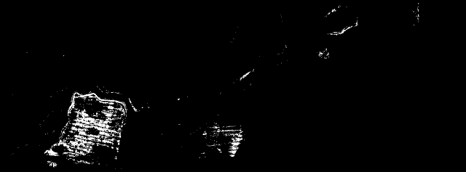

(a)

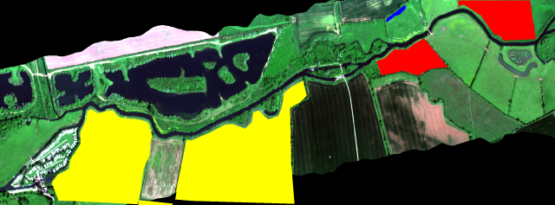

(b)

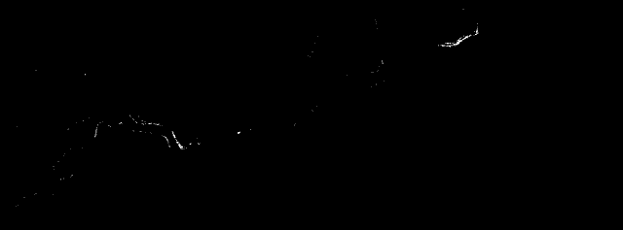

(c)

Fig. 4. (a) Classification of image of Fig. 1b (white = B. rapa), (b) solid colour blocks (yellow and red) representing areas known not to be B. rapa, (c) classification after masking out coloured blocks.

negative rate of ATM than CASI-2 in Table 3 indicates that ATM is able to detect B. rapa more accurately than CASI-2. This implies that extra spectral information is more important for detecting B. rapa than increased spatial resolution, and the subsequent analysis was performed using the ATM data (resampled to 1m pixel size for consistency with the CASI-2 data).

Table 3. Accuracy of K-means classification for the detection of large (>2m x 2m) B. rapa
populations in (a) ATM, and (b) CASI-2 images of the red rectangle in Fig. 1b.

No. of clusters | False negative rate (%) | False positive rate (%)
200 | 9.9 | 23.4
400 | 20.3 | 17.5
800 | 21.5 | 10.4

(a)

No. of clusters | False negative rate (%) | False positive rate (%)
200 | 15.4 | 19.4
400 | 29.2 | 52.9

(b)

4.1.2 Detection in images not containing ground reference data

Unsupervised K-means classification as described above was not suitable for all images because it was not always possible to obtain ground reference data. Since sites occupied by B. rapa are often small and scattered, it was also not possible to use photo-interpretation to identify training pixels in such images. Thus, a method was needed to classify images for which no ground survey data were available. We aimed to obtain training data from an image acquired under similar conditions that contained ground reference information and use these training data to classify the other images.
The reflectance recorded by the aircraft sensor for a given point on the ground varies according to several factors, including sun illumination direction, sensor viewing direction and atmospheric conditions, and so is only a relative value rather than the actual ground reflectance [16]. It was necessary to calibrate the images to correct for differences both within and between images. The relative radiometric values recorded by the sensor from a given land cover type can vary across the swathe due to different sensor viewing angles and need to be normalized. The cross-track illumination correction function in the ENVI software package [17] was therefore used to correct for relative radiometric differences across the width of each swathe.
Once each image had been corrected for the differences in sensor viewing angle across the swathe, we corrected for differences in flight direction, flight time and atmospheric conditions between images. There are two ways to compensate for these disparities; radiometric calibration and relative radiometric normalisation [18]. Radiometric calibration is primarily only critical when comparing multi-date and multi-sensor images. The flight swathes for this study were all taken from the same altitude and on the same day, but at slightly different times, so that atmospheric conditions should only vary slightly. Furthermore, only images from the ATM sensor needed to be compared. Thus, we elected to carry out a relative normalization. Flat field or dark-object calibration was performed to correct for differences in flight direction, flight time and atmospheric conditions between images. The darkest water pixels in an image are used to represent the ‘flat-field’ pixels with the assumption that they should have a zero reflectance and any measured relative reflectance must be due to scattering and absorption effects between the sun, the ground and the sensor. Fig. 5 shows the effect of normalising the ATM image of the green rectangle in Fig. 1a using the across-track followed by the flat-field methods of normalisation, with the main visual difference being due to across-track correction.

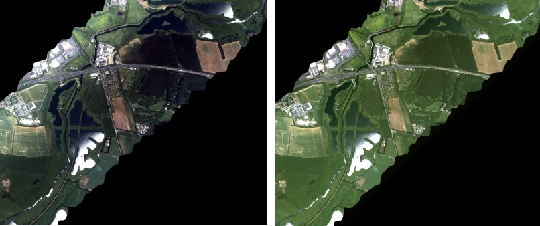

Fig. 5. ATM image of the green rectangle in Fig. 1a (a) before, and (b) after across-track and flat-field normalisation.

To avoid inaccuracy due to change in the spectral profile for B. rapa as a result of the normalisation procedure, a K-means classification (using 200 clusters and 12 iterations) was carried out on the normalised ATM image of the red rectangle in Fig. 1a, a B. rapa mask was generated in image space and the accuracy statistics were recalculated (false negative rate = 5.1% and false positive rate = 31.8%). Normalisation therefore reduced the false negative rate, though the false positive rate was increased (Table 3).
After normalisation, a supervised maximum likelihood classification was applied to a test image (green rectangle in Fig. 1a) using spectral information from the B. rapa mask and non-B. rapa pixels in the image of the red rectangle in Fig. 1a to train a two-class classifier. This method was evaluated for the test image in which all B. rapa positions were known and resulted in the detection of 94% of the 11500 flowering plants recorded by ground truth survey. This implies that modest (>2m square) to large B. rapa populations/subpopulations can successfully be identified in an ATM image from this data set, using ground reference data from another image in the set.

4.2 Detection of smaller B. rapa populations

However, this method cannot detect smaller stands. Whilst it could be argued that small populations occupying <2m square will generally comprise less than 10 plants and so have questionable status as viable populations, isolated individuals and small stands of plants are more likely to form hybrids because incoming rapeseed pollen experiences reduced competition from conspecific pollen [19]. Furthermore, such stands account for 86% of sites occupied by B. rapa (Table 2) and these may act as genetic bridges between large populations. An attempt was therefore made to detect smaller stands (but larger than 1m square) using a mixed pixel analysis on the ATM image of the red rectangle in Fig. 1b [16, 20]. These small populations account for 18% of occupied sites but only 4% of plant numbers (Table 2). The mixed pixel analysis was based on partial spectral unmixing [17]. Complete linear spectral unmixing requires knowledge of the spectra of all end-members within the scene. Partial unmixing only maps user-chosen targets and treats all others as a composite unknown background. In effect, this is a two-class unmixing, with the classes assigned simply as ‘B. rapa’ or ‘not B. rapa’.
Prior to spectral unmixing, a minimum noise fraction (MNF) transformation was executed (in ENVI) to reduce noise and to determine the inherent dimensionality of the data [21]. None of the ATM bands proved to be dominated by noise, and all were included in the subsequent operations. Also, in order to select pure B. rapa pixels as endmember training pixels, a pixel purity image (PPI) was created, and the 10% of B. rapa training pixels with the highest PPI values were selected as endmember pixels. Partial unmixing was then performed on the noise-reduced image using matched filtering (in ENVI), which filters the input image for good matches to the chosen target spectrum by maximizing the response of the target spectrum within the data and suppressing the response of everything else.

4.3 Combining the results

The results of the mixed pixel analysis were combined with those of the larger population classification. This was done by modifying the spectral profile for B. rapa obtained from the K-means analysis of the normalised training image to include the spectral characteristics of mixed pixels. The modified B. rapa mask in image space gave a slightly lower false negative rate than the large population mask (2.9% and 5.1% respectively). The results were assessed in relation to the ground survey of populations of at least 1m square in size, which determined that there were 28 such populations containing a total of 7291 B. rapa plants. Using the knowledge of the number of plants in each population and their area from the survey, the combined classification detected 99% of the total plants (7223/7291) and 79% (22/28) of the
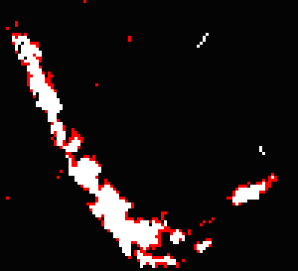

Fig. 6. Pixels detected by whole pixel classification (white), and pixels detected by matched filtering (red) on the riverbank at A in Fig. 1b.

total number of populations. In contrast, the larger population classification detected 98% of these plants (7173/7291) and 61% of the populations (17/28). The mixed pixel analysis thus resulted in the detection of an additional 50 plants and 5 populations. Matched filtering detects the smaller populations and also edge pixels of the larger populations. Fig. 6 shows pixels detected by whole pixel classification in white, and extra pixels detected by matched filtering in red. It is apparent that many of the latter are edge pixels of larger populations.
In summary, the majority of sites occupied by B. rapa larger than 1m square can be successfully identified in ATM images. Taking into account the fact that the 2% of B. rapa in populations <1m square (usually plant singletons) (Table 2) are not detected by airborne remote sensing, and additionally, that some populations 1 - 2m square are not detected during classification, a false negative rate of 3% was achieved.
However, this is coupled with a 43% false positive rate, which is rather large. This rate remains even after expert knowledge has been used to reduce false positives due to cultivated rapeseed in agricultural fields away from the river. The question arises of whether methods can be devised to exclude these false positives. In this case, the most straightforward way would be to combine the aircraft image results with fieldwork to determine the true nature of the detections, rather than utilizing them as a sole resource. The aircraft images provide an effective method for reducing the total amount of fieldwork and for targeting the surveying. The fieldwork need not necessarily be carried out when the B. rapa is in flower, as the plant can be detected on the basis of its morphology. An alternative using remote sensing could be to acquire airborne scanning laser altimetry at the same time as the multispectral imagery, in order to eliminate species with a similar spectral signature to B. rapa but a different height (e.g. Ranunculus is shorter than B. rapa). A more expensive remote sensing alternative might be to acquire a second image prior to the B. rapa flowering period but while rapeseed was in flower, in order to exploit phenological differences. These techniques could allow the nature and frequency of the false positives to be estimated prior to extrapolative modelling to establish fine-scale distribution on a landscape scale.

5. Discussion and conclusions

The present study has illustrated the potential value of airborne remote sensing data to provide more precise spatial distributions of B. rapa on a landscape scale. The methods developed now need to be applied to a larger sample of aircraft data covering a wide area of the UK to determine the overall distribution on main riverbanks and tributaries. A stratified sampling approach should be employed in selecting the locations to image, with the sampling concentrated on the main rapeseed-growing areas of eastern England where most hybrids are produced [5]. After analyzing all images in the stratified sample, the theory that B. rapa is similarly distributed on tributaries and rivers could be tested. These results could then be applied to the whole of the UK and the predicted annual hybrid counts and locations updated accordingly. This information could then be used to produce spatially explicit, national models describing the pattern and rate of transgene spread from these founder F₁ hybrids.
The method of detecting B. rapa that has been presented depends on flowering B. rapa having a spectral signature that is different from those of cultivated rapeseed and other species with similar spectral signatures (e.g. Ranunculus species). In the U.K., this usually only occurs during a ten-day period during the last week of May and the first week of June. This narrow time window could be a restriction for operational application over large areas. It is difficult to quantify the probability of being able to acquire images successfully during any one season. What can be said is that this period is generally one of the sunniest of the year across England and Wales, with an average of 6.5 hours sunshine per day. In addition, the weather does not have to be cloudless for image acquisition, though the cloud base should be above the flying height of the aircraft (600m). As mentioned above, we would also be aiming to perform stratified sampling rather than the imaging of large areas operationally. In this study, we were able to acquire suitable aircraft imagery of the test site with no more than 5% cloud cover at the first attempt made.
We have exploited the tendency of B. rapa to cluster, coupled with the distinctiveness of its spectral profile in its native community, to enable definition of local patch occupancy down to small groups of individuals and even isolated large plants. A similar approach could probably be used to study other relatives of transgenic crops exhibiting distinct spectral profiles. Natural sea cliff populations of another cross-compatible progenitor of rapeseed, Brassica oleracea, provide a fitting example. Coastal B. oleracea exhibit a highly disjunct distribution across the United Kingdom, with metapopulations often isolated by more than 100km [22]. Given the close phenotypic similarity between B. rapa and B. oleracea, and the restricted native distribution of the latter within the United Kingdom, it seems plausible that a similar strategy could be used to assemble high resolution distribution data of this sea-cliff species across the UK by direct airborne surveys and ground truth surveying alone (i.e. without the need for extrapolative modelling). Similarly, the early flowering of weedy B. rapa may allow its detection in rapeseed fields during February/March in the UK. Several workers have already demonstrated the feasibility of using remote sensing to identify weed infestation and to assess efficacy of control (e.g. [23,24,25]). However, other species and scenarios may prove to be problematic (e.g. discrimination of wild and cultivated Helianthus annuus) and so the utility of the approach will have to be assessed on a case-by-case basis.

Acknowledgements

This work was funded by the BBSRC and NERC of the UK. Thanks are due to the NERC ARSF for providing the aircraft data, and to Jeff Settle of ESSC for useful discussions.

References

- S. Manel, H.C. Williams, and S.J. Omeroid, “Evaluating presence-absence models in ecology: the need to account for prevalence,” Journal of Applied Ecology 38, 921-931 (2001) [doi:10.1046/j.1365-2664.2001.00647.x].
- I.J. Davenport, M. J. Wilkinson , D. C. Mason, Y. M. Charters, A. E .Jones, J. Allainguillaume, H. T. Butler, and A. F. Raybould, “Quantifying gene movement from oilseed rape to its wild relatives using remote sensing,” International Journal of Remote Sensing 21, 3567-3573 (2000) [doi:10.1080/014311600750037598].
- M.J. Wilkinson, I.J. Davenport, Y.M. Charters, A. E .Jones, J. Allainguillaume, H. T. Butler, D. C. Mason, and A. F. Raybould, “A direct regional scale estimate of transgene movement from GM oilseed rape to its wild progenitors,” Molecular Ecology 9, 983-991 (2000) [doi:10.1046/j.1365-294x.2000.00986.x].
- G.G. Wright and B. Boag, “The application of satellite remote sensing and spatial proximity analysis techniques to observations on the grazing of oilseed rape by roe deer,” International Journal of Remote Sensing, 15, 3811-3834 (1994) doi:10.1080/01431169408954229.
- M.J. Wilkinson, L.J.Elliott, J. Allainguillaume, C. Norris, R. Welters, M. Alexander, G. Cuccato, J.B .Sweet, M.W. Shaw, T. Harwood, and D. C. Mason, “Hybridization between GM rapeseed and B. rapa in the UK: the first step towards national-scale risk assessment,” Science 32, 457-459 (2003) [doi:10.1126/science.1088200]
- C. James, Preview: Global Status of Commercialized Biotech/GM Crops: 2004, ISAAA Briefs 32. Ithaca: ISAAA (2004).
- L.B. Hansen, H.R.Siegismund, and R.B. Jorgensen, “Introgression between oilseed rape (Brassica napus L.) and its weedy relative B. rapa L. in a natural population,” Genetic Resources and Crop Evolution 48, 621-627 (2001) [doi:10.1023/A:1013825816443].
- S.I. Warwick, M.J.Simard, A. Legere, H.J.Beckie, L. Braun, B. Zhu, P. Mason, G. Seguin-swartz, and C.N. Stewart, “Hybridization between transgenic Brassica napus L. and its wild relatives: Brassica rapa L., Raphanus raphanistrum L., Sinapis arvensis L., and Erucastrum gallicum (Willd.) OE Schulz,” Theoretical and Applied Genetics 107, 528-539 (2003) [doi:10.1007/s00122-003-1278-0].
- A.M. Timmons, Y.M. Charters, J.W. Crawford, D. Burn, S.E. Scott, , S.J. Dubbels, N.W. Wilson, A. Robertson, E.T. O'Brien, G. Squire, and M.J. Wilkinson, “Risks from transgenic crops,” Nature 380, 487 (1996) [doi:10.1038/380487a0].
- L.J.Elliott, D. C. Mason, M.J. Wilkinson, J. Allainguillaume, C. Norris, M. Alexander, R. Welters, and M.W. Shaw, “Using satellite image processing for large-scale gene flow studies from genetically modified oilseed rape,” Journal of Applied Ecology 41, 1174-1184 (2004) [doi:10.1111/j.0021-8901.2004.00963.x].
- H. Luo , A.P. Kausch, Q. Hu, K. Nelson, J.K. Wipff, C.R.R. Fricker, T.P. Owen, M.A. Moreno, J.Y. Lee, and T.K.Hodges, “Controlling transgene escape in GM creeping Bentgrass,” Molecular Breeding 16, 185-188 (2005) [doi:10.1007/s11032-005-4784-8].
- H. Al-Ahmad, and J. Gressel, “Transgene containment using cytokinin-reversible male sterility in constitutive, gibberellic acid-insensitive (Delta gai) transgenic tobacco,” Journal of Plant Growth Regulation 24, 19-27 (2005) [doi:10.1007/s00344-004-0003-9].
- S. Kumar, A. Dhingra, and H. Daniell, “Stable transformation of the cotton plastid genome and maternal inheritance of transgenes,” Plant Molecular Biology 56, 203-216 (2004) [doi:10.1007/s11103-004-2907-y].
- http://arsf.nerc.ac.uk/data/azimuth.asp
- R.O. Duda and P.E. Hart, Pattern classification and scene analysis. John Wiley, New York (1973).
- T.M. Lillesand, R.W.Kiefer and J.W. Chipman, Remote sensing and image interpretation. John Wiley, New York (2004).
- http://www.ittvis.com/ProductServices/ENVI.aspx
- J-F. Mas, “Monitoring land-cover changes: a comparison of change detection techniques,” International Journal of Remote Sensing 20, 139-152 (1999) [doi:10.1080/014311699213659]..
[19] J. Allainguillaume, M. Alexander, J. M Bullock., M. Saunders, C. J. Allender, G. King, C. S. Ford and M. J. Wilkinson Fitness of hybrids between rapeseed (Brassica napus) and wild B. rapa in natural habitats. Molecular Ecology 15, 1175-1184 (2006) doi:10.1111/j.1365-294X.2006.02856.x.
[20] J.J. Settle and N.A. Drake, “Linear mixing and the estimation of ground cover proportions,” International Journal of Remote Sensing, 14, 1159-1177 (1993) doi:10.1080/01431169308904402.
[21] A.A. Green, M. Berman, P. Switzer and M.D. Craig, “A transformation for ordering multispectral data in terms of image quality with implications for noise removal,” IEEE Transactions on Geoscience and Remote Sensing 26, 65-74 (1988) doi:10.1109/36.3001.
- C.D.Preston, D.A. Pearman, and T.D. Dines, New Atlas of the British and Irish Flora: An Atlas of the Vascular Plants of Britain, Ireland, the Isle of Man and the Channel Islands, Oxford University Press, Oxford, UK (2002).
- K.D. Gibson, R. Dirks, C.R. Medlin, and L. Johnston, “Detection of weed species in soybean using multispectral digital images,” Weed Technology 18, 742-749 (2004) [doi:10.1614/WT-03-170R1].
- C.C. Yang, , S.O. Prasher, and P.K. Goel, “Differentiation of crop and weeds by decision-tree analysis of multi-spectral data,” Transactions of the Asae 47, 873-879 (2004).
- F. Lopez-Granados, M. Jurado-Exposito, J.M. Pena-Barragan, and L. Garcia-Torres, “Using remote sensing for identification of late-season grass weed patches in wheat,” Weed Science 54, 346-353 (2006).

Luisa J. Elliott is a GIS consultant in Australia. She received a B.Sc. in Genetics from Cardiff University and worked on this project as part of her Ph.D. from Reading University.

David C. Mason is a Reader in the Environmental Systems Science Centre, University of Reading. He received B.Sc. and Ph.D. degrees in Physics from Imperial College, University of London. He has published over 70 journal papers and 15 book chapters, mainly on the topics of extracting environmental information from remotely sensed data and in using such data to improve environmental models.

Joel Allainguillaume is a lecturer in the Institute of Biological, Environmental and Rural Sciences, Aberystwyth University. His research centres on the exploitation of molecular genetics to address problems in GM risk assessment and plant ecology.

Mike J. Wilkinson is a Professor in the Institute of Biological, Environmental and Rural Sciences, Aberystwyth University. He received a B.Sc. in Biological Sciences and a Ph.D. in Plant Biology from Leicester University, UK. He has published around 70 papers in refereed journals, largely in areas relating to plant genetics, risk assessment of GM crops, crop improvement and evolutionary mechanisms.

Current address: Institute of Biological, Environmental and Rural Sciences, Aberystwyth University, SY23 3DA, UK.

