Interaction of 6,6’’-bis(5,5,8,8-tetramethyl-5,6,7,8-tetrahydro-1,2,4-benzotriazin-3-yl)-2,2’:6’,2’’-terpyridine (CyMe₄-BTTP) with some Trivalent Ions such as Lanthanide(III) Ions and Americium(III)
Frank W. Lewis,*ª Laurence M. Harwood, *ª Michael J. Hudson,ª Michael G. B. Drew,ª Giuseppe Modolo,^{b} Michal Sypula,^{b} Jean F. Desreux,^{c} Nouri Bouslimani^{c} and Geoffrey Vidick^{c}
Received (in XXX, XXX) Xth XXXXXXXXX 200X, Accepted Xth XXXXXXXXX 200X
First published on the web Xth XXXXXXXXX 200X
DOI: 10.1039/b000000x
The new solvent extraction reagent 6,6’’-bis(5,5,8,8-tetramethyl-5,6,7,8-tetrahydro-1,2,4-benzotriazin-3-yl)-2,2’:6’,2’’-terpyridine (CyMe₄-BTTP) has been synthesized in 4 steps from 2,2’:6’,2’’-terpyridine. Detailed NMR and mass spectrometry studies indicate that the ligand forms 1:2 complexes with lanthanide(III) perchlorates where the aliphatic rings are conformationally constrained whereas 1:1 complexes are formed with lanthanide(III) nitrates where the rings are conformationally mobile. An optimized structure of the 1:2 solution complex with Yb(III) was obtained from the relative magnitude of the induced paramagnetic shifts. X-ray crystallographic structures of the ligand and of its 1:1 complex with Y(III) were also obtained. The NMR and mass spectra of [Pd(CyMe₄-BTTP)]_{n}^{2n+} are consistent with a dinuclear double helical structure (n = 2). In the absence of a phase-modifier, CyMe₄-BTTP in 1-octanol showed a maximum distribution coefficient of Am(III) of 0.039 (±20%) and a maximum separation factor of Am(III) over Eu(III) of 12.0 from nitric acid. The metal(III) cations are extracted as the 1:1 complex from nitric acid. The generally low distribution coefficients observed compared with the BTBPs arise because the 1:1 complex of CyMe₄-BTTP is considerably less hydrophobic than the 1:2 complexes formed by the BTBPs. In M(BTTP)³⁺ complexes, there is a competition between the nitrate ions and the ligand for the complexation of the metal.

Introduction
Over the last three decades, research in Europe has resulted in the development of the combination of the DIAMEX and SANEX processes for the reprocessing of spent nuclear fuel produced in the PUREX process. These are based on the co-separation of trivalent actinides and lanthanides (DIAMEX process),¹ followed by the subsequent separation of actinide(III) from lanthanide(III) in the SANEX process.² If these trivalent actinides (particularly americium and curium) are removed from the waste (partitioning) and converted by neutron fission (transmutation) into shorter-lived or stable elements, the remaining waste loses most of its long-term radiotoxicity. Partitioning and transmutation are therefore considered attractive options for reducing the burden on geological waste disposal.³
The development of N-heterocyclic ligands which are capable of separating actinides from lanthanides has thus been the subject of intensive research.⁴ Two classes of ligand have emerged that show both high affinities and high selectivities towards the trivalent actinides; the 2,6-bistriazinylpyridines (BTPs)⁵ 1 and the 6,6’-bistriazinyl-2,2’-bipyridines (BTBPs)⁶ 2 (Figure 1). One member of the BTBP ligands (CyMe₄-BTBP 3)⁷ in particular has shown many of the desirable qualities (stability towards hydrolysis and relative stability towards radiolysis, reversible metal binding which allows stripping, etc) for use in an industrial separation process. Its suitability for a SANEX process has been demonstrated recently in a ‘hot-partitioning demonstration test’ on genuine spent fuel solution.⁸ However, the stripping of the metal cation from the CyMe₄-BTBP complexes was rather slow.
The coordination chemistry and solvent extraction properties of the related bistriazinyl-2,2’:6’,2’’-terpyridine (BTTP) ligands 4 with trivalent cations have not been previously studied. The introduction of an additional pyridine ring into the BTBP framework could lead to a moderate reduction in the affinity of the ligand towards americium and therefore enhanced stripping. In addition, we anticipated that BTTPs could be capable of forming helical metal complexes
Figure 1. The structures of the BTP, BTBP and BTTP molecules.
similar to those formed by the oligopyridine ligands⁹ which have found widespread use in coordination and metallosupramolecular chemistry.¹⁰ Consequently, the palladium(II) complex of CyMe₄-BTTP 5 was studied. Herein we describe the synthesis, selective extraction and coordination chemistry of the novel ligand 6,6’’-bis(5,5,8,8-tetramethyl-5,6,7,8-tetrahydro-1,2,4-benzotriazin-3-yl)-2,2’:6’,2’’-terpyridine (CyMe₄-BTTP) 5 which by virtue of its aliphatic tetramethylcyclohexenyl-rings is designed to be more soluble than many of the oligopyridine ligands in organic solvents.
Experimental
Melting points were obtained on a Stuart SMP10 instrument. IR spectra were recorded as Nujol® mulls on a Perkin Elmer RX1 FT-IR instrument. ¹H, ¹³C−{¹H} and ¹³C NMR spectra were recorded using either a Bruker AMX400, an Avance XXX400 or an Avance DPX250 instrument. Chemical shifts are reported in parts per million downfield from tetramethylsilane. Assignments were verified with ¹H-¹H and ¹H-¹³C COSY experiments as appropriate. Mass spectra were obtained under electrospray conditions on a Thermo Scientific LTQ Orbitrap XL instrument. Elemental microanalyses were carried out by Medac Ltd., Brunel Science Centre, Surrey (UK). Solvent extraction studies were performed at Forschungszentrum Jülich (Germany). Solution phase NMR studies were carried out at the University of Liege (Belgium). All organic reagents were obtained from either Acros or Aldrich, while inorganic reagents were obtained from either BDH or Aldrich and used as received.
3,3,6,6-Tetramethylcyclohexane-1,2-dione¹¹ was obtained by the acyloin reaction of diethyl 2,2,5,5-tetramethylhexanedioate with sodium/trimethylchlorosilane,¹² followed by oxidation with bromine.¹³ Diethyl 2,2,5,5-tetramethylhexanedioate¹¹ was obtained by the dimerization of pivalic acid using Fenton’s reagent,¹⁴ followed by esterification of 2,2,5,5-tetramethylhexanedioic acid with conc. sulfuric acid in ethanol.¹¹ 2,2':6',2''-Terpyridine-6,6''-dicarbonitrile¹⁵ 6 was obtained by the oxidation of 2,2’:6’,2’’-terpyridine with m-CPBA,¹⁶ followed by modified Reissert-Henze reaction with N,N-dimethylcarbamyl chloride and trimethylsilyl cyanide in DCM.¹⁷ WARNING: trimethylsilyl cyanide is a volatile hydrogen cyanide equivalent. The synthesis of CyMe₄-BTTP 5 is shown in Scheme 1.
2,2':6',2''-Terpyridine-6,6''-dicarbohydrazonamide 7
To a suspension of 2,2':6',2''-terpyridine-6,6''-dicarbonitrile 6¹⁵ (0.93 g, 3.28 mmol) in DMSO (25 mL) was added hydrazine hydrate (64 % aq. soln., 12 mL). The suspension was stirred at room temperature for 7 days, then warmed to 50 ºC for a further 24 hours and was then allowed to cool to room temperature. Distilled water (500 mL) was added and the precipitated solid was filtered and washed with distilled water (100 mL) and allowed to dry in the air to afford the title compound 7 as a pale brown solid (1.13 g, 99%) contaminated with minor amounts of compound 8 (see Figure 2). The full characterization of compound 7 was hampered by its insolubility but 7 was identified by the successful preparation of 5. Mp > 300 ºC (from H₂O/DMSO). v_{max}(nujol)/cm⁻¹ 3438 (NH₂), 3293 (NH₂), 2916, 1650, 1567, 1454, 1376, 1265, 1169, 1072, 988, 927, 870, 795, 744 and 631. δ_{H}(249.8 MHz; DMSO-d₆; Me₄Si) 5.49 (br s, NH₂), 6.04 (br s, NH₂), 7.50-7.54 (m), 7.93-8.03 (m), 8.11-8.17 (m), 8.42-8.45 (m), 8.57-8.59 (m), 8.75-8.78 (m), 8.83-8.86 (m), 8.93-8.96 (m). m/z (CI) 348.1675 ([M + H]⁺); C₁₇H₁₈N₉ requires 348.1685.
Scheme 1. Synthesis of CyMe₄-BTTP 5
6-Cyano-6’’-(5,5,8,8-tetramethyl-5,6,7,8-tetrahydro-1,2,4-benzotriazin-3-yl)-2,2’:6’,2’’-terpyridine 9 and 6,6’’-bis(5,5,8,8-tetramethyl-5,6,7,8-tetrahydro-1,2,4-benzotriazin-3-yl)-2,2’:6’,2’’-terpyridine 5
2,2':6',2''-Terpyridine-6,6''-dicarbohydrazonamide 7 (1.10 g, 3.17 mmol) was suspended in THF (70 mL) and 3,3,6,6-tetramethylcyclohexane-1,2-dione (1.06 g, 6.34 mmol) was added. Triethylamine (6 mL) was added and the suspension was heated under reflux for 24 hours. The resulting solution was allowed to cool to room temperature and stirring was continued for a further 2 days. The solvent was removed in vacuo and the residue was purified by chromatography, eluting first with DCM, then with 2.5 % MeOH in DCM to afford two products. The first product to elute was compound 9 as a yellow solid (0.11 g, 7.8%). Mp 231 ºC (from MeOH/DCM). Found: C, 72.21; H, 5.89; N, 21.82%; C₂₇H₂₅N₇ requires C, 72.46; H, 5.63; N, 21.90%. v_{max}(nujol)/cm⁻¹ 2925, 2235 (CN), 1577, 1562, 1459, 1376, 1269, 1146, 1099, 989, 799, 739, 719. δ_{H}(400.1 MHz; CDCl₃; Me₄Si) 1.48 (6H, s, 2 × Me), 1.53 (6H, s, 2 × Me), 1.90 (4H, s, 2 × CH₂), 7.73 (1H, dd, J 7.8 and 0.6, 5-H), 8.01 (1H, t, J 7.8, 4-H), 8.03 (1H, t, J 7.8, 4’-H), 8.06 (1H, t, J 7.8, 4’’-H), 8.53 (1H, dd, J 7.8 and 0.6, 3’-H), 8.56 (1H, dd, J 7.8 and 0.6, 3’’-H), 8.75 (1H, dd, J 7.8 and 0.6, 5’’-H), 8.87 (1H, dd, J 7.8 and 0.6, 5’-H), 8.90 (1H, dd, J 7.8 and 0.6, 3-H). δ_{C}(100.6 MHz; CDCl₃; Me₄Si) 29.3 (2 × Me), 29.8 (2 × Me), 33.3 (CH₂), 33.7 (CH₂), 36.5 (quat), 37.3 (quat), 117.4 (CN), 121.7 (C-3’), 122.1 (C-5’’), 122.7 (C-5’), 123.8 (C-3’’), 124.3 (C-3), 128.1 (C-5), 133.2 (C-6), 137.8 (C-4’), 137.8 (C-4), 138.3 (C-4’’), 153.1 (quat), 153.1 (quat), 155.3 (quat), 156.0 (quat), 157.8 (quat), 160.8 (quat), 163.1 (quat), 164.4 (quat). m/z (CI) 448.2240 ([M + H]⁺); C₂₇H₂₆N₇ requires 448.2250.
The second product to elute was compound 5 as a yellow solid (1.38 g, 71%). Mp 257 ºC (from MeOH/DCM). Found: C, 72.41; H, 6.56; N, 20.44%; C₃₇H₄₁N₉ requires C, 72.64; H, 6.75; N, 20.60%. v_{max}(nujol)/cm⁻¹ 2921, 1565, 1508, 1458, 1376, 1268, 1244, 1143, 1079, 1049, 1018, 989, 853, 802, 749, 682 and 631. δ_{H}(400.1 MHz; CDCl₃; Me₄Si) 1.48 (12H, s, 4 × Me), 1.53 (12H, s, 4 × Me), 1.89 (8H, s, 4 × CH₂), 8.03 (1H, t, J 7.8, 4’-H), 8.07 (2H, t, J 7.8, 4-H and 4’’-H), 8.55 (2H, dd, J 7.8 and 1.0, 3-H and 3’’-H), 8.83 (2H, d, J 7.8, 3’-H and 5’-H), 8.84 (2H, dd, J 7.8 and 1.0, 5-H and 5’’-H). δ_{C}(100.6 MHz; CDCl₃; Me₄Si) 29.3 (4 × Me), 29.8 (4 × Me), 33.3 (2 × CH₂), 33.8 (2 × CH₂), 36.5 (2 × quat), 37.3 (2 × quat), 121.9 (C-3’ and C-5’), 122.3 (C-5 and C-5’’), 123.7 (C-2 and C-2’’), 137.8 (C-4 and C-4’’), 138.0 (C-4’), 152.9 (2 × quat), 154.9 (2 × quat), 156.5 (2 × quat), 161.0 (2 × quat), 163.0 (2 × quat), 164.5 (2 × quat). m/z (CI) 612.3574 ([M + H]⁺); C₃₇H₄₂N₉ requires 612.3563.
Yttrium(III) complex of CyMe₄-BTTP 5
CyMe₄-BTTP 5 (0.0142 g, 0.0232 mmol) was dissolved in DCM (5 mL). To this solution was added a solution of Y(ClO₄)₃ (0.0112 g, 40 wt. % solution in H₂O, 0.5 eq) in acetonitrile (2 mL). The two solutions were mixed and allowed to evaporate to dryness over several days to afford crystals suitable for X-ray analysis.
Palladium(II) complex of CyMe₄-BTTP 5
CyMe₄-BTTP 5 (0.1 g, 0.1636 mmol) was suspended in MeOH (20 mL) and Pd(OAc)₂ (0.036 g, 1 eq) was added. The flask was heated under reflux until a clear solution was obtained. After 20 mins of refluxing, a saturated solution of NH₄PF₆ in MeOH (10 mL) was added and the solution was evaporated to a volume of approx. 15 mL. The flask was cooled to 0 ºC and the precipitate was filtered and washed with MeOH (10 mL) and allowed to dry in air to afford the complex as a pale green solid (0.12 g, 75%). Mp 298 ºC (decomposed). Found: C, 43.83; H, 3.87; N, 12.58; P, 5.92; Pd, 10.37%; C₇₄H₈₂N₁₈F₂₄P₄Pd₂ requires C, 44.08; H, 4.10; N, 12.50; P, 6.14; Pd, 10.56%. v_{max}(nujol)/cm⁻¹ 3086, 2925, 1610, 1532, 1460, 1377, 1251, 1150, 1111, 1065, 1000, 938, 853 (PF₆), 833 (PF₆), 742, 556. δ_{H}(400.1 MHz; acetone-d₆; Me₄Si) 0.85 (3H, s, Me), 0.89 (3H, s, Me), 1.29 (3H, s, Me), 1.34 (3H, s, Me), 1.35 (3H, s, Me), 1.66 (3H, s, Me), 1.67-1.72 (2H, m, CH₂), 1.74 (3H, s, Me), 1.84 (3H, s, Me), 1.93-1.99 (2H, m, CH₂), 2.09-2.21 (4H, m, 2 × CH₂), 7.87 (1H, dd, J 7.8 and 1.2, 3 or 5-H), 8.15 (1H, dd, J 7.8 and 0.9, 3’ or 5’-H), 8.24 (1H, t, J 7.8, 4’-H), 8.33 (1H, t, J 7.8, 4-H), 8.52 (1H, dd, J 7.8 and 0.8, 3’ or 5’-H), 8.70 (1H, dd, J 7.8 and 1.2, 3 or 5-H), 8.75 (1H, dd, J 7.8 and 1.2, 3’’ or 5’’-H), 8.86 (1H, dd, J 7.8 and 1.2, 3’’ or 5’’-H), 8.91 (1H, t, J 7.8, 4’’-H). δ_{C}(100.6 MHz; acetone-d₆; Me₄Si) 28.6 (2 × Me), 29.2 (Me), 29.4 (Me), 30.1 (Me), 30.2 (Me), 30.5 (Me), 30.6 (Me), 32.3 (CH₂), 32.6 (2 × CH₂), 33.3 (CH₂), 38.1 (quat), 38.3 (quat), 39.5 (quat), 39.6 (quat), 126.4 (C-3 or C-5), 126.8 (C-3’ or C-5’), 128.6 (C-3’’ or C-5’’), 129.3 (C-3’ or C-5’), 129.3 (C-3’’ or C-5’’), 130.2 (C-3 or C-5), 141.2 (C-4’), 144.4 (C-4), 146.4 (C-4’’), 147.5 (quat), 151.1 (quat), 155.3 (quat), 156.7 (quat), 156.8 (quat), 160.1 (quat), 162.2 (quat), 166.3 (quat), 167.4 (quat), 171.2 (quat), 175.0 (quat), 176.6 (quat). m/z (CI) 358.6264 ([5 + Pd]²⁺); (C₃₇H₄₁N₉Pd)²⁺ requires 358.6259.
Solvent Extraction Studies
The aqueous solutions were prepared by spiking nitric acid solutions (0.001-4 mol dm⁻³) with stock solutions of ²⁴¹Am and ¹⁵²Eu tracers (10 μL) in nitric acid. The radiotracers ²⁴¹Am and ¹⁵²Eu were supplied by Isotopendienst M. Blaseg GmbH, Waldburg (Germany). Solutions of CyMe₄-BTTP 5 (0.01 mol dm⁻³) were prepared by dissolving 5 in n-octanol, with or without an additional phase modifier. Each organic phase (500 μL) was shaken separately with each of the aqueous phases for one hour at 22 ºC using an IKA Vibrax Orbital Shaker Model VXR (2,200 rpm). The contact time of one hour was sufficient to attain the distribution equilibrium. After phase separation by centrifugation, 200 µL aliquots of each phase were withdrawn for radio analysis. Activity measurements of the γ-ray emitters ²⁴¹Am and ¹⁵²Eu were performed with a HPGe γ-ray spectrometer, EG-G Ortec. The γ-lines at 59.5 keV, and 121.8 keV were examined for ²⁴¹Am, and ¹⁵²Eu, respectively. The acidities of the initial and final aqueous solutions were determined by potentiometric titration against sodium hydroxide solution (0.1 mol dm⁻³) using a Metrohm 751 GPD Titrino device. The distribution ratio D was measured as the ratio between the radioactivity in the organic and the aqueous phase. Distribition ratios between 0.1 and 100 exhibit a maximum error of ± 5 %. The error may be up to ± 20 % for smaller and larger values.
Nuclear Magnetic Resonance and Electrospray Mass Studies of Lanthanide Complexes
Anhydrous perchlorate and nitrate lanthanide salts were prepared by metathesis in dried CH₃CN between the corresponding anhydrous silver salt (Aldrich) and an anhydrous lanthanide trichloride (Aldrich). CH₃CN was replaced by dried CD₃CN (Aldrich) by evaporation of the solutions to dryness and dissolution in the deuterated solvent. If needed, the procedure was repeated several times to ensure that all the non-deuterated solvent was eliminated. All manipulations were performed in an inert atmosphere glove box (less than 0.5 ppm of water) and the solutions were prepared by weighing with a XP56 Mettler Toledo XP56 balance (0.002 mg readability). All spectra were recorded on a 250 MHz and/or a 400 MHz Avance Bruker spectrometer at 25°C. Electrospray mass spectra (ES-MS) of the lanthanide complexes were recorded with a MicrOTOF mass spectrometer. The absence of traces of silver complexes after each metathesis procedure was verified with the same instrument.
Crystallography
X-ray diffraction data were collected with Mo-Kα radiation at 150K using the Oxford Diffraction X-Calibur CCD System. The crystals were positioned at 50 mm from the CCD. 321 frames were measured with a counting time of 10s. Data analyses were carried out with the CrysAlis program.¹⁸ The structures were solved using direct methods with the Shelxs97 program.¹⁹ The non-hydrogen atoms were refined with anisotropic thermal parameters. The hydrogen atoms bonded to carbon were included in geometric positions and given thermal parameters equivalent to 1.2 times those of the atom to which they were attached. The hydrogen atoms bonded to oxygen in water molecules in the yttrium complex could not be located. One perchlorate in the yttrium complex was disordered over 3 different sites and refined with occupancy factors of 0.4, 0.4 and 0.2 with distance constraints. An absorption correction was applied using the ABSPACK program.²⁰ The structures were refined on F² using Shelxl97.¹⁹ Crystal Data have been deposited at the Cambridge Crystallographic Data Centre as CCDC XXXXX. These data can be obtained free of charge from the Cambridge Crystallographic Data Centre via http://www.ccdc.cam.ac.uk/data_request/cif.
Results and discussion
As an extension of our work on actinide(III)-selective organic ligands, our aim was to synthesize CyMe₄-BTTP 5, which is a symmetrical molecule similar to CyMe₄-BTBP 3⁶ (Figure 1). The molecule 5 has two outer 1,2,4-triazinyl moieties bound to a central terpyridine core meaning that there is one additional pyridine ring compared with 3. It was expected that the comparison between 5 and 3 would prove useful in the future design of selective actinide extractants. Moreover, the coordination chemistry of 5 has not been previously reported. Accordingly, 2,2’:6’,2’’-terpyridine was converted in two steps to the dinitrile 6 in 17% overall yield by formation of the bis-N-oxide using m-CPBA, followed by a modified Reissert-Henze reaction (Scheme 1). The reaction of 6 with hydrazine hydrate²¹ afforded the novel dicarbohydrazonamide 7 which on treatment with 3,3,6,6-tetramethylcyclohexane-1,2-dione in refluxing THF in the presence of triethylamine gave the novel bistriazinylterpyridine 5 as a yellow solid. To our knowledge, this is the first reported example of this class of ligand.
In addition to 5, a minor amount (ca. 10% by ¹H NMR analysis of the crude product) of nitrile 9 was also obtained which presumably arose from contamination of the dicarbohydrazonamide 7 with the monocarbohydrazonamide 8 (Figure 2). Fortunately, 9 could be separated from 5 by careful column chromatography. The formation of 9 indicates that the reaction of dinitrile 6 with hydrazine does not reach completion. Despite employing long reaction times, a large excess of hydrazine and heating, minor amounts of 9 were always obtained in the subsequent condensation reaction. Ligand 5 showed low solubility in dodecane but showed good solubility in n-octanol (up to 0.01 mol/L). The solvent extraction studies reported herein were subsequently carried out in n-octanol.
Figure 2.
Admixture of a DCM solution of 5 (2 equivalents) with an aqueous solution of yttrium(III) perchlorate (1 equivalent) in CH₃CN, followed by slow evaporation over several days afforded crystals of the complex suitable for X-ray analysis. In order to compare the coordination chemistry of 5 with that of the quinquepyridine ligands, we synthesized a palladium(II) complex. The reaction of 5 with Pd(OAc)₂ (1 equivalent) in refluxing methanol afforded a pale green solution from which a pale green precipitate was obtained following the addition of a saturated methanolic solution of ammonium hexafluorophosphate.
Solvent Extraction Studies
The distribution coefficients and the separation factors for CyMe₄-BTTP 5 in 1-octanol as a function of nitric acid concentration are shown in Figure 3. In the absence of a phase-modifier, the distribution coefficients for Am(III) are greater than those for Eu(III) at nitric acid concentrations of 1.0-4.0 mol dm⁻³ and reach a maximum value of 0.039 at 2.0 mol dm⁻³. In comparison, CyMe₄-BTBP 3 gives a distribution coefficient of approximately 4.5 at a nitric acid concentration of 0.5 mol dm⁻³.⁷ The resulting separation factors were uniform over this range of nitric acid concentration increasing to a maximum of 12.0 before decreasing to 6.6 in 4.0 molar nitric acid. However, some emulsion formation was observed at all nitric acid concentrations except 4.0 molar. These results show that ligand 5 will not extract Am(III) to any significant extent regardless of nitric acid concentration (DAm < 1). Clearly, the extracted species is not hydrophobic enough to dissolve in the organic phase at a sufficiently high concentration.
Figure 3. Extraction of Am(III) and Eu(III) by 5 in n-octanol as a function of nitric acid concentration.
This led us to carry out the extractions in the presence of certain additives that confer a greater hydrophobicity on the extracted species. In the presence of 2-bromohexanoic acid,²² higher distribution coefficients were obtained for both Am(III) and Eu(III) at low nitric acid concentrations but these values decreased rapidly at higher acidities. The distribution coefficients for Am(III) were greater than those for Eu(III), while the separation factors increased to a maximum value of 20.5 before decreasing sharply at higher nitric acid concentrations (Figure 4). This decrease at higher nitric acid concentrations is due to the inability of 2-bromohexanoic acid to dissociate and form a more lipophilic complex with the Am(CyMe₄-BTTP)³⁺ cation. These results indicate that an effective extraction of americium is only possible at low nitric acid concentrations. Employing N,N’-dimethyl-N,N’-dioctyl-2-(2-hexoxyethyl) malondiamide (DMDOHEMA)^{7-8,23} as a phase-modifier did not lead to any significant improvement. The maximum distribution coefficient for americium observed in this case was 0.213 at 3 molar nitric acid while the highest separation factor observed was 10.8 in 1.0 molar nitric acid (Figure 5). The decrease in selectivity at higher nitric acid concentrations is presumably due to the non-selective extraction of both americium and europium by DMDOHEMA itself, rather than by 5. This reduction in selectivity in the presence of DMDOHEMA is also observed with the BTBP ligands.⁶
Figure 4. Extraction of Am(III) and Eu(III) by 5 + 2-bromohexanoic acid (1 mol/L) in n-octanol as a function of nitric acid concentration.
Whilst CyMe₄-BTTP 5 clearly shows some selectivity for Am(III) over Eu(III), the distribution coefficients for Am(III) were uniformly low in nitric acid concentrations of 0.01 molar and above and generally decreased with decreasing pH. The distribution coefficients for Am(III) are significantly lower than those for the BTPs and the BTBPs. CyMe₄-BTTP 5 is thus inferior as a selective Am(III) extractant compared to the
Figure 5. Extraction of Am(III) and Eu(III) by 5 + DMDOHEMA (0.25 mol/L) in n-octanol as a function of nitric acid concentration.
bistriazinylpyridines (BTPs) 1⁵ and the bistriazinylbipyridines (BTBPs) 2.⁶ It is likely that the lower extraction efficiency exibited by 5 is due to its inability to completely enclose the coordination sphere of the metal, leaving vacant coordination sites to which other ligands (eg: nitrate, water) can bind.
Crystallography
The X-ray crystal structure of CyMe₄-BTTP 5 was determined and is shown in Figure 6 together with the atomic numbering scheme.‡ The five aromatic rings in CyMe₄-BTTP 5 are approximately planar with successive torsion angles (from left to right in Figure 6) between the aromatic rings of 19.6(1), -9.1(1), 1.5(1) and -24.7(1)º. As expected the conformation of the central pyridine ring can be characterised as trans, trans from the relative positions of the pyridine nitrogen atoms. When bound to a metal, terpyridine will have the cis, cis conformation. The trans, trans conformation however is usually found when terpyridine is not chelating as the ortho hydrogens in adjacent rings do not clash.
Figure 6. The structure of 5 with ellipsoids at 50% probability.
The conformations of the outer triazine rings show that N(11) is trans to N(21) and N(51) is trans to N(41). This is somewhat unexpected as in previous work on the BTPs 1⁵ and BTBPs 2⁶ the relative positions of adjacent triazine and pyridine rings were cis. However this cis conformation is found when chelating to a metal, as it is N(15) and N(55) that binds rather than N(11) and N(51). The crystal packing of 5 is shown in Figure 7. As is apparent, there is π-π stacking between the central aromatic rings with the closest distances ranging upwards from 3.42 Ǻ while the aliphatic tetramethylcyclohexenyl rings form vertical columns.
Figure 7. The packing of CyMe₄-BTTP 5 in the ‘a’ projection.
We next attempted to prepare complexes of 5 with various lanthanides by ad-mixture of DCM solutions of 5 with solutions of lanthanide(III) nitrates in acetonitrile in both 1:1 and 2:1 ratios of ligand:metal, followed by slow evaporation over several days. However, in the case of europium, cerium and lanthanum(III) nitrates, suitable crystals were not obtained despite repeated attempts and any crystals that were obtained turned out to be of the free ligand 5 rather than the desired complexes. We then used the corresponding perchlorate salts but again suitable crystals of the complexes could not be obtained with europium, lanthanum or ytterbium(III). One notable exception however was yttrium(III) perchlorate. Its complex with 5 is shown in Figure 8.‡ A 1:1 complex was obtained despite two equivalents of ligand 5 being used during the crystal growing. This may be because the 1:1 complex packs better in the solid state than the 1:2 complex. As shown the complex is a mononuclear helicate with all five ligand coordination sites bound to the metal in addition to four aqua ligands. The five donor nitrogen atoms form a distorted equatorial plane with deviations of 0.498(3), -0.480(4), -0.009(4), 0.503(4) and -0.512(3) respectively. The metal is -0.026(3)Ǻ from the plane with two water molecules above and two below this plane. The helicity of the complex is indicated by sucessive N-C-C-N torsion angles (from left to right in Figure 8) of .1(9), -15.6(9), -10.5 (9) and 1.7(1)º. The five bond lengths from the metal are Y-O 2.331(5), 2.356(5), 2.378(5), 2.381(5)Ǻ and Y-N(11) 2.614(6), Y-N(21) 2.518(6), Y-N(31) 2.504(6), Y-N(41) 2.535(6), Y-N(51) 2.584(6)Ǻ.
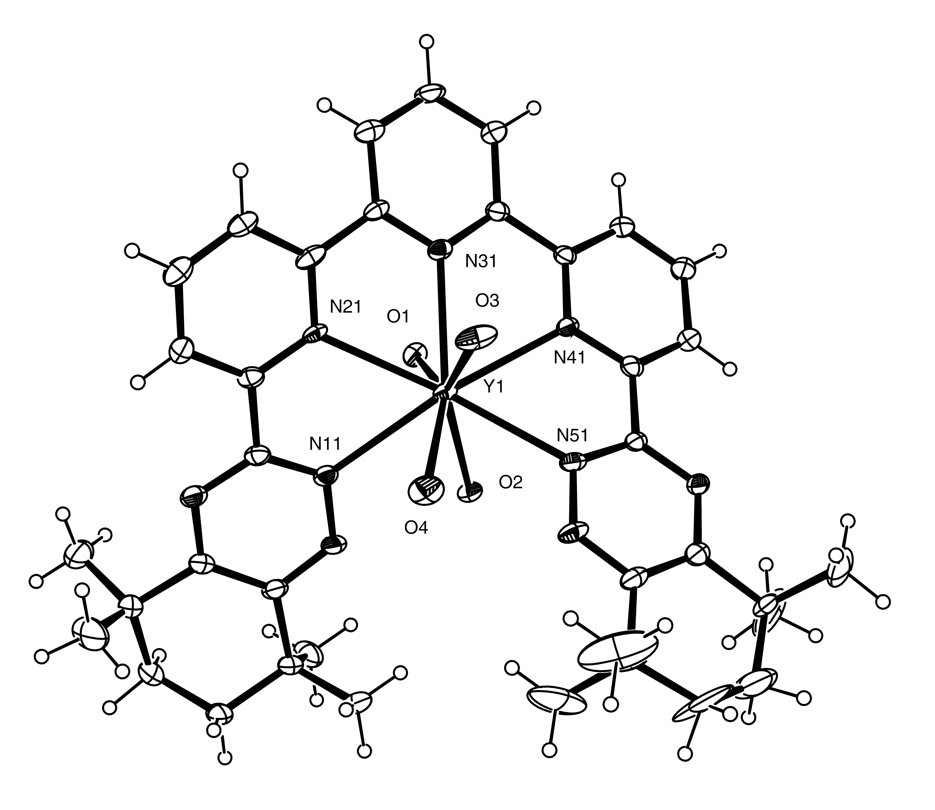
Figure 8. Y³⁺ complex of 5 with ellipsoids at 50% probability. Counterions have been omitted for clarity. Hydrogen atoms on water molecules were not located and are not included.
We then attempted to obtain an X-ray structure of the palladium complex of 5. However, despite repeated attempts at crystal growing (slow evaporation from acetone solutions, diffusion of diethyl ether into acetonitrile solutions), crystals suitable for X-ray analysis could not be obtained. Subsequently, we recorded the NMR and mass spectra of the complex. The aromatic region of the ¹H NMR spectrum of the complex in deuterated acetone is shown in Figure 9. A total of 9 well-resolved resonances were observed (three triplets and six double doublets). As in the parent ligand 5, the three triplets were assigned to the protons at the 4-positions of each ring while the remaining signals were assigned to the protons at the 3- and 5-positions of each ring. The tentative assignments were made as shown in Figure 9 based on a comparison with the ¹H NMR spectrum of the corresponding quinquepyridine complex.²⁴ In the aliphatic region, 8 singlets were observed corresponding to each of the methyl groups while the methylene protons appeared as poorly-resolved multiplets. In addition, the ¹³C NMR spectrum displayed 7 methyl environments and 3 methylene environments in the aliphatic region while in the aromatic region, the methine carbons appeared as 9 singlets.
Figure 9. Aromatic region of the ¹H NMR spectrum of [Pd(5)(PF₆)₂]₂ in acetone-d₆. Assignments were verified by H-H and C-H COSY.
These data are clearly consistent with an asymmetric environment for the ligand 5 in the complex. Two structures are then possible. One is a dinuclear double-helicate (2:2 complex) similar to the Pd(quinquepyridine)²⁺ complex published by Constable et al²⁴ where each metal centre is in a square pyrimidal coordination geometry and each ligand 5 is divided into two binding domains; a bidentate triazinylpyridyl domain and a tridentate triazinylbipyridyl domain. This can be achieved by twisting about the interannular axis between C-2 and C-2’ of 5. The other possible structure is a mononuclear 1:1 complex where the metal is in a square planar coordination geometry and one terminal triazene ring is non-coordinated. The electrospray ionisation mass spectrum showed a mass peak at m/z = 358.6264 which is consistent with the formula [Pd(5)]_{n}^{2n+}. The isotope distribution pattern of this peak (see Supporting Information) is consistent with that calculated for a 1:1 complex (n = 1) but additional mass peaks were also observed which corresponded to those calculated for the 2:2 complex (n = 2). It thus appears that a mixture of 1:1 and 2:2 complexes is present under the electrospray ionisation conditions used. Although definitive evidence in the form of a solid-state structure could not be obtained, it appears that the complex is a dinuclear double-helicate of 2:2 stoichiometry similar to the quinquepyridine complex published by Constable et al.²⁴
Nuclear Magnetic Resonance and Theoretical Studies
Solution-phase NMR studies were undertaken in order to establish the nature of the complexed species in solution. The stoichiometry of the lanthanide complexes of 5 was deduced form nuclear magnetic relaxation dispersion titrations as shown in Figure 10.^{25,26} The decrease in relaxation rate (or relaxivity) upon formation of a paramagnetic complex was used to establish its stoichiometry.²⁵ As solvent molecules are removed from the paramagnetic centres, their protons relax more slowly in the bulk of the solution. Relaxivity is thus decreasing and a plateau is finally reached once a complex is fully formed. This procedure has been successfully used for the BTPs 1²⁵ but in the present case, the perchlorate complex precipitated once a 2:1 5/Gd(III) ratio was reached. The exact value of the relaxation plateau is thus uncertain but it seems clear that a 2:1 ligand:metal complex is essentially formed as we obtained a linear relaxivity decrease until this concentration ratio was reached. Similarly, a precipitate was observed once the ligand:metal ratio was between 0.8 and 1.5 in the presence of nitrate ions. This could mean that a 1:1 complex is the major species in anhydrous acetonitrile.
Figure 10. NMR titration of Gd³⁺ by 5 (anhydrous CD₃CN, 25°C); ▲: perchlorate salt, ▼: nitrate salts. Solubility limits are indicated by vertical dotted lines and relaxivity plateaux are tentatively presented as horizontal dash lines.
In view of the uncertainty of the stoichiometries of the complexes, we initiated an electrospray mass spectrometry study of the perchlorate solutions. The ES-MS spectrum of a solution of Gd(ClO₄)₃ with 2.5 equivalents of 5 is shown in the Supporting Information. Intense mass peaks were observed for the protonated free ligand and for its sodium complex together with a peak assigned to the bis-complex at m/z = 460.19. In contrast, the electrospray mass spectrum of a 1:1 mixture of 5 and Yb(NO₃)₃ displayed a peak at m/z = 909.27 corresponding to the 1:1 complex [Yb(5)(NO₃)₂]⁺ in addition to mass peaks due to the protonated free ligand and its sodium complex. No peak corresponding to the bis-complex was observed even for 1:3 mixtures of Yb(NO₃)₃ and 5. Expanded views of the experimental and computed mass patterns of the metal complex peaks are shown in the Supporting Information.
We next recorded the NMR spectrum of the Eu(III) bis-complex in perchlorate medium. The Eu(III) ion is not suitable for a conformational analysis because the dipolar contribution to the paramagnetic shifts is comparable to the contact contribution, but this ion causes minimal broadening of the NMR peaks and well-resolved spectra are usually obtained.^{26,27} A qualitative analysis of the NMR spectra is thus greatly facilitated. As shown in Figure 11, this was indeed the case for the bis-complex of 5. As expected, the spectrum of the Eu(III) complex exhibited five resonances due to the terpyridine moiety. Surprisingly, four resonances due to the methyl groups and four resonances due to four different types of methylene protons were also observed. In contrast, the free ligand 5 and its Lu(III) complex exhibited a pair of singlets for the methyl groups and an 8-proton multiplet for the methylene protons as expected for rapidly inverting cyclohexenyl groups.
Figure 11. ¹H NMR spectrum of a 2:1 5:Eu(ClO₄)₃ mixture in anhydrous CD₃CN at 25°C. Peak assignments: meta and para protons in the central pyridine ring (●): -2.45 and -0.25 ppm; meta and para protons in the outer pyridine rings (●): 14.85, 11.90 and 4.0 ppm; methyl protons (+): 2.90, 1.53, -0.29 and -4.83 ppm; methylene protons (x): 1.53, 0.62, 0.45 and -0.50 ppm.
It thus seems that the aliphatic tetramethylcyclohexenyl groups of the metal complexes are constrained on the NMR time scale used in the present work. Rapid inversion of the cyclohexenyl groups appears to be prevented by steric hindrance, a phenomenon that is readily observed for the Eu(III) complex because of the large induced paramagnetic shifts. An expanded view of the methylene resonances that clearly shows the methylene coupling patterns is shown in the Supporting Information. Two resonances only would be expected if the tetramethylcyclohexenyl groups were conformationally mobile. We also recorded a H-H COSY spectrum of the bis-complex with Eu(III) in order to show that there are indeed four types of methylene protons that are all coupled together (see Supporting Information). Crosspeaks are found for the four types of methylene protons as well as for the two groups of terpyridine protons.
Figure 12 presents the ¹H NMR spectrum of the Yb(III) perchlorate bis-complex of 5. There are again resonances for four different methylene protons and four different methyl groups. Coupling patterns are observed for the four methylene peaks (see Supporting Information), an unusual feature because the NMR resonances of Yb(III) complexes are usually so broad that J couplings cannot be observed. The COSY spectrum clearly shows all the expected cross peaks and a ¹³C-¹H HSQC correlation confirms the peak assignments and clearly shows which of the methylene peaks are due to two protons on the same carbon atom (see Supporting Information). The latter spectrum displays two ¹³C peaks each connected with two methylene protons as expected for rigid cyclohexenyl units. The methylene proton coupling patterns (see Supporting Information) are also in keeping with a rigid structure. No spectral changes were observed in the limited temperature range available with acetonitrile and we were thus unable to estimate the energy barrier for conformation inversion.
Yb(III) is the ideal ion for a conformational analysis as it induces essentially pure dipolar shifts.^{26,28} The solution structures of its complexes can be inferred from these shifts provided the complexes under study display some form of symmetry and are conformationally rigid.²⁷ We thus decided
Figure 12. ¹H NMR spectrum of a 2:1 5:Yb(ClO₄)₃ mixture in anhydrous CD₃CN at 25°C. Peak assignments: meta and para protons in the central pyridine ring (●): -14.38 and -14.69 ppm; meta and para protons in the outer pyridine rings (●): 40.69, 25.51 and 8.52 ppm; methyl protons (+): 4.84, 1.83, -5.12 and -16.38 ppm; methylene protons (x): -0.32, -2.40, -3.22 and -6.04 ppm.
to deduce the solution structure of the bis-complex of 5 from the relative magnitude of the paramagnetic shifts induced by Yb(III). A molecular model of the bis-complex was obtained starting with structures built with the Chem3D program (CambridgeSoft, MA, USA) with either two planar ligands perpendicular to each other or at an angle or with the aromatic rings in a twisted conformation so as to obtain metal-nitrogen distances close to 3 Ǻ.
All structures were optimized by a force field approach using parameters published by Cundari et al. for Gd(III) complexes.²⁹ Finally, full optimizations were performed using the SPARKLE Yb(III) parameter set that was proposed by Simas et al.³⁰ and that is included in MOPAC 2009. The minimum energy geometry with expected Yb(III)-N distances (2.41-2.43 Ǻ) was obtained starting from the twisted arrangement.
Different views of the optimized structure are presented below in Figures 13 and 14. The structure is a mononuclear double-helicate with the metal ion at the center of a bicapped square antiprismatic arrangement of donor atoms. Each central pyridine ring is located above the center of a square face formed by the nitrogen atoms of the two adjacent pyridine rings and by the nitrogen atoms of two triazine units belonging to the other ligand in the bis-complex. A bicapped square-antiprismatic arrangement is the most favored geometry when one sphere is surrounded by 10 spheres³¹ and the optimized geometry of Yb(5)₂³⁺ is in keeping with the stereochemical arrangement predicted by theory. It should also be noted that some of the aromatic rings in the ligands are slightly bowed, a feature that is often found in complexes with high coordination numbers even in phenanthroline rings.³² A bowed arrangement of 5 is also observed in the crystal structure of Y(5)(H₂O)₄](ClO₄)₃ (Figure 8). A ligand deformation is of course detrimental to the thermodynamic stability of complexes but is probably imposed by the necessity to rearrange one or more ligands so as to completely encapsulate the metal ion. The optimised geometry of the [Yb(5)₂]³⁺ complex is similar to the coil structure found for a Eu(III) homoleptic bis-complex with the terpytz ligand (Figure 15) that was published by Giraud et al. (EFAXUF in the Cambridge Structural Database).³³ In this crystallographic structure, the metal ion occupies the center of an irregular bicapped trigonal prismatic assembly of nitrogen atoms that is close to a square antiprismatic arrangement.
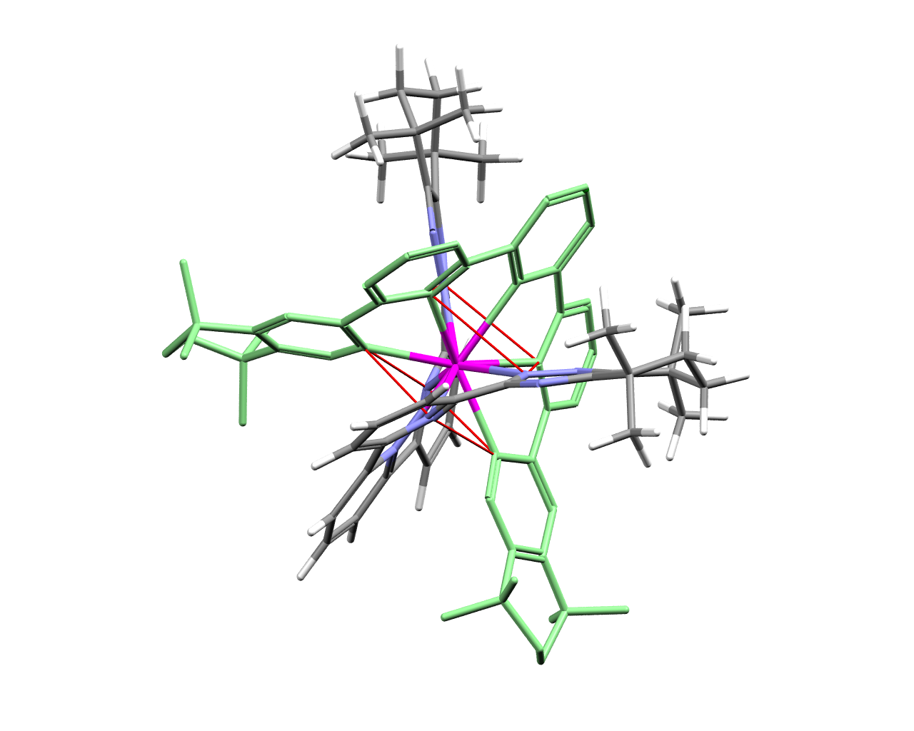
Figure 13. Optimized structure of the bis-complex Yb(5)₂³⁺ complex. The carbon skeleton of one ligand is colored in green and the protons are removed for clarity. The two square faces of the square antiprism are shown in red.
The induced paramagnetic shifts δ_{i} were computed from the spectra of Yb(5)₂³⁺ and of diamagnetic Lu(5)₂³⁺ that was used as a reference. The geometric factors in equation 1 that relate these shifts with magnetic susceptibility terms were deduced from the structure shown in Figure 13.
Equation 1.
where χ_{xx} χ_{yy} and χ_{zz} are magnetic susceptibility terms characteristic of the investigated complex and thus identical for all nuclei. The factors r_{i}, θ_{i} and φ_{i} are the polar coordinates of proton i giving rise to chemical shift δ_{i} in the set of axes of the magnetic susceptibility tensor with the metal ion at the centre. The full dipolar equation has to be used because Yb(5)₂³⁺ is not an axially symmetric complex.^{26,27} However, the orientation of the magnetic susceptibility axes is well-defined as one of them must coincide with the C₂ axis joining the two central pyridine nitrogen atoms and the metal ion. The two other magnetic susceptibility axes must be located in the plane perpendicular to the C₂ axis and must be oriented so as to obtain identical geometric factors for protons giving rise to the same NMR resonance in the two ligands. The x (or y) axis thus bisects one of the square faces of the antiprism.
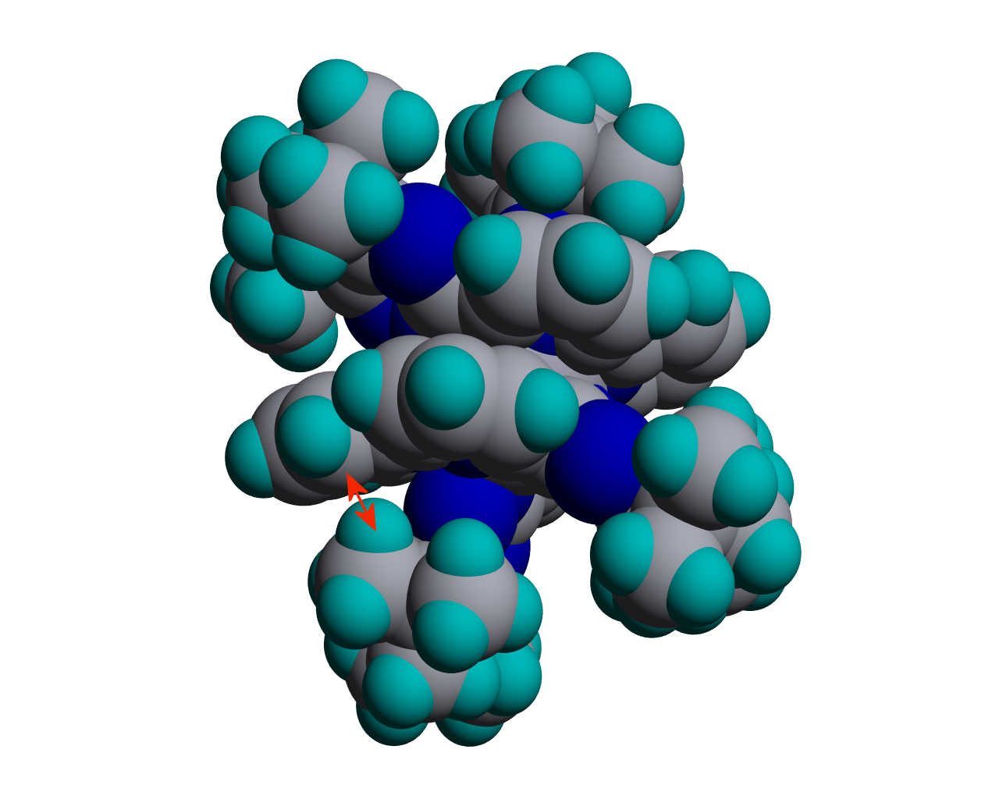
Figure 14. Space-filling model of the Yb(5)₂³⁺ complex. The red arrow shows one of the interatomic distances that is smaller than the sum of the van der Waals radii (2.75 instead of 3.05 Ǻ).
The magnetic susceptibility terms in equation 1 were computed by solving a set of 13 linear equations established for the 13 resonances displayed by [Yb(5)₂]³⁺ for which the geometric factors were deduced from the geometric model shown in Figure 13. An excellent correlation was obtained between the calculated and the experimental shifts as shown in Figure 16 with
The NMR analysis fully supports the structure obtained by the force field calculations and the geometry of the bis-complex Yb(5)₂³⁺ is thus very close to or identical to the structure shown in Figures 13 and 14 above. The ring-inversion barrier of cyclohexene is rather low (23 kJ/mol) and the aliphatic substituents of the triazine moities of 5 were not expected to be rigidified. Several inter-ligand distances involving the cyclohexenyl units are smaller than the sum of the van der Waals distances as shown in Figure 14. Altough it is partially stabilized by π- π interactions between aromatic rings, the Yb(III) bis-complex is sterically crowded and is unable to withstand the competition with other coordinating ligands as shown below in the case of the nitrate ion.
Figure 15. Structure of the terpytz ligand
The partitioning of actinides from lanthanides is performed in nitric acid solutions and information is thus also needed on the structure of the lanthanide nitrate complex of 5. The NMR titration data (see Figure 10) suggest that a 1:1 complex is formed in the presence of nitrate ions and the crystallographic structure of the 1:1 complex with Y(ClO₄)₃ has been obtained (Figure 8). One may then wonder whether this structure is maintained in solution.
The spectrum of a 1:1 mixture of 5:Yb(NO₃)₃ in acetonitrile is presented in Figure 17. This spectrum displays resonances for the Yb(III) complex in addition to peaks due to the free ligand. In our experimental conditions, there is a competition between the nitrate ions and the ligand 5 for the complexation of the metal ion. Adding an excess of Yb(III) displaces the equilibrium towards the 1:1 complex and the free ligand resonances completely disappear. The Yb(5)³⁺ peaks remain broad in all conditions and their assignment is difficult except from the relative areas. Moreover, none of the
Figure 16. Correlation between the calculated and experimental paramagnetic shifts in the ¹H NMR spectrum of [Yb(5)₂](ClO₄)₃. 99% intervals are indicated by dotted lines. (slope: 1.00, intercept: 2.13).
2D NMR techniques applied to the perchlorate complex could be used (COSY, HSQC) because of the broadness of the peaks. Only the protons due to the methyl groups and the para proton in the central pyridine group can be assigned with certainty. Moreover, the number of resonances clearly indicates that the tetramethylcyclohexenyl groups are inverting rapidly on the NMR scale we used in contrast with what we observed for the Yb(III) perchlorate complex. As expected for a mono-complex, the structure is thus much less crowded and the tetramethylcyclohexenyl rings are free to invert rapidly (it should however be noted that the shift range is 25 ppm instead of 60 ppm for the perchlorate complex. Peak coalescences are thus more easily reached).
Despite these uncertainties, we deduced the dipolar geometric factors in equation 1 above from the crystallographic structure of the Y(5)³⁺ mono-complex (Figure 8) and we made a fit between these factors and the induced paramagnetic shifts of the Yb(III) nitrate complex. A reasonably good agreement was obtained (see Supporting Information) and the solution and solid state structures are therefore probably similar. The magnetic susceptibility axes were oriented as follows: the z axis joins the metal ion with
Figure 17. ¹H NMR spectrum of a 1:1 mixture of 5:Yb(NO₃)₃ in anhydrous CD₃CN at 25°C. Tentative peak assignments: meta and para protons of the pyridine rings (●): 16.18, 15.96, 9.96, 0.91 and -2.08 ppm; methyl protons (+):7.20 and -0.79 ppm; methylene protons (x); 4.06 and 3.11 ppm. The narrow resonances between 8 and 9 ppm and between 1 and 2 ppm are due to the free ligand, acetonitrile and a trace of water.
the nitrogen atom and the para carbon atom of the central pyridine unit, the x (or y) axis is perpendicular to the plane formed by the central pyridine ring and the metal ion. This analysis may explain the relatively low distribution coefficients observed in nitrate media (Figure 3) as the 1:1 complex of 5 with Am(III) would be expected to be considerably less hydrophobic than the corresponding 1:2 complex.
Better agreement between the experimental and the calculated paramagnetic shifts could probably be obtained by orienting differently the magnetic susceptibility axes. However, the uncertainties in the assignment of the NMR resonances and on the exact orientation of the magnetic susceptibility tensor in a low symmetry structure would remain and efforts in that direction would not be very fruitful. At this stage, one can only say that the solution and solid state structures of Yb(5)³⁺ are probably close.
Conclusions
In conclusion, we have synthesized the first example of a (1,2,4-triazin-3-yl)-2,2’:6’,2’’-terpyridine ligand and its solvent extraction chemistry has been examined. Low binding affinities for Am(III) but good selectivities for Am(III) over Eu(III) are observed in 1-octanol in the absence of a phase-modifier. The addition of 2-bromohexanoic acid increases the distribution coefficient at low acidities. The addition of DMDOHEMA also increases the distribution coefficient but the separation factor decreases at higher acidities. The stoichiometries and solution structures of the complexes with Gd(III), Eu(III) and Yb(III) have been determined by nuclear magnetic relaxation dispersion titrations, 1D and 2D NMR techniques and mass spectrometry. In the presence of perchlorate ions the ligand forms highly crowded 1:2 complexes where the aliphatic substituents are conformationally immobile on the NMR timescale (250-400 MHz). The solution structure of the 1:2 complex of 5 with Yb(ClO₄)₃ has been deduced from the relative magnitude of the induced paramagnetic shifts. The complex is a mononuclear double helicate where the metal adopts a bicapped square antiprism coordination geometry. In contrast, in the presence of nitrate ions the ligand forms less-crowded 1:1 complexes where the aliphatic substituents are conformationally mobile on the NMR time scale. The nitrate ions compete effectively with the ligand for coordination sites on the metal leading to poorly-extracted complexes of low hydrophobicity. A mononuclear helical 1:1 complex is formed between 5 and Y(ClO₄)₃ and its X-ray structure was determined. The Pd(II) complex of 5 has been synthesized and its NMR and mass spectra are consistent with a dinuclear double-helical structure.
Acknowledgements
We thank the Nuclear Fission Safety Program of the European Union for support under the ACSEPT (FP7-CP-2007-211 267) contract. We also thank the EPSRC and the University of Reading for funds for the X-Calibur system. The Belgian team also acknowledge the financial support of the Fonds de la Recherche Scientifique (FNRS) of Belgium.
References
ª Department of Chemistry, The University of Reading, Whiteknights, Reading RG6 6AD, UK. Fax: +44 (0) 118 378 6121; Tel: +44 (0) 118 378 7417; E-mail: f.lewis@reading.ac.uk, l.m.harwood@reading.ac.uk
^{b} Forschungszentrum Jülich GmbH, Sicherheitsforschung und Reaktortechnik, D-52425 Jülich, Germany. Tel: + 492 46161 4896; E-mail: g.modolo@fz-juelich.de
^{c} Coordination and Radiochemistry, University of Liège, Sart Tilman B16,
B-4000 Liège, Belgium. Fax: + 324 366 4739; Tel: + 324 366 3501; E-mail: jf.desreux@ulg.ac.be
† Electronic Supplementary Information (ESI) available: [Figures of NMR spectra, mass spectra and graphs referred to in the text and X-ray crystallographic data in CIF format]. See DOI: 10.1039/b000000x/
‡ Crystal Data for 5: C₃₇H₄₁N₉, M = 611.79, monoclinic, spacegroup P21/c, a = 9.760(2), b = 10.731(2), c = 31.542(7)Ǻ, β = 95.13(2)º, U = 3290.3(12)Ǻ³ , Dc = 1.235 gcm⁻³, 9533 independent reflections, 4741 data (I > 2σ(I)), R1 = 0.0741, wR2 = 0.1610. CCDC 99999. Crystal Data for [Y(5)(H₂O)₄](ClO₄)₃.2H₂O: C₃₇H₅₃Cl₃N₉O₁₈Y, M = 1107.14, triclinic, Z = 2, a = 13.0611(5), b = 13.7135(7), c = 15.7947(6)Ǻ, α = 108.832(4), β = 105.958(3), γ = 98.035(4)º, U = 2491.91(19)Ǻ³, Dc =1.476gcm⁻³, 13491 independent reflections, 7005 data (I > 2σ(I)), R1 = 0.1054, wR2 = 0.2522. CCDC 99999.
- A. Facchini, L. Amato, G. Modolo, R. Nannicini, C. Madic, P. Baron, Sep. Sci. Technol., 2000, 35, 1055-1068; D. Serrano-Purroy, P. Baron, B. Christiansen, R. Malmbeck, C. Sorel, J.-P. Glatz, Radiochim. Acta, 2005, 93, 351-355; D. Serrano-Purroy, B. Christiansen, J.-P. Glatz, R. Malmbeck, G. Modolo, Radiochim. Acta, 2005, 93, 357-361; G. Modolo, H. Vijgen, D. Serrano-Purroy, B. Christiansen, R. Malmbeck, C. Sorel, P. Baron, Sep. Sci. Technol., 2007, 42, 439-452.
- C. Madic, M. J. Hudson, J.-O. Liljenzin, J.-P. Glatz, R. Nannicini, A. Facchini, Z. Kolarik, R. Odoj, Progr. Nucl. Energ., 2002, 40, 523-526; C. Hill, D. Guillaneux, L. Berthon, C. Madic, J. Nucl. Sci. Technol., 2002, (Sup. 3), 309-312.
- J. Magill, V. Berthou, D. Haas, J. Galy, R. Schenkel, H.-W. Wiese, G. Heusener, J. Tommasi, G. Youinou, Nuclear Energy, 2003, 42, 263-277; International Atomic Energy Agency, Technical Reports Series, ISSN 0074–1914 no. 435, Vienna, Austria, 2004.
- C. Madic, B. Boullis, P. Baron, F. Testard, M. J. Hudson, J-O. Liljenzin, B. Christiansen, M. Ferrando, A. Facchini, A. Geist, G. Modolo, A. G. Espartero, J. De Mendoza, J. Alloys Compounds, 2007, 444-445, 23-27; C. Ekberg, A. Fermvik, T. Retegan, G. Skarnemark, M. R. S. Foreman, M. J. Hudson, S. Englund, M. Nilsson, Radiochim. Acta, 2008, 96, 225-233; Z. Kolarik, Chem. Rev., 2008, 108, 4208-4252.
- M. G. B. Drew, D. Guillaneux, M. J. Hudson, P. B. Iveson, M. L. Russell, C. Madic, Inorg. Chem. Commun., 2001, 4, 12-15; M. G. B. Drew, D. Guillaneux, M. J. Hudson, P. B. Iveson, C. Madic, Inorg. Chem. Commun., 2001, 4, 462-466; C. Boucher, M. G. B. Drew, P. Giddings, L. M. Harwood, M. J. Hudson, P. B. Iveson, C. Madic, Inorg. Chem. Commun., 2002, 5, 596-599; M. J. Hudson, Czech. J. Phys., 2003, 53, A305-A311; M. G. B. Drew, C. Hill, M. J. Hudson, P. B. Iveson, C. Madic, T. G. A. Youngs, Dalton Trans., 2004, 244-251; M. Nilsson, S. Andersson, C. Ekberg, M. R. S. Foreman, M. J. Hudson, G. Skarnemark, Radiochim. Acta, 2006, 94, 1-4; M. G. B. Drew, M. R. St J. Foreman, A. Geist, M. J. Hudson, F. Marken, V. Norman, M. Weigl, Polyhedron, 2006, 25, 888-900; M. J. Hudson, C. E. Boucher, D. Braekers, J. F. Desreux, M. G. B. Drew, M. R. St J. Foreman, L. M. Harwood, C. Hill, C. Madic, F. Marken, T. G. A. Youngs, New. J. Chem., 2006, 30, 1171-1183; A. M. Fedosseev, M. S. Grigoriev, I. A. Charushnikova, N. A. Budantseva, Z. A. Starikova, Ph. Moisy, Polyhedron, 2008, 27, 2007-2014.
- M. G. B. Drew, M. R. S. J. Foreman, C. Hill, M. J. Hudson, C. Madic, Inorg. Chem. Commun., 2005, 8, 239-241; M. R. St J. Foreman, M. J. Hudson, A. Geist, C. Madic, M. Weigl, Solvent Extr. Ion Exch., 2005, 23, 645-662; M. Nilsson, S. Andersson, F. Drouet, C. Ekberg, M. Foreman, M. Hudson, J-O. Liljenzin, D. Magnusson, G. Skarnemark, Solvent Extr. Ion Exch., 2006, 24, 299-318; M. Nilsson, C. Ekberg, M. Foreman, M. Hudson, J-O. Liljenzin, G. Modolo, G. Skarnemark, Solvent Extr. Ion Exch., 2006, 24, 823-843; M. R. S. Foreman, M. J. Hudson, M. G. B. Drew, C. Hill, C. Madic, Dalton Trans., 2006, 1645-1653; T. Retegan, C. Ekberg, I. Dubois, A. Fermvik, G. Skarnemark, T. Johnsson Wass, Solvent Extr. Ion Exch., 2007, 25, 417-431; C. Ekberg, I. Dubois, A. Fermvik, T. Retegan, G. Skarnemark, M. G. B. Drew, M. R. S. Foreman, M. J. Hudson, Solvent Extr. Ion Exch., 2007, 25, 603-617; T. Retegan, C. Ekberg, S. Englund, A. Fermvik, M. R. S. Foreman, G. Skarnemark, Radiochim. Acta, 2007, 95, 637-642; J.-C. Berthet, P. Thuéry, M. R. S. Foreman, M. Ephritikhine, Radiochim. Acta, 2008, 96, 189-197; J. Narbutt, J. Krejzler, Radiochim. Acta, 2008, 96, 219-223; A. Fermvik, C. Ekberg, S. Englund, M. R. S. J. Foreman, G. Modolo, T. Retegan, G. Skarnemark, Radiochim. Acta, 2009, 97, 319-324; A. Fermvik, L. Berthon, C. Ekberg, S. Englund, T. Retegan, N. Zorz, Dalton Trans., 2009, 6421-6430.
- A. Geist, C. Hill. G. Modolo, M. R. St J. Foreman, M. Weigl, K. Gompper, M. J. Hudson, Solvent Extr. Ion Exch., 2006, 24, 463-483.
- D. Magnusson, B. Christiansen, M. R. S. Foreman, A. Geist, J.-P. Glatz, R. Malmbeck, G. Modolo, D. Serrano-Purroy, C. Sorel, Solvent Extr. Ion Exch., 2009, 27, 97-106.
- E. C. Constable, Adv. Inorg. Chem. Radiochem., 1986, 30, 69-121; E. C. Constable, Tetrahedron, 1992, 48, 10013-10059; E. C. Constable, in Comprehensive Supramolecular Chemistry, ed. J. P. Sauvage and M. W. Hosseini, Elsevier, Oxford, 1996, vol. 9, pp. 213-252; C. Piguet, G. Bernardinelli, G. Hopfgartner, Chem. Rev., 1997, 97, 2005-2062; M. Albrecht, Chem. Rev., 2001, 101, 3457-3498; R. P. Thummel, in Comprehensive Coordination Chemistry II, ed. J. A. McCleverty and T. J. Meyer, Elsevier, Oxford, 2004, vol. 1, pp. 41-53; R. A. Fallahpour, Curr. Org. Synth., 2006, 3, 19-39.
- E. C. Constable, Prog. Inorg. Chem., 1994, 42, 67-138 ; E. C. Constable, Pure Appl. Chem., 1996, 68, 253-260 ; R. Ziessel, Synthesis, 1999, 1839-1865; E. C. Constable, C. E. Housecroft, Chimia, 1999, 53, 187-191; R. A. Fallahpour, Chimia, 1999, 53, 195; R. Ziessel, Coord. Chem. Rev., 2001, 216-217, 195-223; E. C. Constable, V. Chaurin, C. E. Housecroft, A. Wirth, Chimia, 2005, 59, 832-835.
- P. Jones, G. B. Villeneuve, C. Fei, J. DeMarte, A. J. Haggarty, K. T. Nwe, D. A. Martin, A-M. Lebuis, J. M. Finkelstein, B. J. Gour-Salin, T. H. Chan, B. R. Leyland-Jones, J. Med. Chem., 1998, 41, 3062-3077; K. Kikuchi, S. Hibi, H. Yoshimura, N. Tokuhara, K. Tai, T. Hida, T. Yamauchi, M. Nagai, J. Med. Chem., 2000, 43, 409-419.
- K. Rühlmann, Synthesis, 1971, 236-250.
- J. Strating, S. Reiffers, H. Wynberg, Synthesis, 1971, 209-211; J. Strating, S. Reiffers, H. Wynberg, Synthesis, 1971, 211-212.
- D. D. Coffman, E. L. Jenner, R. D. Lipscomb, J. Am. Chem. Soc., 1958, 80, 2864-2874; D. H. Bremner, S. R. Mitchell, H. Staines, Ultrasonics Sonochemistry, 1996, 3, 47-52; D. H. Bremner, A. E. Burgess, F-B. Li, Green Chemistry, 2001, 3, 126-130.
- V-M. Mukkala, C. Sund, M. Kwiatkowski, P. Pasanen, M. Högberg, J. Kankare, H. Takalo, Helv. Chim. Acta., 1992, 75, 1621-1632; C. Galaup, J-M. Couchet, S. Bedel, P. Tisnès, C. Picard, J. Org. Chem., 2005, 70, 2274-2284; J. M. Veauthier, C. N. Carlson, G. E. Collis, J. L. Kiplinger, K. D. John, Synthesis, 2005, 2683-2686.
- R. P. Thummel, Y. Jahng, J. Org. Chem., 1985, 50, 3635-3636.
- W. K. Fife, J. Org. Chem., 1983, 48, 1375-1377.
- CrysAlis, (2006) Oxford Diffraction Ltd., Abingdon, UK.
- G. M. Sheldrick, Acta. Cryst., 2008, A64, 112.
- ABSPACK program (2007), Oxford Diffraction Ltd. Abingdon, UK.
- F. H. Case, J. Org. Chem., 1965, 30, 931-933.
- Z. Kolarik, U. Mullich, F. Gassner, Solvent Extr. Ion Exch., 1999, 17, 23-32.
- D. Serrano-Purroy, P. Baron, B. Christiansen, R. Malmbeck, C. Sorel, J.-P. Glatz, Radiochim. Acta, 2005, 93, 351-355.
- E. C. Constable, S. M. Elder, J. Healy, M. D. Ward, D. A. Tocher, J. Am. Chem. Soc., 1990, 112, 4590-4592.
- M. J. Hudson, C. E. Boucher, D. Braekers, J. F. Desreux, M. G. B. Drew, M. R. St J. Foreman, L. M. Harwood, C. Hill, C. Madic, F. Marken, T. G. A. Youngs, New. J. Chem., 2006, 30, 1171-1183.
- I. Bertini, C. Luchinat, G. Parigi, Solution NMR of Paramagnetic Molecules, Elsevier, Amsterdam, 2001.
- J. F. Desreux, C. N. Reilley, J. Am. Chem. Soc., 1976, 98, 2105-2109; R. S. Ranganathan, N. Raju, H. Fan, X. Zhang, M. F. Tweedle, J. F. Desreux, V. Jacques, Inorg. Chem., 2002, 41, 6856-6866.
- J. A. Peters, J. Huskens, D. J. Raber, Prog. Nucl. Magn. Reson. Spectrosc., 1996, 28, 283-350.
- T. R. Cundari, E. W. Moody, S. O. Sommerer, Inorg. Chem., 1995, 34, 5989-5999.
- G. B. Rocha, R. O. Freire, N. B. da Costa Jr., G. F. de Sá, A. M. Simas, Inorg. Chem., 2004, 43, 2346-2354.
- D. L. Kepert, Inorganic Stereochemistry, Springer-Verlag, Berlin, 1982.
- N. E. Dean, R. D. Hancock, C. L. Cahill, M. Frisch, Inorg. Chem., 2008, 47, 2000-2010.
- M. Giraud, E. S. Andreiadis, A. S. Fisyuk, R. Demadrille, J. Pecaut, D. Imbert, M. Mazzanti, Inorg. Chem., 2008, 47, 3952-3954.

