Adaptive Project Planning and Management Based on Best Practices – COBRA System

Bin Ling, Yinshan Tang, Kecheng Liu
Informatics Research Centre, School of Business
University of Reading
Reading, UK
{b.ling, y.tang, k.liu}@reading.ac.uk
Keith Neale
Dytecna Ltd.
Weybridge, UK
keith.neale@dyetcna.com

Abstract

Planning a project with proper considerations of all necessary factors and managing a project to ensure its successful implementation will face a lot challenges. Initial stage in planning a project for bidding a project is costly, time consuming and usually with poor accuracy on cost and effort predictions. On the other hand, detailed information for previous projects may be buried in piles of archived documents which can be increasingly difficult to learn from the previous experiences. Project portfolio has been brought into this field aiming to improve the information sharing and management among different projects. However, the amount of information that could be shared is still limited to generic information. This paper, we report a recently developed software system COBRA to automatically generate a project plan with effort estimation of time and cost based on data collected from previous completed projects. To maximise the data sharing and management among different projects, we proposed a method of using product based planning from PRINCE2 methodology. (Automated Project Information Sharing and Management System – COBRA)

Keywords: project management, product based planning, best practice, PRINCE2

1. Introduction
Nowadays main stream project management methods are process or activity based. Therefore the granularity of information is collected merely at the activity level. Project portfolios which assist the decision makers on corporate strategy and project management practices are also mainly represented based on process. Project information sharing happens only at the activity level or at the project level in this case. At activity level, information is not easily sharable due to the fact that new technologies, process re-engineering and different personnel preferences may all affect the practices of conducting project activities. The vast amount of information in between which contains the best practices of working on certain products (deliverables) is not even collected. There is an emerging requirement from industries to have a tool to use good practices or lessons learned from previous projects to guide the new projects. This paper provides an overview of a web based adaptive project information sharing and management system - COBRA (Cost, Optimisation Benchmarking, Reliability and Assessment). COBRA is developed by IRC (Informatics Research Centre) at The University of Reading in collaboration with the Dytecna Ltd. The development was following modern software engineering methodologies, PRINCE2 principles and the practical experience of project managers. COBRA integrates four main project management functions: project planning, progress monitoring, project reports and human resource allocation. It was designed for managing engineering projects, but its principles should also apply to other project disciplines.

2. COBRA System
The philosophy behind the design of COBRA is to facilitate system learning from previous projects in light of benchmarking criteria and present to the project manager a manageable amount of easily-derived information organised to give insight, information, or alerts about project status.

Figure 1 – COBRA Overview

To achieve this goal, COBRA is designed to intelligently assist in the through life management of projects based on best practice and experience from previous project profiles. The system is expected to automatically deliver project plans to match customer requirements and provides a mechanism for continuous monitoring of project execution via benchmarking and generation of project reports.

In order to fully utilise this service, an additional consultancy package will be provided to help customers to break down their products into sub-products or work packages in accordance with PRINCE2 project management principles. This data is stored in a central database for analysis and benchmarking enabling project managers to control their projects with greater precision. Thus, ultimately COBRA system will consist of two main parts: a web based project management tool which allows users to access it anytime and anywhere, and a consultancy service (shown in Figure 1).

3. Development Approach and Methodologies

3.1 Development approach
At the project initiation stage, it was found that project stakeholders could not really know for sure what they want until they see and use the software, and the external conditions could be changed in the time the project team have spent analysing and reviewing requirements and designing a solution, Thus Agile (Cohen et al., 2004) was selected as the software development model to guide from one stage to another for COBRA. Agile development principles include keeping requirements and documentation lightweight, and acknowledging that change is a normal and acceptable reality in software development (Waters, 2008). In more traditional software development projects, the simplified lifecycle is analyse, develop, test - first gathering all known requirements for the whole product, then developing all elements of the software, then testing the entire product is fit for release. In Agile software development, the life cycle is analyse, develop, test; analyse, develop, test; and so on... almost doing each step for each feature, one feature at a time. In contrast to plan driven or disciplined methodologies such as Rational Unified Process (Kroll and MacIsaac, 2006), the focus of Agile is placed on adapting quickly to the changing realities.

This system is developed using ASP.NET technology and deployed in MS Windows Server 2003 and MS SQL Server 2005 under the Windows environment, it takes advantage of many features of the .NET framework 2.0 such as the SQL data source API, integrated AJAX support and a security model that protects data even in Internet applications. Building on this base, .NET also provides full support for many data controls and declarative data access from Web, all of which have been employed in the system implementation to ensure COBRA is robust, efficient and maintainable.

3.2 Product Based Planning
The starting point for a good project planning is a proper understanding of the business requirement and scope. The work for COBRA to be done is analysed using product breakdown structure to delineate the project scope and defining a list of deliverable products to be constructed during the project. The products must be identified before the activities are defined since the object of the project is to produce deliverables. As mentioned in section 2, in accordance with PRINCE2 project management principles, users need to break down projects into work package sized products (includes intermediate documentary products and final end-products) before fully utilising COBRA. Therefore, it is expected that products (or work packages) are identified through product breakdown structure (PBS) and product flow diagram (PFD) before using COBRA tool.

Compared to activity-based planning or process-based planning, a significant advantage of product based planning is to do with reporting. It can more precisely control the scope of the project and focus only on what is really needed to meet the business case. Products are either finished or not, activities can be 95% finished for a long time even though work is taking place. One tends to forget things that have to be done to complete a project. This method captures them all, reducing the chance that any will be overlooked. Another significant advantage of it is that it will be much easier to benchmark with same or similar products because different project users may have different processes or approaches to delivering the same product, but the properties (e.g. quality, cost and time) used to measure the completed product should be same.

4. Overview of COBRA Functions
As a web based project management system, COBRA is able to intelligently support project managers in project planning, optimising business performance and project cost. Beside it, the other main facilities provided by the system are: reverse planning, resource allocation, project monitoring and project reporting. Each of the facilities will be introduced next.

4.2 Project Planning
COBRA enables project managers to plan a project by following pre-defined products (or work packages) in light of PBS and PFD. It’s also the key step of product-based planning technique in PRINCE2 which has emerged based upon the idea of considering the products that will result from the project rather than how.

Project planning is about effort estimation including time, cost and resources, which is based on expert judgment and analogy using historical data from completed projects. Consistency in historical data gathering is the key to reliable estimates (Basili and Weiss, 1984; Lott, 1993). Especially data for status report in business project management system should be collected during and after project, but in rare cases automatic data capture may be available (Rolstadas, 2000). COBRA is able to store project data automatically as a baseline when a new project plan is generated, and use the collected data for future project planning and project performance analysis.

Apart from creating a project plan from sketch, users can create a new project plan with benchmarking from previous practices and applying desired criteria. They need to decide the Build Priority of the new project is in “time” or “cost”, and decide a criteria level respectively from Maximum, Upper Quartile, Medium, Lower Quartile and Minimum. In term of the chosen category of the new project previously matched projects will be listed. Then users are able to choose the most desirable project(s) from the list to clone. As long as the products together with their activities from the desirable project(s) are selected and submitted for assembling, their portfolios (e.g. product name, activity name, dependencies and feedback) will be copied cross to the new project. The efforts (time and cost) of each activity will be calculated based on the customised benchmarking criteria and benchmarking algorithms. As a result, an interactive project Gantt chart with dependencies according to the time effort of each activity will be generated according to the time effort as shown in Figure 6. By clicking the individual product bar in the interactive Gantt chart, the user will be brought to another level of interactive Gantt chart – activities charts of this product (shown in Figure 7). The User could see the details of an individual activity by clicking the activity bar. Of course, such automatically derived plan allows manual overrides (shown in Figure 8) by privileged users for special considerations such as adding new products, removing unnecessary products or editing the figures of effort before project starts.

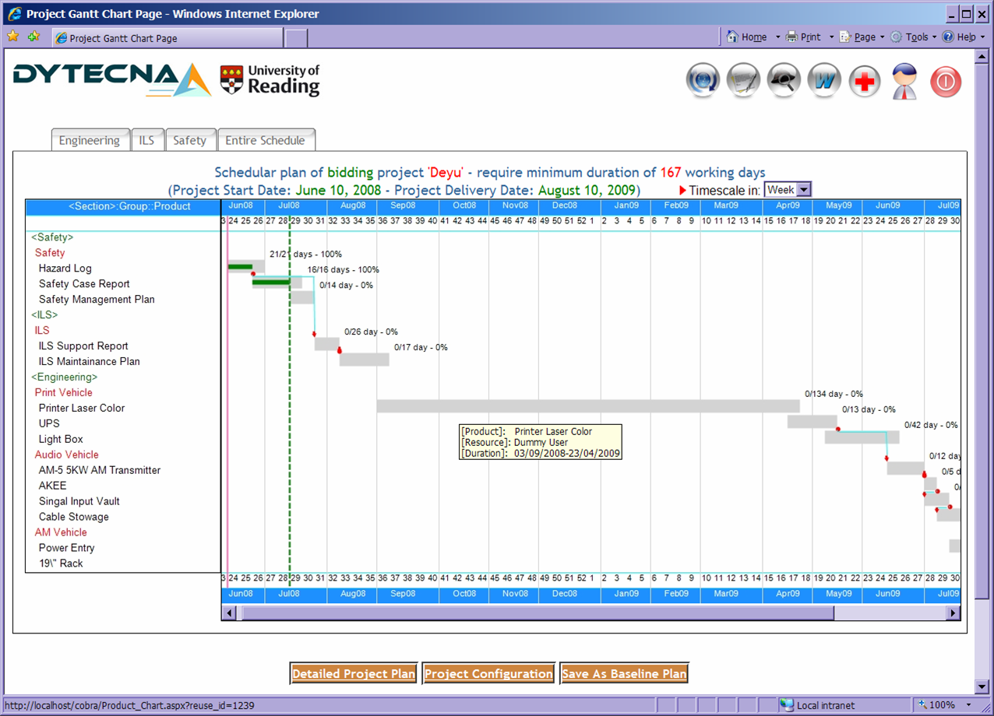
Figure 6 - Project Gantt Plan
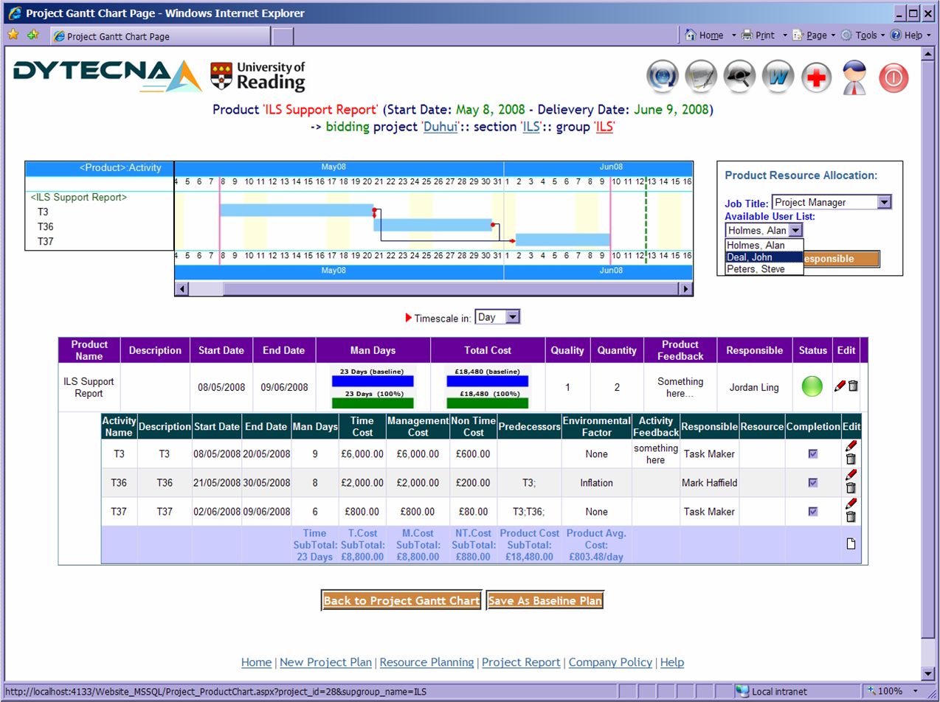
Figure 7 - Product with Associated Activities
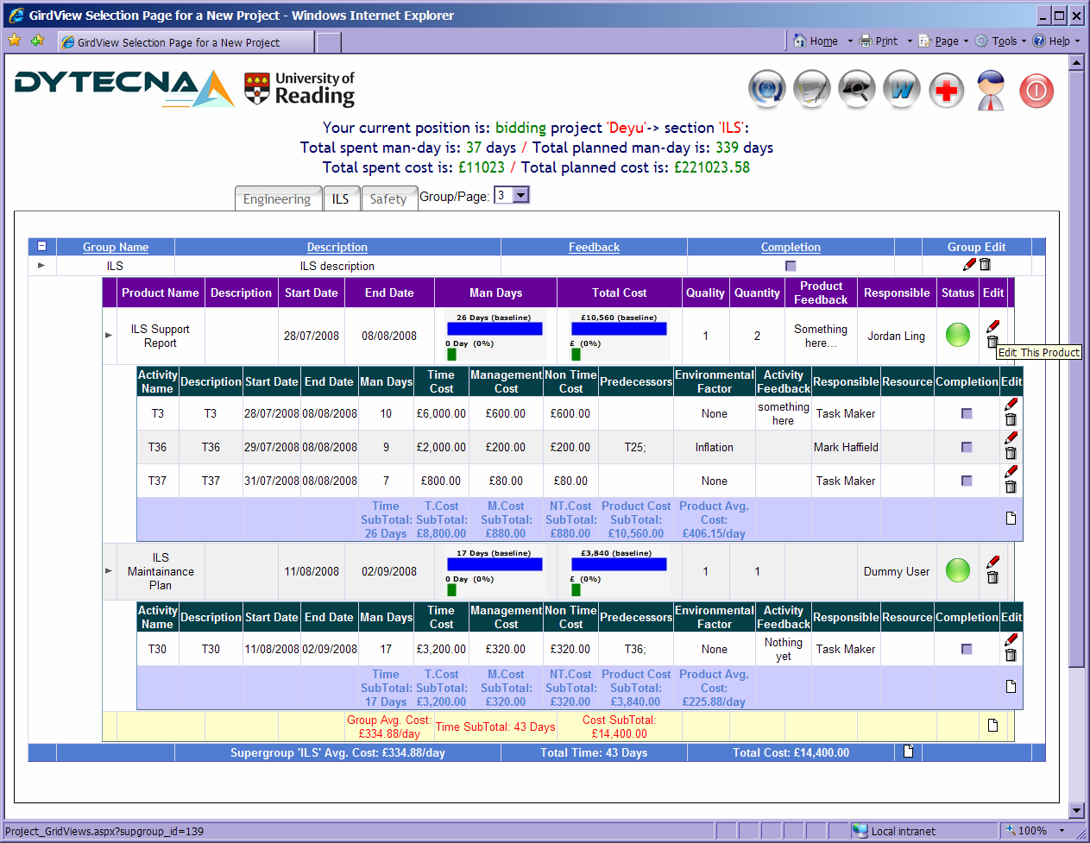
Figure 8 - Project Data View

COBRA also enables Reverse Planning which allows users to amend the project ending date or start date after project plan is generated, the project plan and Gantt chart will automatically adjusted to fit the new duration. Activities within a specific product may be shifted from a time order to be overlapped to each other when the duration of the product is compressed respectively. In this case, an alert message will be sent to relevant users, to draw attention to the person responsible that they may not cover some of the overlapped dates after product duration is compressed, extra resources may be required. Of course users are able to save the new plan as a new baseline if changes are approved, as it is a major task to keep track of all the changes and at anytime to refer to the latest version.

Consequently, through analysis of entered customer specified criteria against benchmarked data, COBRA is able to automatically produce an interactive project Gantt chart to improve the project visibility as well as assist project managers in deciding the project plan.

4.3 Human Resource Planning and Allocation
COBRA provides a basic management of staff resource allocation and activity assignment. It has an embedded feature to allow project manager to authenticate staff’s work absences, in which records the absent period and public holidays for all project team members. With help of this feature, the project manager is able to assign available skilled staff into project products (or work packages) and activities (shown in Figure 7). The data of staff allocation together with other project portfolios stored in the database could be used for generating live project resource allocation reports and other analysing reports. The human resource allocation report is useful to project manager and programme officer, as it truly illustrates how the project is staffed in the whole project time frame and where project resource conflicts occur. If a team member is over-employed, his or her resource data will be automatically highlighted in the report to attract attentions, then the project manager or programme officer is expected to re-allocate some work to other team members till the workload of this member is below the standard quota. Furthermore, if one or more of the activities are cancelled or the project plan has changed, the system will release time effort from allocated staff members. All the information of human resource allocation could be used for rewarding and promoting desired team behaviours as well.

4.4 Project Monitoring and Alert Mechanism
In many cases, project products delivery dates are estimated using expert judgement, thus many project managers will evaluate progress by ad-hoc discussions with the resources. Actual effort is not easy tracked and this measurement of progression is not very precise, as it is quite subjective, and often lead to late discovery of schedule slippage, making it hard to meet deadlines set with users. It is also difficult to assess the impact of changes to user requirements and resource allocation. Moreover, to manage a project well, is very much about establishing good communication and coping with risk. Communication can be facilitated by proper application of information technology. Risk can be dealt with if the correct information for decision making is available.

Thus, a proper mechanism to monitor the runtime project progress and alert relevant users is crucial. COBRA provides such a mechanism to automatically monitor and analyse product effort values and work completion status during the project progress according to project baseline. It is designed to be a central source for all project data and providing all project stakeholders with an immediate view of actual project progress, supporting decision making and control to reduce the need for meetings or reports and freeing the project manager to manage the project.

The project monitoring mechanism of COBRA consists entering on a regular basis the actual effort spent on each activity by responsible person (as long as the activity is completed). The responsible person is also required to enter real efforts to complete a task, comments with environmental factor which affects the delivery result. When the completion box of an activity is ticked, the activity is considered completed. Since activities are associated to products, actual effort can be summarised at product level even project level.

After login, senior members of the project such as project managers or executives are able to check the progress status of all current running projects immediately through a project tolerance Grid chart (shown in Figure 9). This chart is built with a project alerting mechanism. There are two levels of alerting mechanism in COBRA: one is at project level and one is at product level. During the project progress, if the position of a project is inside the tolerance level frame no matter it’s over time or over budget or both, the bubble colour will be shown as amber means the project is still under control but needs to be paid attention – the project manager need to analyse the problem or look for extra resources. If the position of a project is outside the tolerance level frame, the bubble colour will be shown as red means it’s beyond the project tolerance level and needs to launch the exception plan in term of PRINCE2. The project bubble colour will be shown as green if project is on time and on budget. From this Grid view, user is also able to click through the link of the product and find more details in a product view.

For each product, there is a status traffic light indicator designed for project manager to understand what’s due, what’s done and what’s overdue (shown in Figure 8). If this product is not completed yet but still within the planned time and one or more activities are over time, over budget or both, the traffic light of this product status will be shown as amber. The traffic light will be shown as red if the product is completed but either it’s over time or over budget, or product is uncompleted within planned time. In this case, an alert message will be sent to relevant staff automatically, corrective actions will be taken when necessary in order to meet project objectives in terms of effort and schedule.

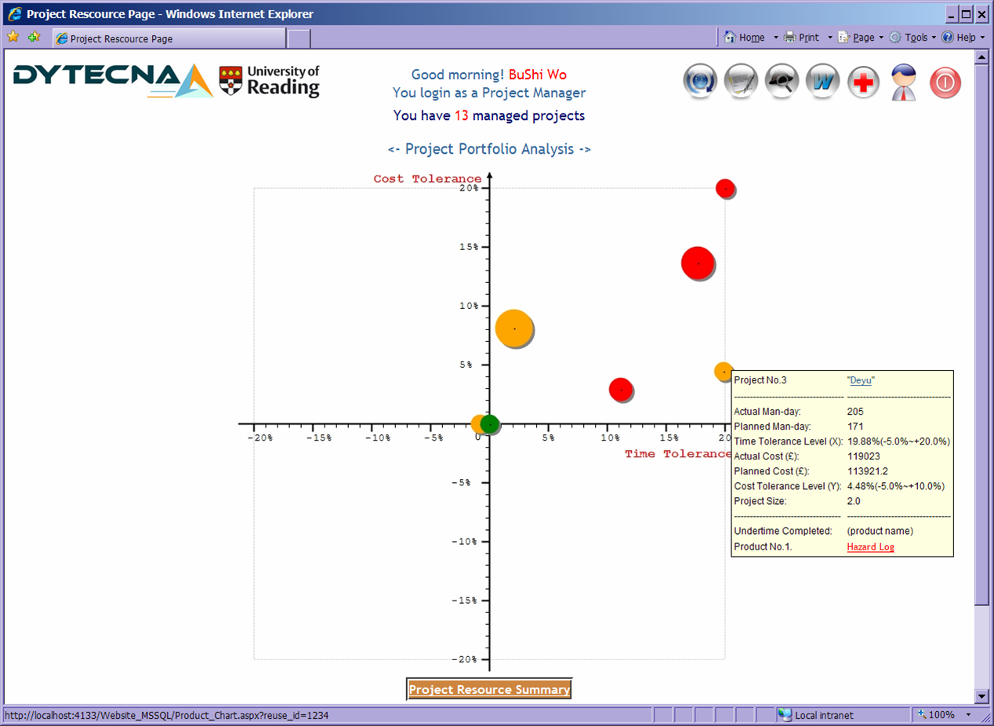
Figure 9 - Project Tolerance Gird

4.5 Project Report
COBRA is able to generate different kinds of report with charts according to customer requirements. Having used a data repository, the actual efforts of each activity can be recorded when it is completed. In that case, almost all status reporting could be accurate and automated. For instance, the system is able to benchmark current project data against data held from previous projects and provide comparison reports, which juxtapose the planned resource usages for the various products with their actual resource usage. Benchmarked data will be recorded in a central database at the end of the project to improve the analysis provided to subsequent projects. COBRA is also able to generate output reports which detail the project costs and time of an entered project configuration and summarise the project. These reports demonstrate project performance, cost analysis, trend analysis, resource allocation and real-time project status etc. All these reports can be exported into varied formats such as PDF, MS Excel and Word. As senior members of a project team, they should be able to find potential or real problems with the critical resources from these reports.

4.6 Summary
It is well recognised that getting everyone consistently using the product based planning method and share project information across entire project team and organisation is not easy. COBRA has been developed to bridge the gap between PRINCE2 main principles and its application, providing user with automated planning, monitoring, reports and human resource allocation. COBRA allows configurable access levels based on roles and rights granted that allow users to access the various management levels and features of the solution based on their individual needs. This approach ensures that each user need only see the functionality and information necessary to perform their responsibilities, thereby making the application easier to use for all stakeholders. COBRA also provides a complete project central database, storing all project data in one location for easy access, saving time and resource. It has built in deliverables' reviews and authorisations are granted online for multi-level granularity cooperation, and progress is updated in real time to reduce the need for costly meetings and expensive time wasting. Accessed across network or intranet, all project staff can have share real time project information, best practices and learn from previous experiences with projects, all these enable more accurate future estimating and planning.

In addition, COBRA was designed generically, thus it can be widely used for different industry such as manufacture, education, medicine, construction and rail industries etc. The report formats also can be customised according to the requirements from specific users. COBRA trial version has been completed and currently is being trialled by UK’s National Physical Laboratory (NPL) and tested by Dytecna Ltd, the feedback is quite positive.

5. Related work
A number of commercial tools haven been created for project information sharing and project management. These commercial applications have been adopted by industry at a remarkable rate such as Microsoft Project (2008), MindManager (2008), @TASK (2008), ASTA Power Project (2008) and IBN Project Management (2008), etc.

However, the most widely used project management features of these applications are fairly conventional. For instance, the classical feature of graphical plan and critical path analysis, display the Gantt chart view by default encourages users to focus on task or activity scheduling too early, rather than identifying objectives and deliverables. Moreover, plans generated by these applications are based on activities which are difficult to do the benchmark facility because different project users may have different approaches to delivery a same product. In addition, due to no shared central database to store historical data, these project management applications can not do benchmarking from previous projects and use the historical data to produce an automated project plan.

Compared with the applications above, COBRA integrates project planning activities with product based planning and automated effort estimation in light of user’s criteria. This is a more sophisticated project plan method which is designed to efficiently support plan creation and adjustment online based on the practices from historical data. With this method, COBRA offers a better guidance to project managers even programme managers, because it can help in shaping the plan and a break down of global project effort estimates into product and activity efforts, tracking project progress with alert mechanisms, ensuring that the project will meet its goals in terms of PRINCE2 main principles. COBRA also takes advantage of this fact by gathering statistics which provides assistance during project management. In general, COBRA is specifically designed for managing projects following a well-defined principle, which is typical in engineering projects (e.g. software, electrical, mechanical and construction).

6. Conclusions and Further Work
COBRA is a web based project planning and management tool adapted to the product based planning technique of PRINCE2. It guides the project manager by reusing historical data and best practices to estimate project effort and to break down this effort into manageable products following PBS and PFD. COBRA provides focus on project objectives, by structuring a plan based on products, by allowing for a close follow-up of these products throughout the project. These features help a project team to stay on track and to meet commitments, while requiring little management overhead.

As can be seen from the above sections, COBRA already is capable of providing considerable assistance in many areas of project management. But it has become clear to us that there are several ways in which COBRA could be further developed to enhance its usefulness.

A possible extension could be to link COBRA database with an organisation’s host database. Since when COBRA collects more and more business practice data from variety of organisations, there is a need to establish an appropriate knowledge base centre. As we know, to compare business practice externally, the project management community needs a data repository of benchmark that addresses a common set of questions that are answered by a wide number and variety of organisations for diverse projects and programmes. This should be run by an independent body. Then only would organisations be able to truly benchmark themselves against a large sub-set of projects, by size, by type, by sector and by many of the other characteristics identified. Without such a data repository, lessons for improvement remain in disorder because there are no genuinely objective measures available. An external benchmarking comparison service also could be provided in order to coordinate with the unique company database system and bring in external knowledge, which will enable the customer to manage the business more efficiently.

In order to reuse tracking data from past project, one must be sure that these projects used the same definitions for deliverables and their activities. For instance, there is often confusion in software engineering about the meaning of various activities like requirements analysis, software architecture, software design, and so on. There are numerous ways of realising those using different deliverables and formats, a good standard definition will help in removing these ambiguities. A semiotic approach may be applied to define the project requirements as well as their deliverables. The future work can also be focused on enhancing human resource management, enhancing the user interface, perfecting the navigation, on line help system and strengthening the statistical ability of the system, etc.

7. References
ATTASK (2008) http://www.attask.com/ accessed on 07/2008

Basili, V.R., Weiss, D.M. (1984) “A Methodology for Collecting Valid Software Engineering Data”. IEEE Transactions on Software Engineering, 10(6), Nov 1984, pp. 728-738.

Bentley Colin (2005), “Practical PRINCE2” Third Edition, ISBN 0-11-703544-0, published by TSO (The Stationery Office) UK

Cadle James and Yeates Don (2004) “Project Management for Information Systems”, Fourth Edition, and ISBN-13: 978-0273685807, published by FT Prentice Hall.

Cohen, D., Lindvall, M., and Costa, P. (2004) “An introduction to agile methods”, In Advances in Computers (pp. 1-66). New York: Elsevier Science.

Dytecna (2006) “Knowledge Transfer Partnerships #1567 – Grant application and proposal report”

Harold Kerzner (2003) “Project Management: A Systems Approach to Planning, Scheduling, and Controlling”, 8th Ed., Wiley. ISBN 0-471-22577-0.

Instant Business Network (IBN) (2008) http://www.mediachase.com/ibn/projectmanagement.aspx accessed on 07/2008

ISEB (2008) “About ISEB” http://www.bcs.org/upload/pdf/ISEBframework.pdf, accessed on 07/2008

Ivar Jacobson, Booch Grady and Rumbaugh James (1998) “The Unified Software Development Process”. Addison Wesley Longman. ISBN 0-201-57169-2.

Kroll Per and MacIsaac Bruce (2006) “Agility and Discipline Made Easy: Practices from OpenUP and RUP” Addison-Wesley Professional

Lott, C.M., Rombach, H.D. (1993) “Measurement-based guidance of software projects using explicit project plans”. Information and Software Technology, 35(6/7):407C419, June/July 1993.

Magnus Penker and Eriksson Hans-Erik (2000) “Business Modeling with UML”, John Wiley & Sons, ISBN 0-471-29551-5.

MindJet (2008) “MindManager Pro 7”, accessed on 06/2008 http://www.mindjet.com/products/mindmanager_pro/default.aspx accessed on 07/2008

OGC Document Library “Benchmarking”, accessed on 10/09/2006 http://www.ogc.gov.uk/delivery_lifecycle_benchmarking_.asp

PRINCE2 (2005) “Managing Successful Projects with PRINCE2 - Reference Manual” (2005 Edition) - ISBN: 0113309465

Project Perfect (2008), “Project Administrator Software” http://www.projectperfect.com.au/index.htm accessed in 07/2008

Rolstadas Asbjorn (2000) “Business Operation by Projects”, pp. 1- 12, proceeding of 16th World Computer Congress 2000, Beijing, China

Quatrani, T. (1998) “Visual Modelling with Rational Rose and UML”, Addison-Wesley Longman Inc., ISBN 0-201-31016-3

Waters Kelly (2008) “Agile Principle #10: No Place For Snipers!”, accessed on 06/2008
http://www.agile-software-development.com/2007/04/agile-principle-10-no-place-for-snipers.html

