Architecture for Living Neuronal Network Control of a Mobile Robot
Dimitris Xydas
MSc Cybernetics, d.xydas@reading.ac.uk

abstract
The intelligent controlling mechanism of a typical mobile robot is usually a computer system. Research is however now ongoing in which biological neural networks are being cultured and trained to act as the brain of an interactive real world robot – thereby either completely replacing or operating in a cooperative fashion with a computer system. Studying such neural systems can give a distinct insight into biological neural structures and therefore such research has immediate medical implications. The principal aims of the present research are to assess the computational and learning capacity of dissociated cultured neuronal networks with a view to advancing network level processing of artificial neural networks. This will be approached by the creation of an artificial hybrid system (animat) involving closed loop control of a mobile robot by a dissociated culture of rat neurons. This paper details the components of the overall animat closed loop system architecture and reports on the evaluation of the results from preliminary real-life and simulated robot experiments.

Introduction
For the purpose of the present research, it is necessary that the disembodied cell culture is provided with embodiment, since a dissociated cell culture growing in isolation and receiving no sensory input is unlikely to develop useful operation since sensory input significantly affects neuronal connectivity and is involved in development of meaningful relationships necessary for useful processing. In particular, the use of rodent primary dissociated cultured neuronal networks for the control of mobile ‘animats’ is a novel approach to discovering the computational capabilities of networks of biological neurones. An animat is any kind of physical or simulated artificial ‘animal’. It is a contraction of the word anima-materials, anima most likely pertaining to the inner personality or the side of the unconscious mind of an individual, as described in Carl Jung’s psychology. The word was coined by S.W. Wilson in 1991, in the first proceedings of the Simulation of Adaptive Behaviour. Thus an animat is an artificial creation that exhibits a minimum set of behaviours characteristic of biological life forms.
Typically, in vitro neuronal cultures consist of thousands of neurones, hence signals generated by them are highly variable and multi-dimensional. In order to extract from such data components/features of interest which are representative of the network’s overall state, appropriate pre-processing and dimensionality reduction techniques must be applied.
The electrically-evoked and spontaneous responses of the neuronal network are coupled to the robot architecture via a machine learning interface mapping the features of interest to specific actuator commands. Mapping sensory data from the robot to a set of suitable stimulation protocols delivered to the neuronal network closes the robot-culture loop. Thus, signal processing can be broken down into two discrete areas: ‘culture to robot’, an output machine learning procedure processing recorded neuronal activity and ‘robot to culture’, an input mapping process, from sensor to stimulus.
Several animats reported in the literature have been constructed in order to investigate the control capacity of hybrid systems. Notably, Shkolnik created a very interesting control scheme for a simulated robot [1]. Two channels of a Multi-Electrode Array (MEA) were selected for stimulation. A stimulating signal consisted of a +/-600mV, 400μs biphasic pulse delivered at varying intervals. The concept of information coding is formed by testing the effect of exciting with a given time delay called the Inter-Probe Interval (IPI) between two probes i.e. electrode pulses. This technique gives rise to a characteristic response curve which forms the basis for deciding the animat’s direction of movement using basic commands (forward, backward, left and right).
Other groups have used a simulated rat [2] which moved inside a four-wall environment including barrier objects, or the physical robots such as ‘Koala’ and ‘Khepera’ robots [3]. The latter were used in an embodiment experiment wherein one of the robots (‘hybrid living robot - hybrot’) would attempt to maintain a constant distance from the other which moved under random control. The Koala robot managed to successfully approach the Khepera and maintain a fixed distance from it.
DeMarse investigated the computational capacity of cultured networks and introduced the idea of implementing the results in a “real-life” problem, such as that of controlling a simulated aircraft’s flight path (e.g. altitude and roll adjustments) [4].
On recent developments on application of learning techniques on neuronal cultures, G. Shahaf S. Marom [5] were one of the first groups to demonstrate achievement of desired discrete output computations by applying a simple form of supervised learning to dissociated randomly connected neuronal cultures. More recently, L. Bull & I. Uroukov [6] confirmed the results of Shahaf and moved a step further by successfully applying a Learning Classifier System (XCS) to manipulate cells into responding in pre-defined ways to electrical input signals. Howewer, these both cases indicated successful results in about one third of experiments, indicating the underlying complexity of these networks. This also underlines the importance of first understanding key functional and effective connectivity features within these cultures before attempting to perform such learning schemes. As such, the analysis and modelling of culture activity and connectivity patterns throughout the culture’s development is a key concern of our group and will provide important knowledge and feedback to the machine learning applications.
It is clear that even at such an early stage animat re-embodiments (real or virtual) have a prevailing role in the study of biological learning mechanisms. Our proposed physical and simulated animats provide the starting point for creating a proof-of-concept control loop around the neuronal culture and a basic platform for future more specific reinforcement learning experiments. As the fundamental problem is the coupling of the robot’s goals to the culture’s input output mapping the design of the animat’s architecture discussed in this paper emphasises the need of flexibility and the use of machine learning techniques in search of such coupling.
The next section describes the main elements of the closed loop control of the animat and details the current system’s architecture and section 3 describes the initial tests and our preliminary results. Section 4 provides a brief explanation of the Machine Learning (ML) context and finally Section 5 concludes with an overview of current progress and a discussion on planned future extensions.

Closing the Loop
Our animat system is constructed with a closed-loop, modular architecture in mind. Neuronal networks exhibit spatiotemporal patterns with millisecond precision [7], processing of which necessitates a very rapid response from neurophysiological recording and robot control systems. The software developed for this project runs on Linux-based workstations communicating over the Ethernet via fast server-client modules, thus providing the necessary speed and flexibility required when working with biological systems.
The study of cultured biological neurones has in recent years been greatly facilitated by the availability of commercially available systems such as the MEA’s manufactured by MultiChannel Systems GmbH [8]. These consist of a glass culture petri-dish lined with an 8x8 array of electrodes as shown in Figure 1 next.

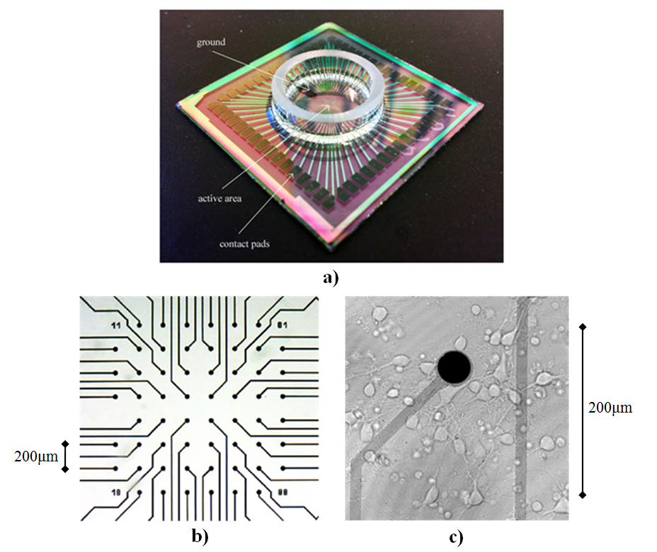
Figure 1, a) Typical glass MEA, showing large contact pads which lead to the electrode column – row arrangement b) Electrode arrays in the centre of the MEA, as typically seen under an optical microscope, c) Single electrode close-up, showing a number of neuronal cells in close proximity along with a vast number of neural connections between them.

A standard MEA measures 49 mm x 49 mm x 1 mm and its electrodes provide a bidirectional link between the culture and the rest of the system. The data acquisition hardware is provided by MCS and includes the head-stage (MEA connecting interface), amplifier, stimulus generator and PC data acquisition card.
We have created a modular closed loop system between a robotic platform and a neuronal network using Multi-Electrode Array (MEA) electrophysiological recording methods, allowing for bidirectional communication between the culture and the robot. The spontaneous electrochemical activity of the culture is used as an input to the robot’s actuators and the robot’s sensor readings are converted into stimulation signals received by the culture, effectively closing the loop. For the software-hardware/robotic framework we have selected the Miabot (Miabot Pro Research Pack [9]), a commercially available robotic platform exhibiting very accurate motor encoder precision (~0.5 mm) and speed (~3.5 m/s). Recording and stimulation hardware is provided by MultiChannel Systems MCS GmbH [8] and controlled via the open-source MEABench [10] software. We have also developed custom stimulator control software which interfaces with the commercially available stimulation hardware. A simulated counterpart for the real-life robot and its environment has also been developed, which can communicate with the culture software in the same manner as the real robot system, adding to the modular capabilities of the system. This simulation will be particularly helpful in early long-running experiments where a real robot would face issues such as power requirements, as well as in the deployment of various machine learning experiments explained below.
The closed loop system consists of several modules including the real-life or simulated robot, the MEA and stimulating hardware, a directly linked workstation for conducting computationally expensive neuronal data analyses and a separate machine running the robot control interface. The various components of the architecture communicate via TCP/IP sockets, allowing for the distribution of processing loads to multiple machines throughout the university’s internal network. The modular approach to the problem can be seen in more detail in Figure 2 next.

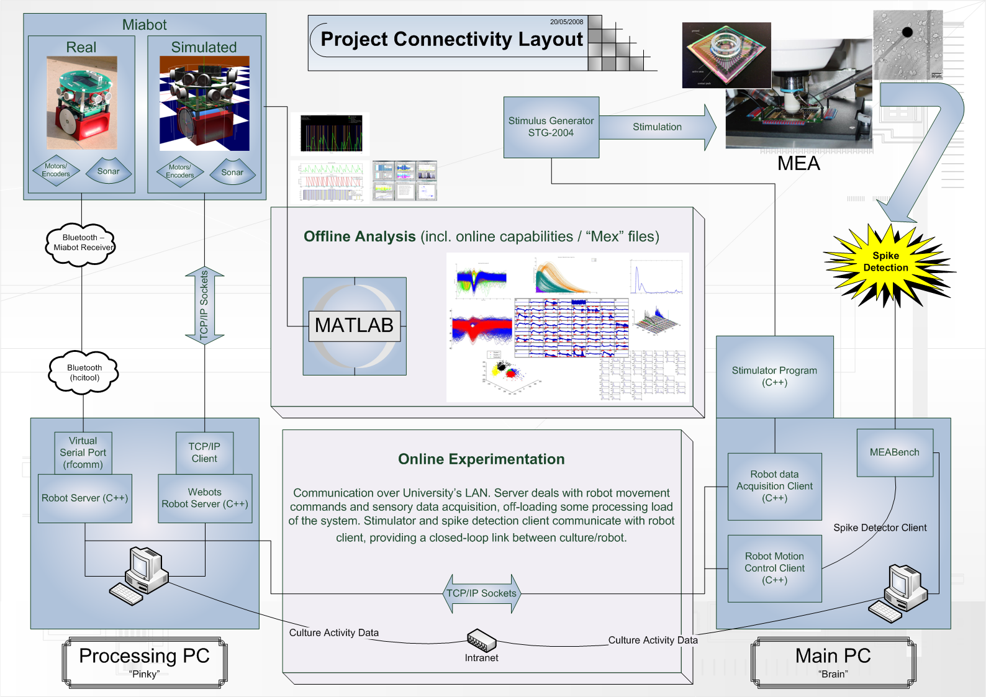
Figure 2, Modular Layout of Animat/MEA System

The Miabot is wirelessly controlled via Bluetooth. Communication and control is performed through custom C++ code and TCP/IP sockets, with the Server running on a PC within Bluetooth range of the Miabot, and the clients running on the main rig which has direct control of the MEA recording and stimulating software. The server sends motor commands and receives sensory data via a virtual serial port over the Bluetooth connection, while the client programs contain the closed loop code which communicates with and stimulates the MEA culture.

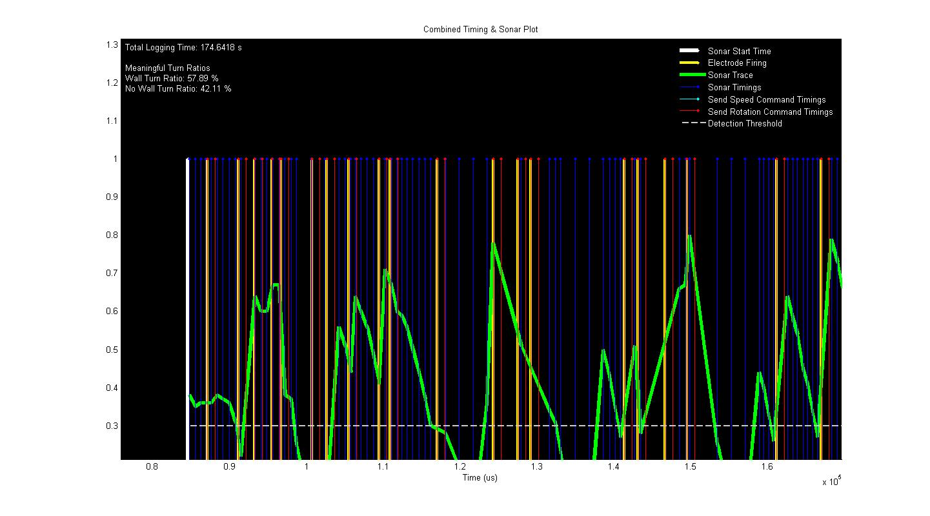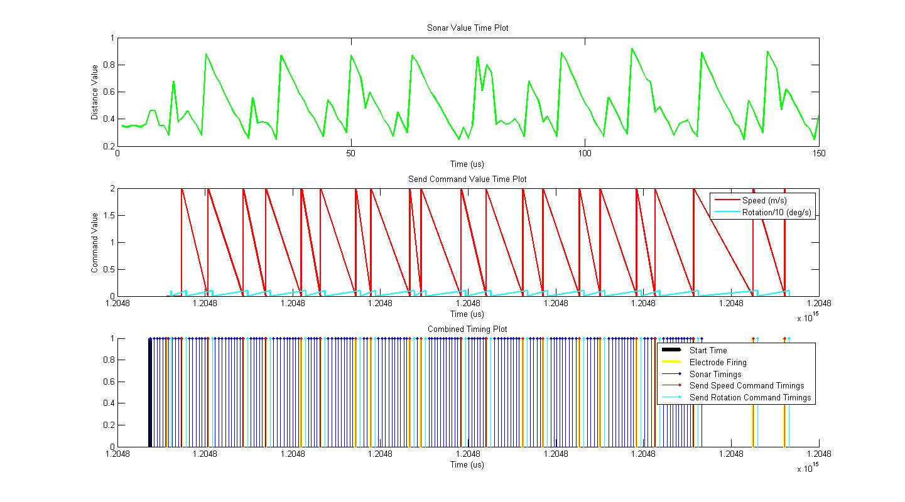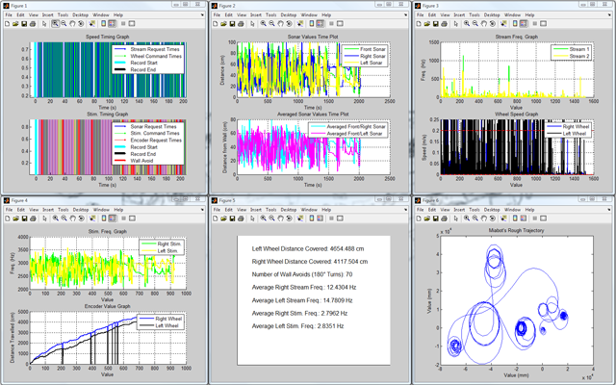
a)
b)
c)
Figure 3, Data analysis of closed loop experiments, a), b) Sonar and stimulation visualisation from wall avoidance experiment, with precise timing information retained for each robot command, c) Various data collected from the direct motor control experiment, such as frequencies of detected spikes and stimulation pulses, sonar values, as well as the wheel speed control, which can be used to construct a rough trajectory of the robot’s movement. All important information retains a saved timestamp, so that the closed loop’s performance can be evaluated.

Subsequently, a 3D model simulation was also developed for closed loop experiments. The main advantage of any simulated device over its real-life counterpart is of course the avoidance of all potential real-life noise sources and physical constraints imposed upon the experiment. The simulation enables rapid deployment of experiments without dealing with real-time problems, power consumptions etc. An added advantage is that noise parameters can be modelled to emulate real-life conditions if required by the experiment. However, a real-life robot is the ultimate aim of the project, since its principal objective is the evaluation of the potential of live cultures in real-life problem solving situations; with all the related noise and disturbances included.
The 3D Miabot model was created using the 3DStudio Max modelling package (Autodesk Inc. [11]) and exported as a Virtual Reality Modelling Language (VRML) file into the robot simulation software Webots [12], where it was further edited. A simulated environment was also created.
A custom Webots C++ controller server enables the simulated robot to either communicate via TCP/IP sockets to the same clients which perform the close loop experiments. The simulated robot server encodes and decodes information in the format of the real-life Miabot commands, thus the clients treat real-life server and simulated robot server as the same, making the whole system modular and interchangeable.
The same Webots server can also communicate data between the Matlab mathematics package [13], which is a very useful feature for the development and deployment of initial machine learning techniques.
The client code also performs text logging of all important information during the experiment run, which is then analysed offline with Matlab. Figure 3 shows an example of collected and visualised data, such as sensory information, wheel positioning and speed, stimulator frequencies and timings, etc.
The modular approach to the architecture has resulted in a system with easily re-configurable components. The obtained closed-loop system can efficiently handle the information-rich data that is streamed via the recording software. A typical sampling frequency of 25 kHz of the culture activity recording leads to a very large required bandwidth and in consequence vast data storage space for raw data. For this reason, on-the-fly streaming of spike-detected data is the preferred method when investigating real-time closed-loop learning techniques.
A Linux-based system constitutes the core of our developed software, which also incorporates the open-source recording and data analysis toolkit MEABench, a tried-and-tested software kit used by many leading research groups around the world (Georgia Tech [14], Caltech, [15] and the University of Florida [16]).

ClosED LOOP EXPERIMENTS
A notable recent experiment utilised the custom stimulation software in a successful closed loop test with a model cell (electronic test circuit equivalent of a passive live culture) as well as a live culture (using older control system). Initially, an appropriate neural pathway within the culture was identified and a stimulus-response electrode pair was chosen prior to the run. The pair was chosen based on the criteria that the response electrode shows minimal spontaneous activity and responds robustly to the stimulating electrode. The robot followed a forward path within its confines until it reached a wall, at which point the front sonar value dropped below a set threshold value (approx. 30 cm) which triggered a stimulation (positive-first biphasic pulse of 600 mV, 100 μs each phase). If the responding electrode registered activity (any spike) following the pulse, the robot turned in order to avoid the wall. The robot would also turn spontaneously if activity is registered on the response electrode, however the results of interest were the chain of events: Wall Detection–Stimulation–Response. Experimental data is logged during run for later analysis. The model cell experiment gives a realistic representation of how fast the closed loop response currently is, with an aim to further reduce this.
Another closed loop experiment (improved robot control system) has the robot’s individual wheel speeds controlled via the frequency recorded from two chosen electrodes. This process is performed by one of the aforementioned clients, while the other client receives sonar information which is used to directly control (proportionally) the stimulating frequency of two other chosen electrodes. The setup is reminiscent of a simple Braitenberg model, however the direct sensor-to-speed control has been interjected by the cultured network. Another group with similar research interests has previously used this method in closed loop demonstration experiments [17, 18].
The experiment above has been performed with both real and simulated robots. Run-times have only been executed for approximately 30 min., which is not enough to typically evoke Long Term Potentiation (LTP) effects between the stimulating-recording electrode sites. However, the experiment yet again was to test the performance of the improved robot control system as well as simulated robot interface, and also tested the initial data analysis tools.
This experiment has ‘closed the loop’ inclusive of the custom stimulation protocols and has set the basis for the following experiments which will focus on characterising the culture responses and include ML techniques for performing more complex robot control.

Machine Learning
Following the completion of the first phase of the infrastructure setup, the author’s main research contribution will now lie within the application of ML techniques on the hybrid system’s closed loop experiments. These techniques may be applied in various areas, such as the spike sorting process (dimensionality reduction of spike data profiles, clustering of neuronal units), the mapping process between sensory data and culture stimulation as well as mapping between the culture activity and motor commands, and last but not least the application of learning techniques on controlled electrical stimulation of the culture, in an attempt to exploit the cultured networks’ computational capacity, which have been established and demonstrated in recent research in the field (see Introduction).

Conclusions
The project, although still in early stages, has achieved a number of milestones and overcome a large array of technological challenges. The culture preparation techniques are constantly being refined and have lead to successful and stable cultures that exhibit both spontaneous and induced spiking/bursting activity.
A stable robotic infrastructure has been set up, tested and is in place for future machine learning and culture behaviour experiments. The animat platform consists of both a hardware element and a software simulation element. The current rate of progress could be the inspiration for offspring projects investigating culture-mediated control of a wide array of additional robotic devices, such as robotic arms/grippers, mobile robot swarms and multi-legged walkers to name but a few.

Future Work
There are a number of ways in which the current system will be expanded in the future. The Miabot may be extended to include additional sensory devices such as extra sonar arrays, mobile cameras and other range-finding hardware. A considerable current limitation is the battery power supply of an otherwise autonomous robot. A main future consideration is the inclusion of a powered-floor, which would provide the robot with relative autonomy for a longer period of time while the suggested machine learning techniques are applied and the culture’s behavioural responses are monitored. The future work will adapt a Miabot to operate on an in-house powered floor, so the animat can be provided with a constant power supply; this feature is necessary since machine learning and culture behaviour tests will be carried out for many minutes and even hours at a time. At present however the robotic simulation provides an alternative solution to continuous operation of the closed loop avoiding current hardware limitations.
The current hardcoded mapping between the robot goals and the culture input output relationships will be extended to ML techniques which will reduce or even eliminate the need for a priori mapping choice. Modern RL techniques will first be applied to various mobile robot tasks such as wall following and maze navigation, in an attempt to provide a formal platform within which the actual learning capabilities of the neuronal culture will be introduced.
Also, progression of the project will require benchmarking both the machine learning techniques and the results obtained by the culture. In order to achieve this, we will aim to develop a simulation of the neural network, based on the culture’s observed connectivity density and activity. This behavioural evaluation model is likely to provide great insight into the workings of the neuronal network by comparing the model’s performance versus the culture’s performance as well as learning capabilities as expressed by changes in its neural plasticity.
Acknowledgements: This work is funded by the Engineering and Physical Sciences Research Council (EPSRC) under grant No. EP/D080134/1.

References

