A DESIGN OF BENCHMARKING METHOD FOR ASSessING PERFORMANCE OF E-GOVERNMENT SYSTEMS
Cleopa John Mushi
School of Systems Engineering
sir07cjm@reading.ac.uk

abstract
This paper is an initial work towards developing e-Government benchmarking model that is user-centric. To achieve the goal then, public service delivery is discussed first including the transition to online public service delivery and the need for providing public services using electronic media. Two major e-Government benchmarking methods are critically discussed and the need to develop a standardized benchmarking model that is user-centric is presented. To properly articulate user requirements in service provision, organizational semiotic method is suggested.

Introduction
Public services is a term which is usually used to define services provided by government to its citizens, either directly (through the public sector) or by government funded agency [1]. The term is associated with a social consensus (usually expressed through democratic elections) that certain services should be available to all, regardless of income for the interest of the general safety, welfare and convenience of the community. However, since the mid-1990’s, governments around the world have been executing major initiatives in order to tap the vast potential of the internet for the distinct purpose of improving and perfecting the public services. Like the personal computer, the internet has become an indispensable tool in the day-to-day administration of government. Considerable resources, both human and financial, have been committed to launching and perfecting programs which deliver government information and services online. Such initiatives were intended to improve administrative operations and enhance government efficiency while realizing the residual effect of deeper citizen involvement in the governing process [2].
Website content and online applications have since progressed from static, public affairs e-brochures to virtual information centres where the interaction between users and the public sector is continuous including also an increase in the online transaction of business with government. In 2001, it was estimated that globally there were well over 50,000 official government websites with the US Federal government alone making 44%of the sites [2]. The services provided have included arranging for a new passport, paying taxes, marriage and birth certificates, online business registration, requesting for a building permit and e-democracy activities. These were expected to provide conveniences to service provisions, increase efficiency, and cut down cost and time that were ever increasing in meeting the demands of these services. No sooner then, needs arose to develop benchmarking methods to assess the performance and the level of e-Government services in different countries [3]. However, this resulted into different countries having different benchmarking methods and criteria, different indicators and difficulty in measuring these indicators for effective benchmarking implementation.
This work then aims at developing a concrete benchmarking method that will be used as a standard to assess the performance of e-Government services in various nations. In-depth research will be conducted to identify key performance indicators for e-Government services (a case of Government to Business services) so as to develop a model that will be used to automate benchmarking process. The major contribution of this work is expected to be an assessment of online public service delivery which is user-centric using the contributions of organizational semiotics and requirements engineering in benchmarking methods. The user of e-Government can be citizen, business or government itself although future work will focus on businesses.
The organization of this paper is as follows. Chapter 1 discusses the introduction of the work discussing key terms in e-Government services, the current practice, limitations and the intended approach to solution. Chapter 2 provides the background and motivation to the work, which include the recent developments to the e-Government services as well as the current problems and the objectives of the work. Chapter 3 presents the transformation background from traditional public services deliveries to the online delivery of public services. Chapter 4 gives the evaluation of current e-Government assessment methods and chapter 5 presents the proposed solution with chapter 6 giving the conclusion and future work recommendations.

BACKGROUND AND MOTIVATION

Background
In the 1990’s, the penetration of internet and opportunities involving information and communication technologies (ICTs) within the private sector organizations occurred at an escalating rate. This caused governments and public sector organizations around the globe to take notice of this phenomenon considering it as a technological challenge to its services [2]. Earlier in his book Tools of Government published in 1983, Christopher Hood demonstrated that much of government work actually consisted of information processing [3]. This therefore could attribute much of the cost the governments spent in providing public services traditionally.
All these reasons together with the rising demands of public services by the citizens and other industrial and business institutions, forced various governments in the world to consider technological approach to encounter such challenges. Technology was expected to provide conveniences to service provisions, increase efficiency, cut down cost and time that were ever increasing in meeting the demands of these services. This then was the beginning of online public service delivery which became known as e-Government. However, e-Government development has been constant and conspicuous. It has received considerable attention through a steady steam of event at the national and international levels [4]. In March 2001, for example, the 3rd Global Forum on reinventing government chose for its theme: Fostering development through E-Government.
Ever since then, wide-ranging e-Government programs have remained at, or near, the top of most countries’ policies agendas. For many nations, digitizing service deliveries like filling personal income taxes online, arranging for a new passport, marriage and birth certificates, or paying VAT electronically represents a marked departure from the traditional paper-based way of offering services. Also, providing citizens with new choices is a goal that resonates throughout many of the national e-Government strategic plans. Both the intended and the residual outcomes of this objective are considerable: open communication, enhanced transparency, increased social inclusion and citizen participation, democratic enrichment and superior governance. These outcomes however, tend to be more potential than extant, and objectively quantifying a potentiality is in itself a test.
This research is therefore in itself a challenge as it attempts to balance both the abstract and the tangible to transform a public sector organization’s commitment so that it can function as truly user-centric and provide cost effective services to the private sector contributing to the development of business and promoting long-term economic growth. The types of services that can be delivered over the internet are still being conceived, developed and improved by both the public and private sectors. It is expected that with time there will be an increased experimentation, innovation and organizational learning in an effort to perfect e-Government. All these will need a benchmarking system that will act as a standard means of evaluation against which all e-government progresses can be measured to see how far they have reached and what is lacking for improvement.

Research Problem Definition
Current evaluation methods (benchmarking techniques) for e-Government systems require a huge investment in data collection, analysis and compilation [5]. The techniques need someone to go physically to the respective government office and conduct interview or to do interview via the telephone or visit respective government website for survey [6]. For example, Janssen et al examined 18 different international benchmarking studies on e-Government or the information society and found variations in the scope and definition of e-Government and in the type of measurement criteria used [7]. This therefore has caused difficulty in articulating appropriate indicators which can be used to assess the systems’ performances.
Also, there are varieties of standards and definitions in benchmark studies in e-Government. This means then, comparing benchmarking findings to each other has been resulting into discrepancies in the overall conclusion. Ojo et al examined a series of three different benchmark studies in an attempt to create common indicators in order to resolve the disparity between rankings arising from the use of different indicators and weighting schemes [8]. The result showed a great difficulty in benchmarking e-Government systems due to prevailing variations. Together with the varieties, the majority of benchmarking studies have focused on citizen-related e-services leaving apart other important components of e-government such as business and even government itself [3]. This biases the e-government benchmarking studies and doesn’t give a full meaning of the user of e-government services. Of more significance here however, is the lack of user-centric benchmarking methodology [6]. Since the quality of the system is determined by the user satisfaction, this means then, for effective and efficient online public service delivery the user must be consulted whose level of satisfaction contribute as well to the means of evaluating the service provision.

Research Aim and Objectives
This work aims at developing a benchmarking method that will be used to assess the performance of e-Government services. The major contribution of this work is expected to be an assessment of online public service delivery which is user-centric using the contributions of organizational semiotics and requirements engineering in benchmarking methods. The user of e-Government can be citizen, business or government itself although future work will focus on businesses.
The following objectives are set for achieving the aim of the research work:
- To understand public services in government and e-Government systems.
- To examine the current practices in online public service delivery.
- To survey different benchmarking methods that there exist today and relate these with e-Government benchmarking methodologies that have been undertaken so far.
- To identify the means for an automated benchmarking model that will assess an e-government service based on the performance indicators.
- To realize the use of requirement engineering knowledge through semantic modelling in articulating user requirements that can be used in developing benchmarking model.

TRANSFORMATION OF PUBLIC SERVICES TO e-SERVICE DELIVERY

The Need for Transforming Government Services
Government can be defined as an organization or a body that has the authority and power to make and enforce rules and laws within a community [9]. The fundamental purpose of a government is the maintenance of basic security and public order, and the overall supervision of the social wellbeing. However, due to globalization pressures and competitive service is the revival of the use of the term governance. According to the European Union (EU) publication handbook on promoting good governance in European Community (EC) development and cooperation, the term Governance addresses the way public functions are carried out, public resources are managed and public regulatory powers are exercised [10]. This means then, that the global increase in information sharing and challenges that have arisen in the areas of service provision call for alternative ways to service provision apart from traditional means that have been in use so as to meet the challenges for having good governance.
Many organizations therefore, incorporated information and communication technology (ICT) in their services so as to increase efficiency and effectiveness in service delivery and add a competitive advantage to their goals [11]. In a move to encounter such challenges then, over the past ten years there have been moves of various governments globally to intersect government, society, and ICT. This domain is often characterized as e-government, e-governance, information society, and similar terms [12]. The domain focuses on the use of ICT to support or improve public policies and government operations, engage citizens, and provide comprehensive and timely government services.

E-Government
By late 1990’s, many governments had embarked in implementing e-Government services as a means for big cost relief in government services. The aim was to offer the potential of increased convenience to the public by making such services available 24 hours a day, 7 days a week, coupled with advantages of improved accuracy and also reduced cost to the government, deriving from its requiring little or no direct interaction with a government employee [13]. Bekkers and Homburg [4] define e-Government as the use of modern information and communication technologies, especially internet and web technology by a public organization to support or redefine the existing and /or future of information, communication, and transaction relations with the stakeholders in the internal and external environment in order to create added value. Thus, by definition one can see that the introduction of e-Government involves technical as well as organizational aspects.
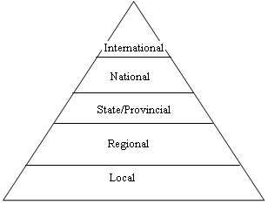
A general structure of E-government can be put into 5 potential levels as illustrated below [3]:

Figure 1: Levels of E-Government

It is expected that e-Government has to cover all the levels for a full-fledged system. E-Government therefore has been considered a necessary achievement by governments due to its ability to provide a common framework and direction in the implementation of government policies. E-Government can make the government more result oriented, efficient and citizen centred whereby citizens and outside world can access government services and information as efficiently as possible [13].
E-Government services are provided in three levels [14]:
- Government to citizen (G2C) - Back office introduction of ICT, intra- and inter-governmental exchange, government networks, standards, expertise.
- Government to business (G2B) – Delivery of business services and information, e-procurement (tendering), sales of government-owned business relevant information.
- Business to government – Filling of business registration information, taxes, regulatory information, e.t.c.
- C2G – Citizen Information provision, tax filling, citizen reporting, electronic voting (e-Democracy), vehicle licensing.
- G2C – Provision of public information and transparency of information (both passive and active in response to specific requests) about government workings and performance, electronic service delivery (one-stop-shops).
The table below shows some of public services for G2C and G2B in EC states [14]:

Citizens
Income taxes
Job search
Social security benefits
Personal documents
Car registration
Application for building permission
Declaration to the police
Public libraries
Birth & marriage certificates
Enrolment in higher education
Announcement of moving
Health-related services
Businesses
Social contribution for employees
Corporate tax
VAT
Registration of a new company
Submission of statistical data
Customs declaration

Environment-related permits
Public procurement

Despite the incredible advances made in information technology (IT), e-Government has, and will continue to be into the foreseeable future, a complex and constant process. Countries vary radically in their approach, level of development and overall commitment to e-Government [6]. Critical endemic factors like available resources, political leadership, economic capacity and the character of the civil society deeply impact on the scope and breadth of a government’s e-Government policy. How a nation ultimately shapes its e-Government commitment ideally should consider these factors and respect the user-centric approach rather than being influenced by short-lived trends or what outcomes may be politically expedient. However, to attain this goal an effective benchmarking methodology needs to be developed upon which the government can measure to know the level of achievement it has reached and the way forward.

EVALUATION OF ONLINE PUBLIC SERVICES

Benchmarking Review
Benchmarking is the process of identifying best practice in relation to both products (including) and the processes by which those products are created and delivered [15]. The search for best practice can take place both inside a particular industry, and also in other industries (for example - are there lessons to be learned from other industries?). The objective of benchmarking is to understand and evaluate the current position of a business or organisation in relation to best practice and to identify areas and means of performance improvement. Benchmarking can be used as a continuous improvement tool for organization’s processes, products or services with those identified as best practice [16]. The following are the different types of benchmarking methods in existence today:
- Strategic – Concerned with comparing different companies’ strategies and assessing the success of those strategies in the marketplace. This can be achieved through surveys to measure customer satisfaction and the gaps between a company’s performance and its customers’ standards.
- Functional – Concerned with performance of core business functions such as Finance, Sales, and human resource efficiency.
- Process – Focuses on improving specific critical processes and operations. Also known as best practices benchmarking.
- Global – Across the world where the aim is to achieve world class status or simply because there are insufficient national businesses against which to benchmark.
- Cost – Focusing on cost dynamics
- Performance or competitive – Concerned with the relative level of performance in key areas or activities in comparison with others in the same sector and finding ways of closing gaps in performance is the main feature of this method.

E-Government Benchmarking Methodologies
Different methods based on different countries have existed concerning assessments of online public services [3]. These are tailored towards individual countries and may not be useful in this work. Of importance, are two major benchmarking methods that have been developed which include a number of countries concerned. These are for the EU member states [6] and the United Nations (UN) member states developed by the United Nations Division for Public Economic and Public Administration (UNDPEPA) and the American Society for Public Administration (ASPA) [2].
These two e-Government benchmarking methods have been undertaken by reviewing comparative performance of e-Government between nations or agencies [3] which means they have been using both performance and global types of benchmarking processes. Benchmarking e-Government is important because:
- It helps in understanding and evaluating the current position of e-Government system in relation to best practice. It is the best tool in assessing the performance of e-Government systems.
- It helps in identifying areas and means of performance improvement.
- It can be used as a continuous improvement tool for e-Government processes, products or services with those identified as best practice. It helps in checking and improving the quality of services.
According to performance or competitive benchmarking method, it is important to identify key performance indicators so as to be able to conduct assessment analysis [2]. Below is an approach that has been used to assess online public service delivery so far [14]:
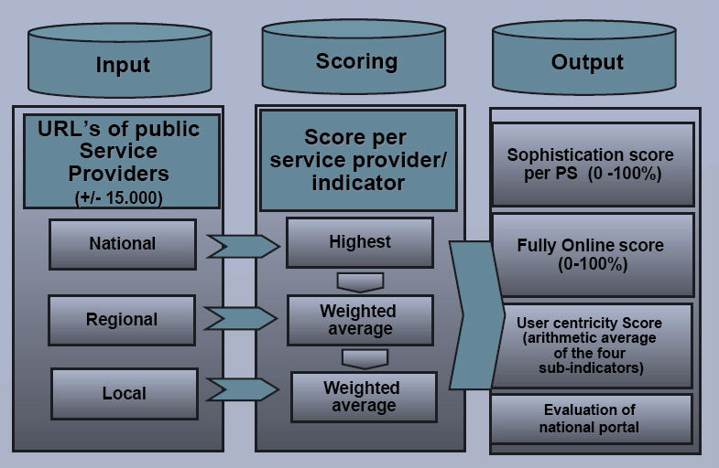

The assessment looks at the level of user-centricity, sophistication level, and the number of basic public services that are available online. Assessment also looks at different potential levels of e-Government from the national level down to the local level with scoring process based on the indicators identified.

Figure 2: Web-Based Benchmark on Electronic Public Service.

However, differences have existed on which indicators to use in benchmarking e-Government. For example, in order to best capture a balanced interpretation, three distinctive measures consisting of primary indicators available for most of the UN member states were developed [11]. The measures are web presence measure, telecommunication infrastructure measure, and the human capital. On the other side, the EU benchmark survey done by Capgemini for the EU Commission came up with a list of 20 basic public services in which 12 are for households and 8 for enterprises [17]. These focused on public services instead of e-Government readiness used by the UN report. The EU report used the following model for the e-Government indicators:
- Stage 1: Information – online information about public services,
- Stage 2: Interaction – downloading of forms,
- Stage 3: Two-way interaction: processing of forms, including authentication,
- Stage 4: Transaction – case handling; decision and delivery (payment).
However, with both reports one can observe that much effort has been directed towards the supply-side of e-Government with little emphasis on the demand side [18]. This means there is a danger of users to be turned into consumers of e-Government services and not active participants if measures will not be taken to address the gap [6]. And since the majority of benchmarking studies have focused on citizen-related e-services, this work considers business side of e-Government for assessment purposes.

PROPOSED SOLUTION

Developing User Profile
The model to be suggested for assessing online public service delivery should be:
- Dynamic, i.e., catering for user expanding needs, and
- User-centric, i.e. assessing online services based on user requirements.
In order for a model to be user-centric, there is a need to develop a user profile. User profile can be defined as a repository that contains user’s personal data and preferences retained from session to session [19]. It has information about site registration details, user behaviour and his/her interaction with the environment [20]. User profile schema can be used to model user’s information requirements which can be focused in benchmarking process. Two important items in user profile are suggested in this work; goal and preference. Goal presents information push, that is, the provider’s services. This entails information accessibility, level of technology, and type of service available. Preference represents the information pull for the user’s readiness and ability to undertake online public services. Below is the EU benchmarking survey model for e-Government [14]:

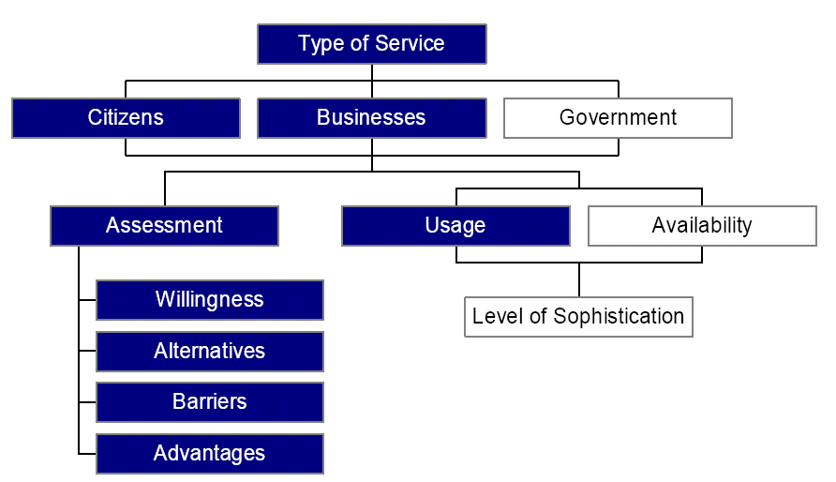
Figure 3: Public Services Delivered through E-Government.

Type of services for citizen, business and government as observed in figure 3 above are grouped into three areas, availability, usage and assessment. This helps us to see the implementation of e-Government based on two sides:
- The supply-side (G2C and G2B) giving us information push. This has the usage and availability and the level of sophistication.
- The user perception, i.e. demand-side (C2G and B2G). This gives us the information pull with the user preferences represented by assessment category depicting willingness, alternatives, barriers and advantages.
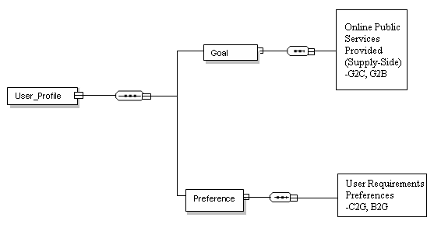
Below is a suggested sketch of user profile:
Figure 4: Overview of User Profile Schema

Organizational Semiotics Approach
Organizational semiotics is a particular branch of semiotics concerned with understanding organizations as information systems [21]. In this context then, business processes are seen as processes that involve the creation, exchange and use of signs. This approach is necessary in articulating user’s requirements. Using semiotics approach, an organizational activity becomes an information process based on the notion of responsible agent with the ability to accommodate both the social dimension in organizational agents’ behaviour and the relative autonomy that individual agents exhibit in organizations.
Agents use their knowledge and take into account their obligations and authorizations which they may choose to accept or violate and to define their goals [21]. In the process they use individual preferences defined in their system of values where as organizational concepts and activities such as power relationships, roles, or contracts, can be defined by norms. An agent in our context can be citizen, business or government itself. The above behaviour exhibited by agents and the overall organizational concepts presented show us that organizational semiotics approach can well be used to represent activities indicated in figures 3 and 4 above for users and government and the semantic modelling can be developed to help articulate G2B/ B2G services and hence indicators necessary for benchmarking process.

A Sample Model
A model can be suggested that performs a systematic assessment following integrated performance indicators that considers both service provider and user requirements. Below is an illustration:
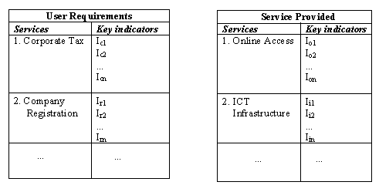

Figure 5: Model for Preference (Demand) and Goal (Supply)

Both side indicators can be integrated into a user case base profile that can be used to compare with a standardized model to identify the performance level of e-Government of a particular country.

CONCLUSION
In this paper, an initial work on user-based assessment of online public service has been presented. Various concepts surrounding public service and online delivery of public services have been discussed. Different benchmarking methods for e-Government have been critically discussed especially the ones for UN member states and the EU Commission. User-centricity in benchmarking process has been emphasized in the paper including the use of semiotics method has been suggested to properly articulate and elicit user requirements. Future works will be to research and identify an ideal set of key performance indicators obtained from a combination of UN benchmarking indicators, EU survey benchmarking indicators and other indicators based on business service requirement to online public delivery.

references
- D. Chavez (ed), “Beyond the Market: The Future of Public Services”, TNI Public Services Yearbook 2005/6, Trans National Institute (TNI) / Public Services International Research Unit (PSIRU), Feb. 2006.
- S.A. Ronaghan, “Benchmarking E-Government: A Global Perspective”, New York, 2002.
- R. Heeks, “Understanding and Measuring E-government: International Benchmark Studies”, IDPM, 2006.
- V. Bekkers and V. Homburg, “E-Government as Information Ecology: Backgrounds and Concepts”, IOS Press, Amsterdam, 2005, pp. 1-20.
- http://www.globalforum.org (Mar., 2001).
- N. Helbig, S.S. Dawes, F.H. Mulki, J.L. Hrdinova, M.E. Cook, “International Digital Government Research: A Reconnaissance Study, 2008.
- A. Ojo, T. Janowski, E. Estevez, “Determining progress towards e-government: What are the core indicators?”, The 5th European Conference on e-Government (ECEG), Antwerp, Germany, 2005.
- C. Hood, “The Tools of Government”, 1983, Macmillan.
- http://www.wmo.ch/web/spla/R&Op-II(02)APPENDIX_G.doc
- http://ec.europa.eu/europeaid/where/worldwide/eidhr/index_en.htm
- S. Ntiro, “e-Government in Eastern Africa”, KPMG, Dar-es-Salaam, 2000.
- D. Brown, “Electronic government and public administration”, International Review of Administrative Sciences, Vol. 71, No. 2, 2005, pp. 241- 254.
- S. H. Holden, “The Evolution of Information Technology Management at the Federal Level: Implications for Public Administration,” 2003, pp. 53-73 in Public Information Technology: Policy and Management Issues, G. David Garson, Ed., Hershey, Pa.: Idea Group.
- K. Liu, “E-Government Benchmarking for Online Public Services”, Apr. 2008.
- http://tutor2u.net/business/strategy/benchmarking.htm
- M. Kozak, “Destination benchmarking: concepts practices and operations.” CIBA Publishing, Cambridge, Massachusetts, USA, 2004.
- H. Buchow, “Development of Indicators on E-government at EU Level and Preliminary Information on a 2004 Pilot Survey for ICT Usage in Enterprise of the Financial Sector”, European Commission, Eurostat, 2004.
- L. Lee-Kelley, A. Kolsaker, “E-government: the “fit” between supply assumptions and usage drivers.” Electronic Government, an International Journal, Vol. 1, No. 2, 2004, pp. 130-140.
- L. Sun, K. Ousmanou, “Requirements engineering”. Springer-Verlag London limited, 2006, pp 279-293.
- J. Choudrie, G. Ghinea and V. Weerakkody, “Evaluating Global e-Government Sites: A View using Web Diagnostic Tools”, 2005, ISSN: 1479-439X.
- J. Filipe and K. Liu, “The EDA Model: An Organizational Semiotics Perspective to Norm-Based Agent Design”, 2002.

