Detection of Parkinson’s Disease Tremor-Onset with a Frequency Analysing Artificial Neural Network
Cybernetics, j.g.burgess@reading.ac.uk

abstract
Deep Brain Stimulator devices are becoming widely used for therapeutic benefits in movement disorders such as Parkinson’s disease. Prolonging the battery life span of such devices could dramatically reduce the risks and accumulative costs associated with surgical replacement. This paper demonstrates how an artificial neural network can be trained using pre-processing frequency analysis of deep brain electrode recordings to detect the onset of tremor in Parkinsonian patients. Implementing this solution into an ‘intelligent’ neurostimulator device will remove the need for continuous stimulation currently used, and open up the possibility of demand-driven stimulation. Such a methodology could potentially decrease the power consumption of a deep brain pulse generator.

Introduction
Parkinson’s disease (PD) is a chronic progressive neurodegenerative disorder in which degeneration of mesencephalic dopamine neurons in the substantia nigra causes deterioration in motor behavior. The disease is associated with a range of symptoms of which most common is muscle tremor and rigidity. In advanced stages of PD other symptoms such as Bradykinesia, Akinesia, and Dysarthria can occur, as can symptoms unrelated to motor function such as depression. The drug levodopa (L-dopa) has been the most commonly administered therapy for the management of PD since its approval in 1970. L-dopa is a chemical precursor to dopamine, yet unlike dopamine itself can cross the blood-brain barrier. By metabolising in the brain, insufficient levels of dopamine, thought to be a primary cause of PD, can be restored providing the patient with improved mobility and allowing them to function relatively normally. Larger dosages of L-dopa are generally required as PD worsens. Indeed this is true for other drug treatments such as Parlodel (bromocriptine), Requip (ropinirole), Permax (pergolide), and Mirapex (pramipexole dihydrocholoride).
Although drug treatments for PD are relatively cheap and straightforward to administer, serious side effects in many patients are not uncommon, predominantly in the long term (5-10 years). Such side effects include dyskinesias and unpredictable ‘on-off’ switching and freezing [1, 2], all of which are, for the most part, resistant to any other therapy [3]. In addition, the fundamental effects of drug treatments can become substantially less effective after continual use.
Surgical treatments are available to patients and are usually recommended as an alternative treatment for PD when drug treatments have become ineffective. In 1989, Aziz et al., began to study the effects of lesioning the subthalamic nucleus (STN) in primates with MPTP (1-methyl-4-phenyl-1,2,3,6-tetrahydropyridine) induced Parkinsonism and showed that, using standard neurosurgical techniques, lesioning could alleviate symptoms thus reducing the need for dopaminergic therapy [4]. Since then the majority of neurosurgeons have moved over to implanting neurostimulators to deliver mild deep brain stimulation (DBS) to the STN or globus pallidus interna (GPi) of the brain, which have similar effects to lesioning, although is considered less hazardous because it is largely reversible [5]. A typical DBS device contains an intracranial electrode lead with (typically four) cylindrical electrodes attached to an internal extension lead connecting the electrodes to the implantable pulse generator (IPG), which is surgically implanted below the collar bone.
The effect DBS has on the targeted region depends on the adjustable stimulation parameters including the stimulus duration (pulse width), the amplitude and the rate of stimulation. Symptoms of PD can often be relieved if these parameters are optimally set because DBS is able to take command of local neurons, restraining them from spontaneous oscillation. This type of stimulation is probably highly effective because it prevents the neurons from relapsing into slow synchronous cycles that appear to cause motor symptoms [6, 19].
Despite the advantages of DBS, a small number of problems remain which can limit the number of patients that can benefit from this successful treatment. The need for additional intervention for battery replacement (~ every 3 years, ~$25,000 per patient [7]) puts a patient at the notable risks of surgery and further tissue scarring [20]. Additionally, time is required from the clinician to program the device and adjust medication each time after replacement. All this makes DBS a costly treatment for both patient and surgery. Furthermore, continuous stimulation, which is currently utilised in these devices, permanently subverts normal functions of the basal ganglia networks and can cause adverse neuropsychological effects [8, 9].

RECORDING AND DEMAND DRIVEN STIMULATOR
In order to improve some of the problems of using DBS to treat symptoms of PD, an ‘intelligent’ stimulator is proposed. Such a device should not only be able to detect the presence of tremor activity but also have the ability to detect a tremor-onset. Rather than continuously stimulating, the on-demand stimulator will lay dormant until a positive indication of tremor-onset is detected from the neural activity around the intracranial lead electrodes; stimulation will then be triggered such that the impending tremor can be suppressed before it has a chance to take hold. This method will not only conserve power usage while in its dormant mode, but will also enable the neurons in the thalamus, sub-thalamus or globus pallidus to function normally while no tremor is present, thereby potentially producing a clinically superior result [21,22].

Background to Data Collection
Along with a number of similar establishments, neurosurgeons at the John Radcliffe Hospital (JRH), Oxford, UK, routinely implant deep brain electrodes into the thalamus, pallidum or sub-thalamic nucleus to alleviate the symptoms of PD, multiple sclerosis and dystonia [10]. The depth electrode leads are left externalised for a week to ascertain effect prior to internalisation. If good symptom relief is achieved, the control unit and battery is then implanted in the chest cavity and the electrode connections internalised. During the period prior to internalisation, an opportunity exists to extensively record the local field potentials (LFPs) from the nucleus via the electrodes and to correlate these with electromyograms (EMGs) recorded simultaneously from affected muscle groups. LFPs can be recorded before and during stimulation (with stimulation artifacts suppressed [18]).

The intracranial electrode consists of 4 electrode contacts of 1mm in length and evenly distanced 1mm apart. This maximizes the possibility that 1 or more electrodes are in contact with STN neurons, surgeons also have the freedom to use either contact to deliver the stimulating pulse. The recorded signal from a single electrode contact is an average of the STN LFPs voltage measured at the point of contact, simultaneously surface electrodes are attached to 1 or more effected muscles to record individual EMG signals and the combined recordings are grouped into patient-referenced datasets.

SIGNAL ANALYSIS
Datasets from 6 Parkinsonian diagnosed patients who have undergone successful DBS surgery targeting the STN are analysed in this experiment. Some of the datasets relate to time periods (~100s) where no tremors are apparent. Other data is however pertinent to the onset and continuation of tremor. Hence in principle it is possible to employ this data to assess whether it is possible to detect signal changes in the target nuclei that predict the onset of tremors. Recordings have been taken from the left STN of Parkinsonian patients sat in a stationary position, with stimulation turned off (for parameters of analysed datasets see Table. 1).
Tags in the time domain of the datasets have been categorized into tremor, non-tremor and tremor-onset classes. A tremor event is identified by the increase of power in a low frequency, EMG recording. Typically in the region of 3~7Hz, muscle selection and severity of condition can alter the dominant frequency. A non tremor EMG signal has no dominant frequency over time, although the recording sessions are monitored to ensure any recorded non tremor periods are not the result of Akinesia. Tremor-onset is a defined time period prior to a physical tremor, previous studies [11,23] investigating LFP signals from the STN have discovered tremor like characteristics present prior to a monitored tremor up to 10 seconds pre-tremor, and so a 10 second pre-tremor window is initially chosen to represent tremor onset. Fig.1 is an example of the LFP and EMG channels of a dataset mutually plotted in the time domain showing the 3 possible tremor states.

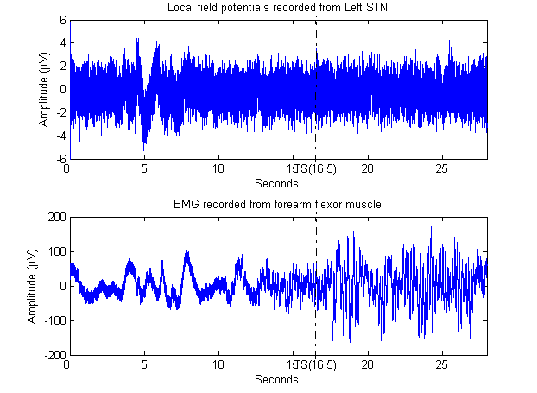
Figure 1. 28 seconds of LFPs and EMG data including a tremor event marker at 16.5 seconds.

By examining the EMG data in Fig.1 (the lower trace) it can be seen that little arm movement is apparent for the initial ~12 seconds, shortly followed by a noticeable (involuntary) arm motion or twitch which may relate to the onset of the following tremor. Approximately 10 seconds later, the EMG signal indicates a 6-7Hz tremor has begun. When comparing the EMG with the LFP plots, the spontaneous muscle events appear to be correlated with irregular activity in the LFP data. This directly correlated activity, which suggests that raw LFPs can reveal tremor precursors, is not suitable for stimulation triggering because such behavior is inconsistent between patients, also the time lag might result in the device becoming active after a short tremor event has happened. Ideally the system needs to detect tremor characteristics prior or during tremor onset periods, such that the stimulator can be activated, consequently leaving the patient oblivious to any tremor activity having initiated.
Characteristic changes in the LFPs prior to tremor have previously been exploited for potential tremor predictor models [11, 12], such research suggests that tremor onset detection is possible using an artificial neural network trained on raw data extracted from the LFPs. However over long durations this method produced high amounts of false detections. These are less serious than detection failure, which in a demand-driven model would subsequently lead to a physical tremor. However too many false predictions conflict with the aims of limiting stimulation. Investigations between LFPs and EMG signals using correlation and time-frequency methods have indicated variations in the time-frequency features of the LFPs during and pre tremor [13]. Frequency suppression in the β-band (10-30Hz) was found in the LFPs prior to tremor-onset, giving rise during tremor to greatly increased power in the tremor-frequency band (δ-band, 3.0-5Hz). After tremor ceases, the δ-band power decreases in the LFP signal and β-activity is restored to its previous state. Although the time delay between changes in the β-band suppression and tremor-onset vary between episodes, it is nevertheless similar at both ends of each episode. These initial findings suggest that tremors can be identified by monitoring the power in the β and δ frequency bands for periods, which fall below or rise above threshold values.
Table 1
Datasets’ details
Patient No. | Dataset No. | Dataset type | Length | Samp. Freq. | Contact Location | EMG location | Tremor Freq. | Notes
1 | P101 | Training | 10s | 800Hz | L STN | Flexor | 6-7Hz
 | P102 | Validation | 100s | 800Hz | L STN | Flexor | 6-7Hz
2 | P201 | Training | 80s | 1000Hz | L STN | Flexor | 6-7Hz | Training set for Patients 2-4
 | P202 | Validation 1 | 28s | 1000Hz | L STN | Extensor | 6-7Hz
 | P203 | Validation 2 | 40s | 1000Hz | L STN | Extensor | 6-7Hz
 | P204 | Validation 3 | 51s | 1000Hz | L STN | Flexor | 6-7Hz
3 | P201 | Training | 80s | 1000Hz | L STN | Flexor | 6-7Hz | Cross Patient ANN
 | P302 | Validation | 87s | 800Hz | L STN | Flexor | N/A | No tremor event
4 | P201 | Training | 80s | 1000Hz | L STN | Flexor | 6-7Hz | Cross Patient ANN
 | P402 | Validation | 112s | 800Hz | L STN | Extensor | N/A | No tremor event

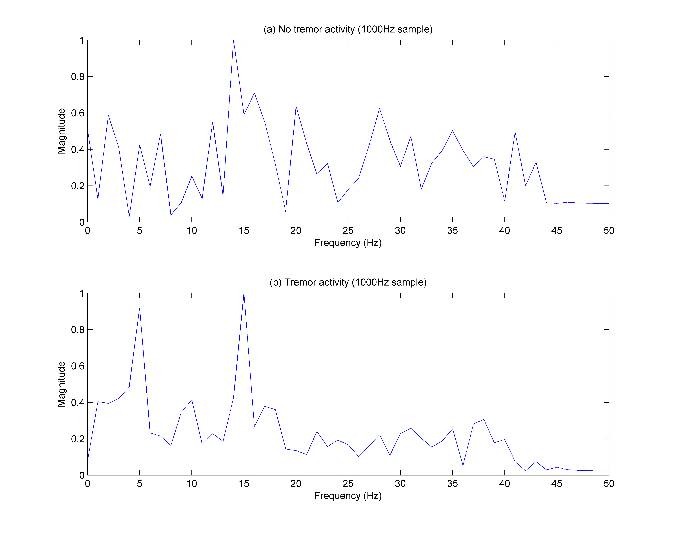
Figure 2. (a) A frequency spectrograph from LFP data during no tremor activity. (b) A frequency domain spectrograph of LFP data during tremor activity.
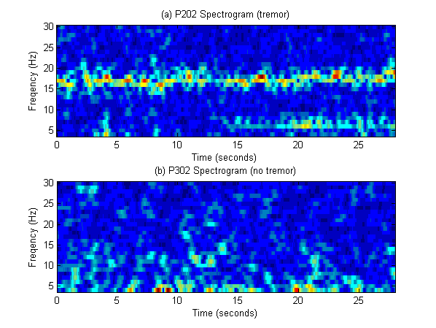
Figure 3. (a) Spectrogram of dataset P202 – tremor starts at 16.5s (b) Spectrogram of dataset P302 – no tremor accompanies this signal.
Fig.2(a) is a power-frequency plot from the 5th second of the LFP data from dataset 1 (Fig.1), which is a period of no recorded tremor activity in the EMG channel. Fig.2(b) is the power-frequency plot from the 27th second of the same dataset where tremor activity is present. Since interest lies in the β and δ frequency bands the frequency is cut off above 50Hz, furthermore the magnitude of the LFPs voltages is normalised as the intracranial electrodes are not always implanted into the precise area of the STN with each operation, which results in varied amplitude recordings for each Parkinsonian patient. The plot in Fig.2(a) illustrates an abundance of power in the β-band, whilst Fig.2(b) in comparison shows suppressed power in the β-band and increased power in the δ-band (a spectrogram of the entire duration can be seen in Fig.3(a)). The observed characteristic differences are a promising means for detection, although they do not consistently occur, whereas signals exhibiting tremor features can appear during periods of no tremor (shown in Fig.3(b)).

ARTIFICIAL NEURAL NETWORK DETECTION
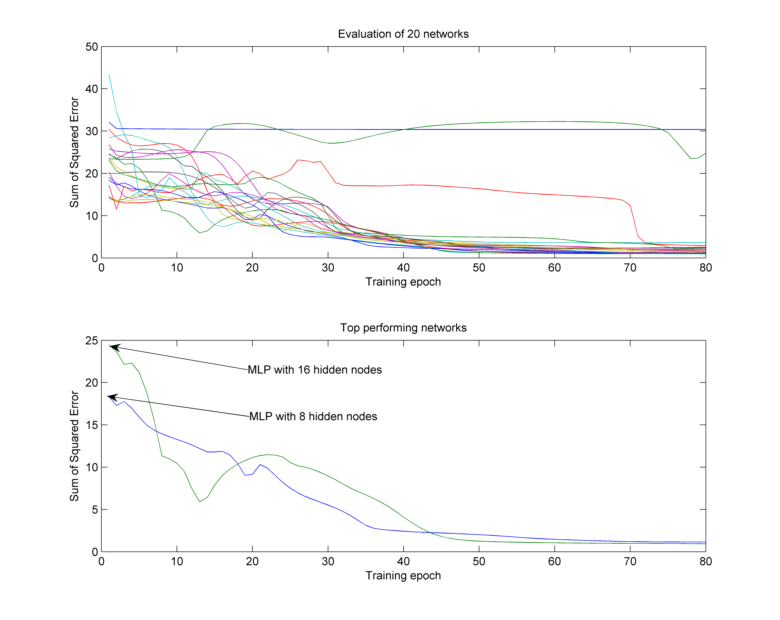
Figure 4. An evaluation of 20 networks during training
Artificial Neural Networks (ANNs) have universal nonlinear statistical modeling and noise tolerance abilities [14, 15]. ANNs have been widely used in medical applications as pattern recognition and identification tools, most notably for electroencephalogram [16], and electromyogram [17] data. Initial research with ANNs on raw LFP data for tremor prediction [11] has proven insightful, although such analysis has shown to be inconsistent across extended patient data, most notably in periods of no tremor activity. Therefore by integrating the properties of β and δ frequency band fluctuations into the current ANN model, the detection of tremor onset can be improved.
The Neural Network model is a Multi-Layer Perceptron (MLP) trained using a back-propagation supervised learning algorithm. Although a tremor onset period is defined, only tremor and non tremor periods will be used to train the ANN giving the output 2 classes. Validation datasets can pass through the ANN for the output to be reviewed, including tremor onset periods. During operation, computational requirements are proportional to total amount of neurons in the network, and so it is sensible to attempt to minimize this number so that a fast and low cost prediction can be made. However, the network must have enough connections to perform accurately, and categorise the tremor states. A frequency domain analysis has produced considerably more information about tremor activity than a time-domain approach, therefore this method has been utilised and frequency pre-processing is applied to the input ANN signal.
The power-frequency plots and the spectrographs shown, created by the Fast Fourier Transform (FFT) and Short Term Fourier Transform (STFT) respectively, are cropped from 1 to 50Hz, in the knowledge that β and δ frequency bands contain pertinent information for the purpose of tremor detection. Each frequency magnitude that is calculated by the FFT is taken as an individual input, so the network could analyse 50 inputs with each epoch, however by only monitoring the β and δ frequency bands this number can be reduced to 27, thus 7 input neurons are utilised to monitor the frequencies (2-8Hz) around the δ band and 20 (10-30) for the β band. The 27 frequency power values are passed into the MLP as a pre-defined window γ(•). As the window width decreases, the time resolution improves but the frequency resolution reduces as the number of data points within the window decreases accordingly. The signal sample rate (λ) of the datasets acquired ranges between 250-1000Hz, the window length equals the sample rate so the window is always covering 1 second, delivering adequate accuracy. γ(•) has an overlap of 90% between each epoch making the output frequency of the MLP 10Hz.
The MLP has 3 layers (input, hidden and output), γ(•) is passed through a FFT and the resulting 27 values are used as the network input. The number of nodes in the hidden layer will affect the performance of the overall network as for every extra hidden layer node in the network 28 additional connections will be required in the MLP. To optimise the MLP structure, twenty networks were constructed each with a distinct number of hidden neurons spanning from 1 to 20. Training with a total of 80000 tremor and non-tremor data-points per network, an overall evaluation of each structure is produced (Fig. 4). Whereas the most efficient structure held 16 hidden neurons, which after training had a sum of squared errors value of 0.94, the slightly inferior 8 hidden neuron configuration is preferred because of its economical size and performance, demonstrating a sum of squared error of 1.14 after the same amount of training epochs and over the same training set.
The network output layer is a solitary node utilizing the sigmoid function to produce a classification value between 0 and 1; a 0 output indicates that the network did not identify any tremor pattern within the signal; a 1 output indicates that the network identified the tremor pattern, any value between can be thought to represent the degree which tremor can be expected to occur.

Results
An output is calculated every 100 milliseconds and the network performance can be assessed by comparing the EMG recordings and tagged tremor state with the network output; taking into account timings of detections prior to, and detections during, tremor activity. See Fig. 5 for the network output for each validation dataset. 6 datasets from 4 individual patients were passed through an ANN of identical structure. The similarities of the datasets are the contact of the DBS electrode (left STN) and the patients’ tremor indicator (6-7Hz on forearm EMG). The ANN was trained using the patients’ training datasets before unseen validation sets were shown to the network.
Recordings from each patient provided training and validation datasets with at least one LFP and EMG channel, patients 1 and 2 experienced tremor during their recording session and with the EMG signal has been located in time. With dataset P102 a 6-7Hz tremor began at 40s, the output from the ANN in Fig. 5 shows an increase of tremor output throughout the entire recording. The point at which the tremor began correlated with no significant alternations of the output. The network classifies a tremor signal from as early as 10 seconds into the recording. Furthermore, during the Tremor onset period this increases, and by 51 seconds a regular tremor signal is classified. Patient 2 had 3 validation sets processed (P202, P203 and P204), all exciting the ANN. All but 1 second of the LFPs are correctly suggested as tremor signals after the noted time of the tremor event. Interestingly, all 3 respond with positive tremor indications inside the defined 10s tremor onset window.
Patients 3 and 4 test the network against the null hypothesis assessment where no tremor has occurred. The majority of the network predictions are very close to 0 indicating no tremor. However there are some peaks indicating the network has recognised tremor-like behavior in the signal. These false prediction-spikes last a few milliseconds and consequently are not critically harmful to the overall systems’ performance.

ANN output for each validation set
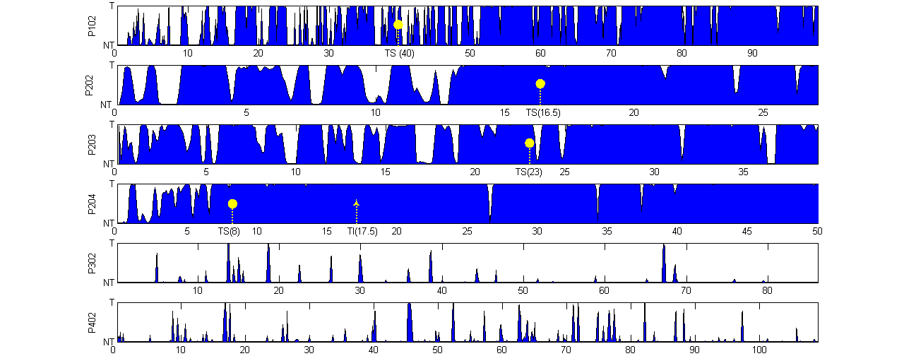
Seconds

T = Tremor NT = No Tremor TS = Tremor Started (time) TI = Tremor Increased (time)

Figure 5. Trained ANN output for each validation set. Values in between NT and T express the confidence of the ANN for either state.
The network had been trained with a bias towards tremor classification as apposed to a nil output associated with periods of no tremor activity. Because of this, the network output is sensitive to signals displaying tremor characteristics, as shown in the Fig. 5, patients 1 and 2 had high amount of tremor detections prior to tremor-onset, and a near constant detection of the tremor activity. This behavior is desirable; as early prediction is valuable to the device thus it can trigger stimulation and suppress the forthcoming tremor.

DISCUSSION
From all the data analysed to date, the frequency based neural network design has shown promising signs of reliably indicating the presence of a tremor. More significantly, the network has also provided an early detection of tremor-onset and hence the output (suitably filtered) would be able to trigger the pulse stimulation required to suppress the tremor while leaving the patient oblivious to any activity. Unlike previous networks [11], which monitor raw LFP data, by extracting β and δ frequency bands as inputs, a higher quality of robustness can be achieved over a range of validation tremor datasets while maintaining a high degree of accuracy with non-tremor datasets.
The network has a low output on data where no tremors are apparent and also not looming. This will increase the battery life of a stimulator immensely, and if a smoothing algorithm is applied to the network’s output further false predictions could be removed thereby decreasing the power usage further. This is also beneficial to the patient because for all times when the network does not predict a tremor the target location is left un-stimulated and can function as normal. [21, 22].
The results in this study indicate that the onset of tremor can reliably be detected by a suitably trained ANN inside a 10 second onset window. With tremor datasets the ANN classifies tremor signals periodically before tremor onset, and the tremor onset window could be increased beyond 10s. Long term data immediately prior to tremor-onset would benefit the definition of tremor onset length. To control the model in real time in vivo and over a larger population of patients will improve the structure, training and eventual classifying assessment of the ANN. Not only can these findings help the eventual construction of a clinically superior deep brain stimulator device but will also give further insight into the Parkinsonian brain’s functions, and ultimately give deeper insight into the underlying mechanisms of PD.
Acknowledgement: The research results presented here are based on data obtained by Prof. T. Aziz’s group at the University Laboratory of Physiology, University of Oxford and the Functional Neurosurgery Group, Department of Surgery, John Radcliffe Hospital, Oxford, UK. Further contribution has been from Kevin Warwick, Mark N. Gasson and Song Pan with the Department of Cybernetics, University of Reading, and John Stein with the University Laboratory of Physiology, University of Oxford.

references
[1] Schelosky L, Poewe W, “Current strategies in the drug treatment of advanced Parkinson's disease--new modes of dopamine substitution,” Acta neurologica Scandinavica. Supplementum, vol. 146, pp. 46-9, 1993.
[2] L. Dibble, “Motor Effects of Dopamine Replacement: Taking the Positive with the Negative,” Journal of Neurologic Physical Therapy, vol. 27, pp. 109-117, 2003.
[3] L. V. Metman, S. Konitsiotis, and T. N. Chase, “Pathophysiology of motor response complications in Parkinson's disease: Hypotheses on the why, where, and what,” Movement Disorders, vol. 15, pp 3-8, 2000.
[4] T. Z. Aziz, et al., “Lesion of the subthalamic nucleus for the alleviation of 1-methyl-4-phenyl-1,2,3,6-tetrahydropyridine (MPTP)-induced parkinsonism in the primate,” Movement Disorders, vol. 6, pp. 228-292, 1991.
[5] A. L. Benabid, P. Pollak, C. Gross, D. Hoffmann, A. Benazzouz, D. M. Gao, A. Laurent, M. Gentil, and J. Perret, “Acute and long-term effects of subthalamic nucleus stimulation in Parkinson's disease,” Journal of Stereotactic and Functional Neurosurgery, vol. 62, pp. 76-84, 1994.
[6] K.Warwick. “The promise and threat of modern cybernetics,” Southern Medical Journal, vol. 100, 112-115, 2007.
[7] E. McIntosh, T.Z. Aziz et al., “Estimating the costs of surgical innovations: the case for subthalamic nucleus stimulation in the treatment of advanced parkinson’s disease,” Movement Disorders, vol.18, pp. 993-999, 2003.
[8] B.J. Bordinia, A. Garga, C.L. Gallagherb, B Bellb, P.C. Garell, “Neuropsychological Effects of Bilateral Deep Brain Stimulation of the Subthalamic Nucleus in Parkinson's Disease,” Journal of Stereotactic and Functional Neurosurgery, vol. 85, 2-3, 2007.
[9] A. Funkiewiez, C. Ardouin, E. Caputo, P. Krack et al., “Long term effects of bilateral subthalamic nucleus stimulation on cognitive function, mood, and behaviour in Parkinson’s disease,” Journal of Neurology Neurosurgery and Psychiatry, vol. 75, pp. 834-839, 2004.
[10] X. Liu, J.F Stein, T.Z. Aziz et al., “Localisation of the Subthalamic Nucleus using Radionics Image FusionTM and StereoplanTM combined with field potential recording,” Journal of Stereotactic and Functional Neurosurgery, vol. 76, pp. 63-73, 2001.
[11] S. Pan, K. Warwick, J. Burgess, M. N. Gasson, S. Y. Wang, T. Z. Aziz and J. F. Stein. “Prediction of Parkinson’s disease tremor onset with artificial neural networks,” Proc. 5th IASTED International Conference on Biomedical Engineering, BioMED, pp. 341-345, 2007.
[12] M.Gasson, T.Aziz, K.Warwick, S.Wang and J.Stein, “Towards a demand driven deep-brain stimulator for the treatment of movement disorders,” Proc. 3rd IEE International Seminar on Medical Applications of Signal Processing, London, pp. 83-86, 2005.
[13] S.-Y. Wang, T.Z. Aziz, J.F. Stein et al., “Time-frequency analysis of transient neuromuscular events: dynamic changes in activity of the subthalamic nucleus and forearm muscles related to intermittent resting tremor,” Journal of Neuroscience Methods, vol. 145, pp. 151-158, 2005.
[14] K. Hornik, M. Stinchcombe, and H. White, “Multilayer feedforward networks are universal approximators,” Neural Networks, vol. 2, pp. 359-366, 1989.
[15] P. Picton, “Neural networks Grassroots series,” 2nd ed. Basingstoke, UK: Palgrave, 2000, pp. 37-45.
[16] B.W. Jervis, M.R. Saatchi, A. Lacey, T. Roberts, E.M. Allen, N.R. Hudson, S. Oke, M. Grimsley. “Articial neural network and spectrum analysis methods for detecting brain diseases from the CNV response in the electroencephalogram,” IEE Proc.-Science, Measurement & Technology, vol. 141, pp. 432-440, 1994.
[17] J. Chu, I. Moon, M. Mun. “A real-time EMG pattern recognition system based on linear-nonlinear feature projection for a multifunction myoelectric hand,” IEEE Transactions on Biomedical Engineering, vol. 53, pp. 2232-2239, 2006.
[18] Rossi, L., et al.,”An electronic device for artefact suppression in human local field potential recordings during deep brain stimulation,” Journal of Neural Engineering, vol. 4, 96-106, 2007.
[19] Ranck, J. B. Jr. “Which elements are excited in electrical stimulation of mammalian central nervous system: a review,” Brain Research, vol. 98, pp. 417–440, 1975.
[20] S.-Y. Chen, et al., “Surgical and hardware complications in subthalamic nucleus deep brain stimulation,” Journal of Clinical Neuroscience, vol. 14, 643-649, 2007.
[21] B.J. Bordinia, A. Garga, C.L. Gallagherb, B Bellb, P.C. Garell, “Neuropsychological Effects of Bilateral Deep Brain Stimulation of the Subthalamic Nucleus in Parkinson's Disease”, J. of Stereotactic and Functional Neurosurgery, 2007;85:2-3.
[22] A. Funkiewiez, C. Ardouin, E. Caputo, P. Krack et al., “Long term effects of bilateral subthalamic nucleus stimulation on cognitive function, mood, and behaviour in Parkinson’s disease”, J. of Neurology Neurosurgery and Psychiatry 2004;75:834-839.
[23] Peter Brown, Thomas Trottenberg, Anatol Kivi, Andreas Kupsch, Gerd-Helge Schneider, “The relationship between local field potential and neuronal discharge in the subthalamic nucleus of patients with Parkinson’s disease”, Experimental Neurology 194 (2005) 212– 220.

