Fusion of Motion Segmentation Algorithms
Anna-Louise Ellis
MPhil/PhD Computer Vision, a.l.ellis@reading.ac.uk
Supervisor: Dr J. Ferryman

abstract
Many algorithms have been developed to achieve motion segmentation for video surveillance. The algorithms produce varying performances under the infinite amount of changing conditions. It has been recognised that individually these algorithms have useful properties. Fusing the statistical result of these algorithms is investigated, with robust motion segmentation in mind.

Introduction
The ability to extract objects of interest from video sequences using motion is an active area of research within the Computer Vision community. The capacity to provide “real-time” silhouettes of these objects will assist in the tracking and reasoning of the behaviour.
Visual surveillance videos often contain unrelated motion such as trees and water, have a range of lighting and weather conditions and contain irrelevant reflections and shadows. In addition the quality of the real-time video is often poor, and at a low resolution resulting in “noisy” motion and “ghosts”. The extraction of objects of interest is frequently tackled by removing all other irrelevant pixels. This is referred to as motion segmentation.
To achieve robust motion segmentation the following criteria must be met:
- Noise, shadows, reflections and “ghosts” must be removed.
- Long term and rapid lighting changes must be handled.
- It must include a means of separating irrelevant motion such as trees, snow and running water.
- It must be as generic as possible to cope with many different types of scenarios (subjective tuning of parameters, specific to the application domain, must be avoided).
- The background model must adapt quickly to changes in the scene.
- The process must be achieved as fast as possible as it is often a precursor to tracking and reasoning algorithms.

Combining Algorithms
No single algorithm performs robustly under the infinite amount of changing conditions. As a result, different ways of combining algorithms are referred to in literature. The following represents a categorisation of methods for combining multiple motion segmentations:

Model Switching
Martin et al. [13] exploit optimal algorithm selection and key parameters tuning. A library of segmentation algorithms are fine tuned against predetermined ground truth images. The features extracted, alongside the optimal algorithm parameters are saved as a case. They are ranked by a number of criteria values. For each image a new case is created composed of a vector of image features, the chosen algorithm, and its optimised parameters. An MLP neural network is trained with this stored knowledge for algorithm selection.
Note: This technique relies on predetermined ground truth which rules out generality.

Layering

Time dependant layered backgrounds
The authors employ “Long term background updating” (over 150 frames) to remove noise and ghosts in [2]. The model works out the average background using a single Gaussian. In addition it uses “Short term background updating” that finds gradual changes in illumination with an IIR filter [3]. It then initiates shadow removal (using an RGB colour vector and HSV colour information). Object segmentation is then achieved by projecting the foreground image in both horizontal and vertical directions.

Framework
Images are processed at pixel, region and frame levels in Toyama et al. model [7]. At pixel level it maintains a model of the background for each pixel using a Weiner prediction filter. At region level it relies on finding connected components. At frame level a whole representative set of background models are chosen in a training phase with a k-means clustering algorithm. The model with the least amount of foreground pixels is used.

Generic “Blob” classification
In [10] Carmona et al. process each pixel according to whether it has been classified as a moving object, shadow, ghost, reflection, fluctuation or noise. The classification is achieved by converting from three colour space to angle moduli space. A Truncated Cone Method is used to segment the image. Characteristics of shadows, ghosts, reflections, fluctuation and noise have been defined and rules are used to detect them in the segmented blobs, again using the Truncated Cone method.

Cascade
Teixeira and Corte-Real [11] remove noise induced changes initially. Illumination variation is then discarded by a co linearity test which includes evaluating the angle between the current pixel colour vector and the reference colour vector. If the identified illumination variation change falls between two set thresholds the pixel is classified as background. The mixture of Gaussian algorithm is run on the remaining subset, to identify the foreground, as a means of reducing execution time.

Adaptive
KaewTraKulPong and Bowden use online EM algorithms to achieve an adaptive Mixture of Gaussians algorithm for background subtraction [4]. Shadows are removed in the resulting foreground by examining the brightness and chromaticity of the foreground pixels and testing against a threshold.

Fusion

Bayes
Two background models are produced using a Mixture of Gaussians algorithm and a brightness and chromaticity algorithm referred to as Statistical Background Disturbance Technique (SBD). Mazeed, Nixon and Gunn combine the results of both algorithms using Bayes’ theorem [12]. If the classifiers disagree whether a pixel is foreground then the conditional probability for the chosen class by each algorithm is calculated.

Boosting
Serre, Wolf, Bileschi, Riensenhuber and Poggio model a neurobiological design of a primate cortex [8]. It is designed using hierarchical alternating layers of “simple units” and “complex units”.
Simple units (16 Gabor filters for each layer) combine their inputs with a (bell shaped) tuning function to increase selectivity. Complex units pool their inputs (from the output of the previous Simple unit layer) through a MAX function.
The image (grey scale only) is propagated through the hierarchical architecture. Standard Model Features (SMFs) are extracted from the complex units and classified using SVM or boosting (Gentle boosting providing the best performance).
It was discovered that because there are variations in the amount of clutter and in the 2D transformations, it is beneficial to allow the classifier to choose the optimal features extracted from either the high or low level SMFs at a point in time, to improve the performance.
A major limitation of the system in the use of real world applications remains its processing speed which is typically tens of seconds per image.

Fusion in Biological Vision
Within biological vision, it has been discovered that Gaussian functions describe the simple symmetrical receptive fields that are in the centre of the retina, and Gabor functions describe the periphery (colour opponent) receptive fields. (In addition cardioid functions define asymmetric fields that are directionally selective). “A retina equipped with these ganglion-cell receptive fields provides a fairly simple but efficient mechanism for defining movements in space”. [9]
Similarities can be found with the frequent use of Mixture of Gaussians and Brightness and Chromaticity combinations.
The application of multiple representations of the “background” in engineered vision systems is analogous to biological vision:
There are “between ten and twelve output channels from the eye to the brain, each carrying a different, stripped-down representation of the visual system.” [9].
“It has been suggested that “immediate recognition” during scene categorization tasks may rely on partial processing by the visual system based on rapid and parallel detection of disjunctive sets of unbound features of the target category” [8], that is the ability to form an image of an object occurs immediately on the fusion of detected sets of partial images.

Performance Evaluation
The means of evaluating an individual algorithm or motion segmentation system has not as yet been standardised. Comparing performances is difficult to achieve from a literature search, as authors use incomparable datasets and evaluation methods. However in evaluating the performance of new algorithms and systems, the authors frequently benchmark against existing systems. Adaptations of the Mixture of Gaussians and Brightness and Chromaticity/Shadow Detection/Illumination algorithms, and the various means of combining these, feature frequently as improvements against the benchmarked systems.

Analysis
It is not realistic to model every aspect of what is already known about biological vision, and gain real-time interpretations of a video surveillance scene. However, the suggestion that the eye detects multiple layers, and then “fuses” these inputs can be acknowledged and assimilated within an engineered vision system. The ability to “reverse engineer” these layers and then combine the relevant ones is in essence a goal.
The weakness with layering is that if any layer is even slightly inaccurate, it automatically increases the inaccuracy of subsequent layers. A form of fusing the results will avoid this pitfall. In addition, the authors of the system modelled on a cortex [8], discovered that using a fusion technique to select the optimum features, instead of relying solely on the results of a hierarchical segmentation, improved performance.

Fusion USING Colour Spaces
Video at a resolution of 720 x 576 was collected from the Pedestrian Accessibility and Movement Environment Laboratory (PAMELA), at University College London using surveillance cameras under a range of lighting conditions. This provided a challenging and realistic representation of surveillance footage.
Using multiple colour spaces, to fuse an ensemble of different classifiers, has been shown to significantly improve accuracy in a texture classification system [14]. To study the effectiveness of the Brightness and Chromaticity (BC), Mixture of Gaussians (MOG) and Kernel Density Estimator (KDE) algorithms as a combination, the algorithms were initially “fused” together, in an approximation of a single RGB colour space fusion.
Foreground silhouettes for each frame were produced using the selected algorithms. The resulting silhouettes were coloured blue, red and green for the KDE, MOG and BC algorithm respectively. Each colour was represented as the value 255 in its respective channel of 24bit RGB representation. Examples of these are shown in Figures 1-3.
The silhouettes were combined by adding their RGB representative colours together and the fusion of the three algorithms could be visualised. Where all algorithms statistically represented foreground pixels the pixels appear white. Where there was no statistical agreement, pixels appeared red, blue or green. These were classified as background and removed. In addition it was observed that many (but not all) pixels that appeared cyan (statistical agreement of BC and KDE) were necessary to represent the foreground accurately. For this initial study all cyan pixels were then classified as foreground pixels.
The resulting binary images for each frame were visibly more accurate than the images produced by the individual algorithms. An example can be seen in Figure 4.
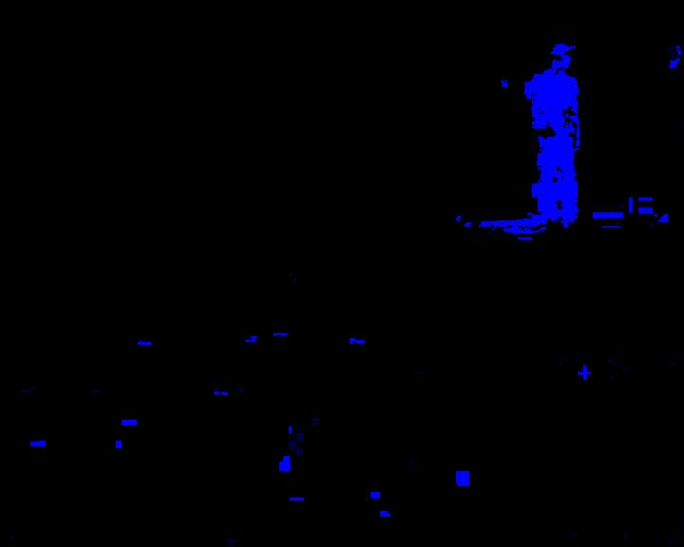
Figure 1. Kernel Density Estimator (blue pixels)

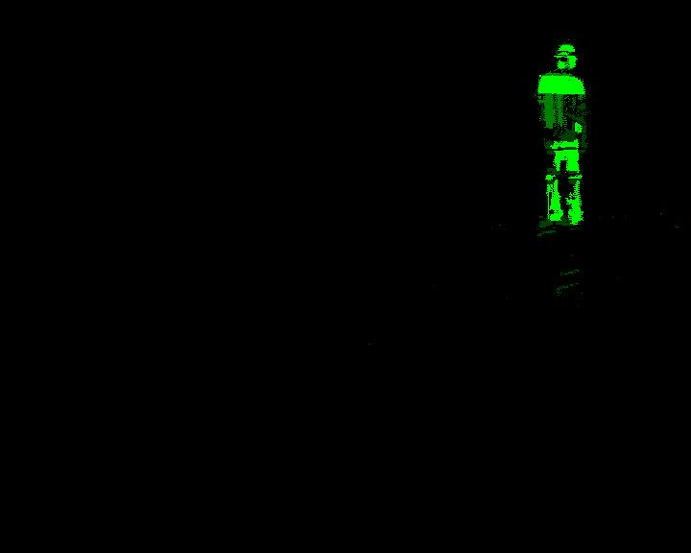
Figure 2. Brightness and Chromaticity (green pixels)

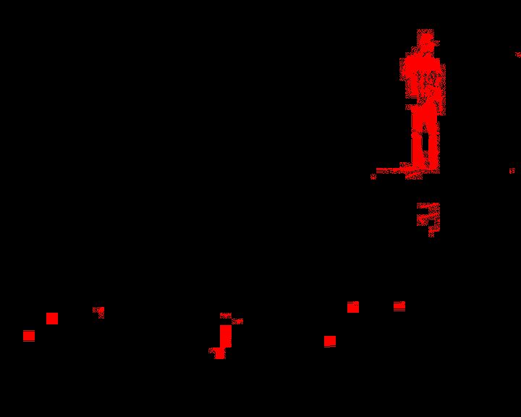
Figure 3. Mixture of Gaussians (red pixels)

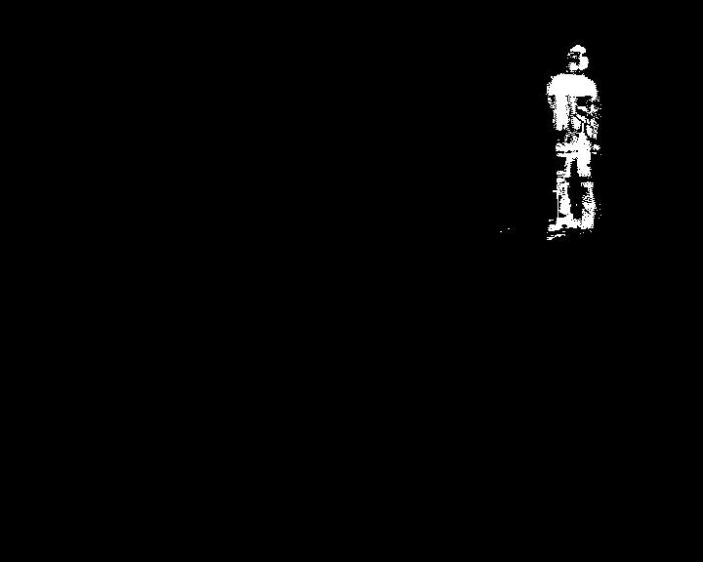
Figure 4. “Fused” Binary Image

Results
Each motion segmentation algorithm and the resulting “fusion” were compared against a set of ground truthed sequences. The ground truth was created manually, using Gimp, over a sequence of 25 frames. An example frame is shown in Figure 5.
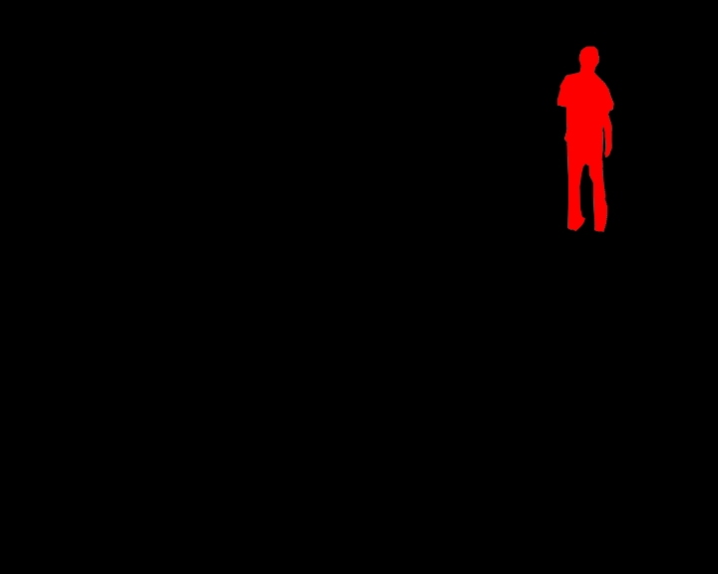
Figure 5. Ground Truth
The numbers of pixels in each ground truthed silhouette (sil) were counted. True Positive (TP), False Positive (FP), True Negative (TN) and False Negative (FN) pixels per frame, per algorithm were calculated. The performance (p) of each algorithm was measured per frame by calculating:
$p=\text{100}−\left(\left(\frac{\text{FN}+\text{FP}}{\text{sil}}\right)∗\text{100}\right)$
(1)
where the greater +ve %, the greater the performance.
The results in Figure 6 demonstrate a clear improvement in performance, using the approximated fusion technique, in comparison to all individually tested algorithms.

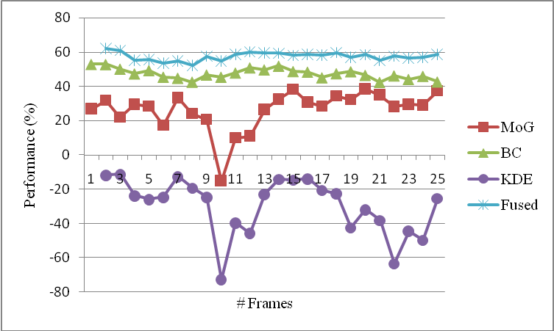

Figure 6. Performance of algorithms

Statistical Fusion
The results of the pilot study highlighted the advantages of fusing algorithms. Algorithms or “classifiers” can be readily fused if a classification of foreground pixel is based on statistical modelling such as KDE.
For example:
Algorithm 1: MoG: performs well in removing repetitive movements such as trees blowing in the wind
- The recent history of each pixel is modelled by a mixture of K Gaussians, in our case three. Training is performed over N frames
- A background pixel is defined as a pixel value within 2.5 σ (99.000% confidence interval) of a distribution (per pixel/per distribution threshold)
- The probability of a pixel X occurring is:
$P\left(x\right)=\sum_{j=1}^{K}{w_{j}η}$
(2)
where w_{j} is the weight of the K^{th} Gaussian distribution, μ_{j} is the mean of the K^{th} distribution, ∑ _{j} is the covariance matrix from the K^{th} distribution, η is a multivariate Gaussian pdf.
Algorithm 2: Brightness and Chromaticity: effective in removing shadows and reflections
- A statistical background model is established, over N frames, to represent mean μ_{c} and standard deviation σ_{c} for each colour c∈{R,G,B} where x is a RGB pixel representation
- If x < σ_{c} , the pixel is classified as background
- If x > = σ_{c} , the pixel’s brightness distortion (α) and chrominance distortion (CD) are computed and normalised
- α and CD are used to classify pixels as Foreground, Background, Shadow and Highlight, dependent on thresholds.

Fusion
Ensembles of pattern classifiers can be combined through various means such as weighted majority vote, naive Bayes, and SVD. Mazeed, Nixon, and Gunn [12] combined the statistical representation of two algorithms using Bayes with favourable results.
Bayes formalism:
$$P\left\langle ω | x\right\rangle =\frac{p\left\langle x | ω\right\rangle P\left\langle ω\right\rangle }{\sum{p\left\langle x | ω\right\rangle P\left\langle ω\right\rangle }}$$
(3)
- When classifiers agree (pixel is foreground or background), a decision is set accordingly
- When classifiers disagree, the conditional probability for chosen class by each classifier is calculated
- The product of each class of conditional probabilities provide the parameters for the final decision :
$\begin{aligned}\text{argmax}\left\{p\left\langle x | ω_{\text{FGi}}\right\rangle \right.P\left\langle ω_{\text{FGi}}\right\rangle ,p\left.\left\langle x | ω_{\text{BGi}}\right\rangle P\left\langle ω_{\text{BGi}}\right\rangle \right\} \\ i∈\left\{1\text{.}\text{.}n\right\}\end{aligned}$
(4)
where$ω$is a foreground (FG) or background (BG) classifier.

Implementation

Extending existing image information
Image information is normally stored as an array of pixels, with intensity values for some colour space, such as RGB, YUV and HSV. Combining classifiers is achievable if the output of each classifier not only provides the greyscale (or binary) colour of a pixel, but the statistical representation that the pixel is foreground or background. The RGB image structure was extended to capture the statistical representation that a pixel had been classified.

Virtual synchrony
Running multiple algorithms is computationally expensive and complex. Each algorithm runs at different speeds, and possibly on different machines. A technique referred to as “Virtual Synchrony” is proposed as an approach to fusing (see Figure 7)
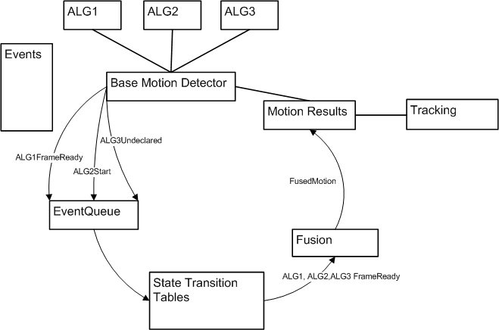
Figure 7. Virtual Synchrony
- Generic events are defined such as Start, FrameReady, Undeclared, Idle, Complete
- Each algorithm generates events as they process pixels
- These are enqueued
- Events are processed by state transition tables
- Fusion occurs when all three frames are ready
- The motion results are ready for use by tracking

Extending algorithms
The classifiers, in general, have not been written with fusion in mind. Additional methods are needed to gain a true representation of statistical fusion in some. For example, adding the ability to calculate the confidence intervals, to the algorithm at the point of initial background classification, is a necessity in the Brightness and Chromaticity algorithm. Incorporating the brightness (α) distortion’s normal distribution and the chrominance (CD) distortion’s gamma distribution, when calculating the posterior probability of a foreground pixel, in the Brightness and Chromaticity algorithm will give the correct confidence intervals at the classification point.
Duin [15] gives the following recommendations: Where probabilistic outputs are needed, these have to be reliably calibrated, as the accuracy of the base classifiers is regarded as less important, than the reliability of the decisions and probability estimates.
This was demonstrated fusing MoG and the Brightness and Chromaticity algorithm (without additional calculations) using Bayes, as previously mentioned. The probability estimates were not calibrated. A nominal value of 1.0e-25 was set for a foreground pixel, for probabilities ranging from 0 to 0.68 (one standard deviation of the normal distribution), for the BC. MoG produces much finer representations of probabilities and as a result the majority of pixels were classified as background.

Conclusion
The ability to fuse the optimum motion segmentation algorithms, such as an adaptive Mixture of Gaussians, Brightness and Chromaticity and the Kernel Density Estimator with a statistical technique has great potential in providing robust motion segmentation for visual surveillance.
The above mentioned algorithms can be regarded as generic in nature and individually solve some of the challenges associated with motion segmentation. MoG is able to capture repetitive irrelevant motion (such as trees moving in the wind), in addition to finding static “background” and separate this from what should be represented in the foreground. BC is effective in removing shadows and reflections and KDE is a good representation of a non-parametric algorithm.
In addition an architecture that enables the fusion of multiple algorithms can include other statistical algorithms such as Colour Mean and Variance as a possible means of fine tuning a robust motion segmentation system. Combinations of algorithms may be explored.

FutUre work
During the fusion methods, the classifiers can be extended by exploiting contextual knowledge such as the diurnal cycle and cloud movement (which generates wide variation in illumination), and 3D geometric shadow prediction.
Acknowledgements: Murray Evans, David Tweed, Longzhen Li

REFERENCES
[1] Chris Stauffer, W.E.L. Grimson, “Adaptive Background Mixture Models for Real-Time Tracking” in: Proceedings of the IEEE Computer Society Conference on Computer Vision and Pattern Recognition, vol. 2, pp. 23-25, 1999
[2] Ying-hong Liang, Sen Guo, Zhi-yan Wang, Xiao-wei Xu, Xiao-ye Cao, “A Robust and Fast Motion Segmentation Method for Video Sequences” in: Proceedings of the IEEE International Conference on Automation and Logistics, pp. 2952-2957, 2007
[3] C. Wren, A. Azarbayejani, and T. Darrell, et al., “Pfinder: Real-Time Tracking of the Human Body”, in: IEEE Transaction on Pattern analysis and Machine Intelligence, vol. 19, no. 7, pp. 780-785, 1997

[4] P. KaewTraKulPong and R. Bowden, “An Improved Adaptive Background Mixture Model for Real-Time Tracking with Shadow Detection” in: Proceedings of the Second European Workshop on Advanced Video Based Surveillance Systems, Kingston, UK, pp. 149-158, 2001
[5] Horprasert, T., Harwood, D., Davis, L.S., “A Statistical Approach for Real-Time Robust Background Subtraction and Shadow Detection.” in: Proceedings of the Seventh IEEE ICCV Frame-rate Workshop, pp. 1-19, 1999
[6] Kolmogorov, V.; Criminisi, A.; Blake, A.; Cross, G.; Rother, C., “Probabilistic Fusion of Stereo with Color and Contrast for Bilayer Segmentation” in: Transactions on Pattern Analysis and Machine Intelligence Volume 28, Issue 9, pp. 1480 – 1492, 2006
[7] Kentaro Toyama, John Krumm, Barry Brumitt, Brian Meyers, “Wallflower: Principles and Practice of Background Maintenance” in: Proceedings of the Seventh IEEE International Conference on Computer Vision, pp. 255-261, 1999
[8] Thomas Serre, Lior Wolf , Stanley Bileschi, Maximilian Riesenhuber, Tomaso Poggio, “Robust Object Recognition with Cortex – Like Mechanisms” in: Transactions on Pattern Analysis and Machine Intelligence, pp. 411-426, 2007
[9] Botond Roska & Frank Werblin, “Vertical interactions across ten parallel, stacked representations in the mammalian retina” in: Letters to Nature, Nature 410, pp.583-587, 2001
[10] Carmona, E. J., Martínez-Cantos, J., and Mira, J., “A New Video Segmentation Method of Moving Objects Based on Blob-Level Knowledge” in: Pattern Recognition Letters 29, (3), pp.272-285, 2008
[11] Teixeira, L.F. Corte-Real, L., “Cascaded Change Detection for Foreground Segmentation” in: IEEE Workshop on Motion and Video Computing, pp. 6-6, 2007
[12] Al Mazeed, A. and Nixon, M.S. and Gunn, S., “Classifiers Combination for Improved Motion Segmentation” in: International Conference on Image Analysis and Recognition, pp. II: 363-371, 2004
[13] Martin, V.; Thonnat, M.; Maillot, N., “A Learning Approach for Adaptive Image Segmentation” in: Proceedings of the Fourth IEEE International Conference on Computer Vision Systems, pp. 40-40, 2006
[14] Chindaro, S. Sirlantzis, K. Deravi, F. “Texture Classification System Using Colour Space Fusion” in: Electronics Letters, Volume: 41, Issue: 10, pp. 589- 590, 2005
[15] R. P. W. Duin “The Combining Classifier: To Train or Not to Train?” in: Proceedings of the Sixteenth International Conference on Pattern Recognition, pp. 765-770, 2002

