Semantic-level Visual Content Descriptor Combining Visual and Textual Cues as Collaterals
Meng Zhu; Atta Badii
IMSS, School of System Engineering, University of Reading
{meng.zhu;atta.badii}@rdg.ac.uk

abstract
In this paper, we introduce a novel high-level visual content descriptor which is devised for performing semantic-based image classification and retrieval. The work can be treated as an attempt for bridging the so called “semantic gap”. The proposed image feature vector model is fundamentally underpinned by the image labelling framework, called Collaterally Confirmed Labelling (CCL), which incorporates the collateral knowledge extracted from the collateral texts of the images with the state-of-the-art low-level image processing and visual feature extraction techniques for automatically assigning linguistic keywords to image regions. Two different high-level image feature vector models are developed based on the CCL labelling of results for the purposes of image data clustering and retrieval respectively. A subset of the Corel image collection has been used for evaluating our proposed method. The experimental results to-date already indicates that our proposed semantic-based visual content descriptors outperform both traditional visual and textual image feature models.
- Introduction
Text and image are two distinct types of information from different modalities, as they represent the world in quite different ways. However, there are still some unbreakable, implicit connections between them somehow. Text can be used to describe the content of image, and image may convey some semantics within the context of text. The reason that we call them implicit connections is due to a gap between text and image information, which is usually referred to as the “semantic gap”. “The semantic gap is the lack of coincidence between the information that one can extract from the visual data and the interpretation that the same data may have for a user in a given situation.” [18]. Different people may describe the same image in various ways using different words for different purposes, each of which may be relevant to a particular idiosyncratic personal world-view (phenomenologically distinct worldhoods) or data-views. The textual description is almost always contextual, whereas the images may live by themselves. Moreover, the text descriptions of images often remain at a higher level to depict the properties that are very difficult to infer by vision, like the name of the person, disregarding the low-level visual features, such as the colour of the person’s clothing.
As a result of the rapid advances in digital imaging technology, a huge plethora of annotated digital images have evolved in widespread collections all over the world.. Typical examples include the online galleries (for example the National Gallery, London. http://www.nationalgallery.org.uk/), most of the news photograph collections on the web, as well as the commercial digital image libraries, such as Corel Stock Photo Library which contains 60,000 annotated images. The most straightforward use of such collections is for the users to browse and search the images that match their needs. Therefore, there is a growing interest in user’s search requirements which motivates research to increase the efficacy of indexing and retrieval of images. The annotated image collections can either be indexed and searched by text (i.e. annotation) [10], or by image content (i.e. visual features). The annotations, typically but not always, refer to the content of the image, and are usually neither fully specific nor comprehensive, and even sometimes are produced for a special purpose or effect as in advertising. For example, the annotations in the digital image gallery often include some content-independent information [4], such as artist’s name, date, ownership, etc. For most annotated image collections, such as Corel Stock Photo Library and news photo archives, the annotations focus on describing specific content of the images, but cannot cover all of the information conveyed by the images. Content-Based Image Retrieval (CBIR) concentrates on exploiting computer vision and image processing methods to facilitate image indexing and retrieval. This was proposed mainly due to the inadequacy of text in representing and modelling the perceptible information conveyed by the rich content of images. A lot of research has been done by many researchers in this area e.g. [17], [18], [14] and [13]. Despite the significant achievements that these researchers have made, it is widely acknowledged that strong retrieval performance is fundamentally predicated on matching low-level visual features such as colour, texture, edges, etc. Only a limited degree of progress has been reported by the research in CBIR which has advocated matching at the level of object semantics. This is to be expected since it is always very difficult to identify visually similar but conceptually different objects if one were to rely on a purist rather than a multi-modal (multiple domains of cues) approach to computer vision.
In this paper, we propose a high-level image feature vector model which combines multi-modal cues i.e. both visual and textual cues for semantic-based image retrieval in order to bridge the so called “semantic gap”. The construction of this novel multi-modally sourced image content descriptor is based on the automated image labelling framework that we refer to as the Collaterally Confirmed Labelling (CCL). Both the image content (i.e. visual features) and the collateral texts are used as the input to the labelling system. Content and context-associative knowledge is extracted from the collateral textual information to confirm the output of the object-level labels generated by the CCL framework. Two different feature vector models are devised based on the CCL framework for clustering and retrieval purposes respectively. The effectiveness of the clustering and retrieval as supported by our proposed feature vector models is examined using SOMs.
In section 2, we seek to further motivate the rationale for CCL. Section 3 reports the design of the CCL framework. In section 4, we have presented a description of how our proposed high-level image feature vector models are built up. Section 5 reports the experiments conducted for evaluating our proposed method. Section 6 presents our conclusions.
- MOTIVATION
According to the studies performed by many researchers (e.g. [6], [9], [12], [15]), who have focused on analysis of users’ needs within the visual information retrieval context, we can conclude that:i) users search for visual information both by types and identities of the entities within the images, ii) users tend to request images both by reference to the innate visual features and the concepts conveyed by the picture. With this conclusion, clearly we can see that using text or image features alone cannot adequately support users’ requests. It has been argued that the low-level visual primitives exploited through CBIR systems are not sufficient for depicting distinctive semantic (object) level representations of the images. On the other hand, dominant commercial solutions like Google and Yahoo image search engines which for indexation and retrieval take advantage of the collateral text information co-occurring with the images, like title, caption, URL, etc, cannot always meet the user’s perceptual needs and sometimes the retrieval results may be unpredictable due to the inconsistency between the collateral text and image content. Figure 1 below shows the response of the Yahoo image search engine for the query: “bear in water”.
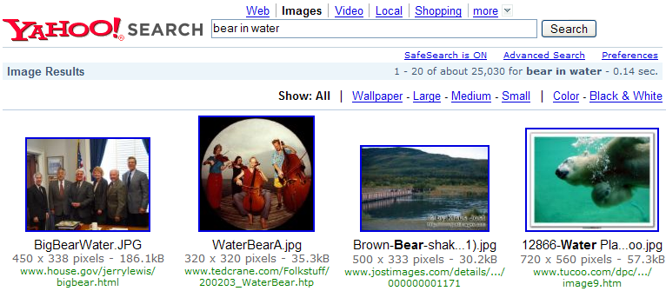
Figure 1. Yahoo’s retrieval result in response to the query of “bear in water”
Therefore, any attempt to combine both visual and textual cues for image representation and indexation should exploit the next generation of integrative multi-modal semantically-cued image retrieval approaches. Srihari has reported some pioneering research in this area of integrating visual and linguistic modalities for image understanding and object recognition [19], [20]. Barnard et al ([1], [2], [3]), have proposed a statistical model for organising image collections into a hierarchical tree structure which integrates semantic information provided by associated text and perceptual information provided by image features. Paek et al [16] presented an integration framework for combing the image classifiers which are based on the image content and the associated textual descriptions. Li and Wang [11] created a system for automatic linguistic indexing of pictures using a statistical modelling approach. The two-dimensional multi-resolution hidden Markov model is used for profiling categories of images, each corresponding to a concept. Zhou and Huang [23] explored how keywords and low-level content features can be unified for image retrieval. Westerveld [21] and Cascia et al [5] both chose an on-line newspaper archive with photos as their testing dataset to combine the visual cues of low-level visual features and textural cues of the collateral texts contained in the HTML documents. Promising experimental results have been reported throughout the literature in this novel research area. These studies have largely motivated our research in combining both visual and textual cues in high-level image feature vector model construction.
- COLLATERALLY CONFIRMED LABELLING
Collaterally Confirmed Labelling (CCL) framework constitutes the fundamental part of the semantically-cued high-level image feature vector model construction and it is aimed at automatically assigning textual keywords to regions of interest for a given image (see Figure 2).
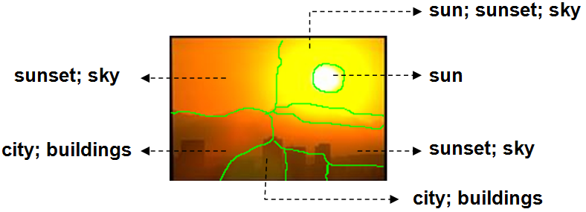
Figure 2. Typical output of the CCL framework
CCL comprises five key components to be identified within the framework as follows:
i) Image segmentation
ii) Region-based, low-level visual feature extraction
iii) Collateral knowledgebase
iv) Visual vocabulary
v) Collaborative mapping procedure.
The raw image data is firstly segmented into a number of regions and then low-level visual features, like colour, edge, shape, texture, are extracted from each segment. Using the region-based feature vectors, we map those low-level visual features to the visual concepts defined in the visual vocabulary with the help of the domain knowledge extracted from the collateral texts. In the following sections, we will discuss each of the above components in detail.

Image Segmentation and Region-based Low-level Feature Extraction
We use the normalised cut [8] method to segment images into a number of regions. A 54-dimessional feature vector, comprising colour, edge, shape and texture features, is created for each segment. 21 colour features of image are extracted using the intensity histogram. 19 edge features, are extracted by applying an edge filter and the water-filling algorithm [22] on the binary edge image. A statistical texture analysis method proposed by Haralick et al [7], the Grey Level Co-occurrence Matrices, was used to extract 7 texture features from each segment. Finally, 7 features related to shape were extracted using Matlab-based functions for extracting the statistics of image regions. We have constructed the final feature vectors by sequentially assembling all the four kinds of features together.
3.2. A Visual Vocabulary
The construction of the visual vocabulary is based on a dataset provided by Barnard [2], which consists of 3478 manually annotated regions of interest segmented from 454 Corel images. The image segments were annotated by Duygulu [2] with a controlled vocabulary which is a subset of the terms that had been used for annotating the Corel images. An image segment may be annotated using single or multiple keywords. The visual vocabulary developed in our system is a set of clusters of region-based visual feature vectors labelled by textual keywords (see Figure 2).
There are two basic approaches of clustering the region-based visual feature vectors. One is to use statistical clustering methods, like K-means or hierarchical, to classify the visual feature vectors into a number of clusters and manually label those clusters using keywords. The drawback of this method is that sometimes it would group together some segments, which are visually very similar but conceptually very different. In other words, this method does not overcome the limitation of content-based image feature classification as discussed earlier. Since we had this dataset of manually labelled image segments, we decided to use another approach to cluster those segments, which is a simple process of grouping together the segments labelled by the same keyword. Finally, 236 visual concepts were extracted to constitute the vocabulary. However, since the segments may be labelled by multiple keywords, there would be overlaps among the clusters.
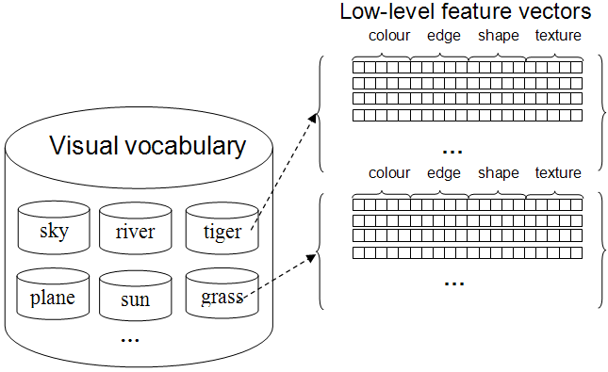
Figure 3. A visual vocabulary consists of 236 visual concepts
3.3. Constructing a Collateral Knowledge Base
We constructed our collateral knowledgebase by extracting and representing both the collateral content and context related knowledge from the collateral textual descriptions of the images.
3.3.1. Collateral Content
The collateral content refers to the knowledge that can be extracted directly from the collateral texts of the images. Such kind of collateral textual information becomes easier and easier to acquire due to the multimodal nature of the modern digitalised information dissemination. There are many different sources where the collateral keywords can be extracted, like captions, titles, URL, etc. Such keywords are expected to depict the subject or concepts conveyed by the image content.
3.3.2. Collateral Context
Collateral context refers to the contextual knowledge, representing the relationships among the visual concepts. We use a conditional probabilistic co-occurrence matrix which represents the co-occurrency relationships among the visual concepts defined in the visual vocabulary. Hence, a 236 × 236 matrix is created based on the annotations of the image segments, where each element can be formally defined as follows:
(1)
The relationships represented via the visual keywords co-occurrence matrix could be considered as bi-directional, because the value of each element is calculated based on the conditional probability of the co-occurrency between two visual keywords. The relationships appear to be reasonable in many cases (see Figure 4). For instance, the relationship between sky and clouds showing that clouds has a larger co-occurrence probability against sky than the other way round. This is reasonable because clouds must appear in the sky while there may be a lot of other things also appearing in the sky.
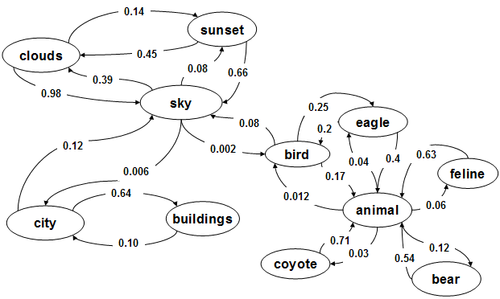
Figure 3. A graph representation of the visual keyword co-occurrence matrix
The exploitation of this co-occurrence matrix is a novel way of bridging the gap between the computer generated image segments and the semantic visual object. Image segmentation by unaided by other domain information is still not fully resolved and remains an open issue with no dominant solution. So far, even the most state-of-the-art image segmentation techniques have failed to generate perfect assigned segmentation which can separate whole objects from each other. Normally, image segments either contain a part of object or several parts of different objects. For instance, it is very likely to get segments containing a wing of an airplane with the background of sky. With our co-occurrence matrix, if the segments can be firstly recognised as a wing then the system will most probably provide other labels like plane, jet, sky, etc. according to the conditional probability between the visual keyword ‘wing’ and the others.
  - Collaterally Confirmed Mapping to Motivate Visual Concepts
Having constructed the visual vocabulary and the collateral knowledge base, we can proceed to map the low-level visual feature vectors of the image segments to the visual keywords. We used two methods to do the mapping, namely Euclidean distance and Gaussian distribution.
For the Euclidean distance method, we calculate the distance between the segment features and the centroids of each cluster within the visual vocabulary calculated as follows:
(2)
x is the segment feature vector and c is the mean vector of the visual feature cluster. For the Gaussian distribution method, we calculate the probability between the segment feature vector and the visual feature clusters, which can be defined as follows:
(3)
where a and σ are the mean vector and the standard deviation of the cluster respectively.
However, labelling assignments based only on the shortest Euclidean distance and highest Gaussian probability cannot always provide accurate labels. Therefore, we introduced the deployment of collateral content knowledge to re-confirm the labelling results and to use the collateral context to expand the labelling with some context related labels.
In collaterally confirmed labelling, the process is quite straightforward. Instead of finding the shortest Euclidean distance or highest Gaussian probability against all the clusters within the visual vocabulary, we seek to determine the best matching visual keywords which appear as collateral keywords. For the collateral context based labelling, we use a Thresholding mechanism to combine both visual similarity between the segment feature and visual keywords, and, co-occurrence probability between the collateral content-based label and the rest of the visual keywords within the visual vocabulary (see equation 4 and 5 below).
Euclidean Distance: | $$\left(\text{Min}\left(\sqrt{{\left\|\vec{f}−{\vec{u}}_{\text{kn}}\right\|}^{2}}\right)/\sqrt{{\left\|\vec{f}−{\vec{u}}_{\text{km}}\right\|}^{2}}\right)×P\left(K_{m}|K_{n}\right)≥\text{Threshold}$$ | (4)
Gaussian Distribution | $$\left(\frac{1}{\sqrt{2{\text{πσ}}^{2}}}\text{exp}\left(\frac{−{\left(\vec{f}−{\vec{u}}_{\text{km}}\right)}^{2}}{2σ^{2}}\right)\right)×P\left(K_{m}|K_{n}\right)≥\text{Threshold}$$ | (5)
where | $$\text{kn}∈\left\{k|k∈{\text{collateral}}_{\text{keyword}}\right\}∩\left\{k|k∈{\text{visual}}_{\text{vocabulary}}\right\}$$  $$\text{km}∈\left\{k|k∈{\text{visual}}_{\text{vocabulary}}\right\}$$
The determination of Threshold is based on experiment and can be adjusted according to the different needs. For example, the lower the value is the more context related labels you get, however the relevance of the label may fall down accordingly. In contrast, greater value leads to more relevant but less labels.

HIGH-LEVEL VISUAL DISCRIPTIOR
Based on the region-based labels generated using the CCL framework, we construct a novel homogenous semantic-level image feature vector model. Thus the new feature vector model combines both the visual features of the image content and the textual features of its collateral text. Two different kinds of feature vectors are created for retrieval and classification purposes respectively.
As indicated the in the Table below, the typical result of the labelling is a set of keywords associated with each segment (see Figure 2). Based on such linguistic labels, we can calculate the weight of each term on the basis of the frequency of its appearance in the labels of all the segments. Therefore, it is expected that the weights should reflect the proportion of the occurrence of the visual object within the whole scene. For the example shown in Figure 2, we can generate the proportions of the key terms as below (see table 1):
Key term | Proportion
Sunset | 3/12 = 25%
Sky | 3/12 = 25%
Sun | 2/12 = 17%
City | 2/12 = 17%
buildings | 2/12 = 17%
Table 1. Proportions of each visual object within the scene
A 236-dimensional feature vector, where each dimension represents a visual keyword in the vocabulary, can be created based on those proportions. Each element of the vector can be defined as:
(6)
where the number_of_keywords_{img} refers to the total number of keywords that are automatically assigned to the image.
Another feature vector model can be applied in a similar way. However instead of defining each visual keyword as a dimension, this time we group the keywords into exponential partitions using a function described in equation 7, according to the tf×idf values for the key terms for each category.
(7)
where a is a statistic parameter which can be specified accordingly.
The aim of developing such kind of feature vector model is to give more weight to the most important keywords for each category. Because the value of the element of the feature vector will be the quotient of the keyword proportion divided by the number of keywords with in the exponential partition. Figure 4, plots the function of f(x) = 3^{x}, which provides an intuitive view of the effect of exponential partition.
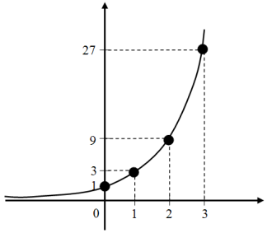
Figure 4. Graph of the function of f(x) = 3^{x}
Table 2 shows an example of an exponential partition based high-level image feature vector, where the value of each element of the vector can be formally defined as follows:
(8)
where v_{i} is the proportion of the keyword calculated using equation 6.
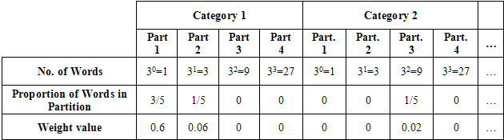
Table 2. An example of exponential partition based feature vector
We believe that this feature vector model can facilitate the classification due to the fact that more weights are given to the most significant and representative key terms for each category which are encoded at the beginning while assigning less weights to the keywords which are located towards the end of each partition.

EXPERIMENTAL PROCEDURE
We conducted all the experiments based on the Corel image dataset. The Corel stock photo library contains more than 600 CDs, each of which has 100 photos grouped as one theme. The pictures are collected from photographers around the world. The collection has been widely used in teaching and research on image processing and retrieval techniques. An interesting aspect of the collection is that each image has been annotated with two kinds of annotation, one is the caption which describe the subject of the whole image in free text, i.e. thematically contextualises the image, and, the other is keywords which depict the key objects contained within the image. In our experiments, we took advantage of the given keywords as collateral keywords for the images. Those keywords can be considered to be extracted from the collateral text information of the image using natural language processing or keyword extraction techniques. We selected 30 categories of Corel images as our experimental dataset (see Table 3).
Class no. | Category Name | Class no. | Category Name
1 | Sunsets & Sunrises | 16 | Greek Isles
2 | Wild Animals | 17 | Coins & Currency
3 | The Arctic | 18 | English Country Gardens
4 | Arizona Desert | 19 | Bald Eagles
5 | Bridges | 20 | Cougars
6 | Aviation Photography | 21 | Divers & Diving
7 | Bears | 22 | Grapes & Wine
8 | Fiji | 23 | Land of the Pyramids
9 | North American Deer | 24 | Nesting Birds
10 | Lions | 25 | Helicopters
11 | Wildlife of Antarctica | 26 | Models
12 | Elephants | 27 | Virgin Islands
13 | Foxes & Coyotes | 28 | Tulips
14 | Rhinos & Hippos | 29 | Wild Cats
15 | Arabian Horses | 30 | Beaches
Table 3. 30 categories of Corel image
  - Extracting Image Features
The 3000 Corel images were firstly segmented into 27953 regions of interest. The segments for each image were sorted in the descending order according to their size (or area), and we selected the top 10 segments, if the image was segmented into more than 10 regions, as the most significant visual objects in the image to label. We used different mapping methods, namely Euclidean distance and Gaussian distribution, to label the 3000 Corel images.
Two different kinds of feature vectors as proposed in section 4 were generated for all the 3000 Corel images. One was the 236-dimensional feature vector, whereby the value of each dimension is determined by the weights (calculated using equation 6) of the visual keywords defined in the visual vocabulary. The other one is the feature vectors based one the exponential partitioning of the keywords in each category. In our case, we divided the keywords into 4 groups by applying the function f(x) = 3^{x} where x {0, 1, 2, 3} according to the tf×idf values of each keyword of the category. Therefore, there were 120 (4 × 30) dimensions in this feature vector. Because we also used different methods for the mapping from the region-based low-level feature vectors to the visual keywords, i.e. Euclidean distance and Gaussian distribution, we finally generated 4 sets of feature vectors for each of the 3000 Corel images, namely Euclidean 236D and 120D, Gaussian 236D and 120D.
In order to compare the performance of the proposed feature vector models with the traditional feature extraction methods, we also extracted 3000 image feature vectors based on the visual content of the image and text feature vectors based on the Corel keywords. For the visual feature vector, we constructed a 46-dimensional feature vector which consisted of colour, edge and texture features for each image. For the textual feature vector, we selected the top 15 keywords with the highest tf×idf values for each category. Then we merged the repeated keywords, and finally built up a 333-dimesional text feature vector model. The value of each element was the occurrence of the keywords.
  - Semantically Cued Image Classification and Retrieval
We created four 30 × 30 SOMs for learning to classify four kinds of feature vectors, i.e. Euclidean 120D, Gaussian 120D, Visual 46D, and Textual 333D. 10 images were randomly selected from each category making a total number of 300 test images, and the rest, i.e. 2700 images, were used as the training set. Each one of the four SOMs was trained with the 2700 feature vectors extracted from the training images using the four methods for 100 epochs.
The trained SOMs were firstly used to perform the image retrieval on the four different kinds of feature vectors. The SOM-based retrieval was performed on the basis of the principle that we would retrieve the training items with respect to their activation values to the Best Matching Unit (BMU) of the test input. The Euclidean 120D and Gaussian 120D outperform both the textual and visual feature vectors for the top 5 retrieved items, and significantly increased the precision as compared to the results achieved by purely using content-based image feature vectors (see Figure 5)
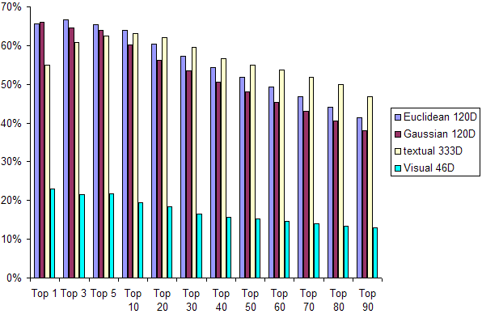
Figure 5. Precisions of the SOM-based image retrieval using four different feature vector sets
Thereafter we examined the classification effectiveness of our proposed high-level image content descriptor by testing the trained network using the 300 test feature vectors. 4 confusion matrices were created for the test results based on which we calculated the classification accuracy using the four different kinds of feature vectors, i.e. Euclidean 120D, Gaussian 120D, Textual 333D and Visual 46D (see Figure 6). The Euclidean 120D showed the best average accuracy at 71% followed by the Gaussian 120D at 70%. Also, the performance of the Euclidean 120D and Gaussian 120D appeared to be more stable that of Textual 333D and Visual 46D.
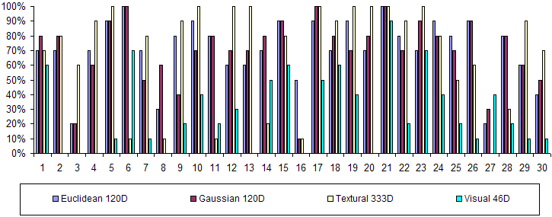
Figure 6. SOM classification accuracy using four kinds of feature vectors
Our other image retrieval experiment deployed all the six different feature vector models, i.e. Euclidean 120D, Euclidean 236D, Gaussian 120D, Gaussian 236D, visual 46D and textual 333D, using cosine distance matching. Despite the fact that Textual 333D provided the best precision in results this time, it has been proved that for 12 categories, at least one of our proposed feature vector models outperforms the traditional textual and visual feature vector models.
However, the statistical calculations alone sometimes are not enough for such evaluation. We believe that one of the advantages of our proposed semantically-cued high-level visual content descriptors is that they can combine both the visual and semantic similarity of the image. Take the retrieval results shown in Figure 7 as an example. Although Textual 333D got the best statistical results in terms of precision, it cannot meet the user’s perceptual and conceptual needs on the objects of the interest. Moreover, the word ‘animal’ for instance misleads the system to retrieve any image whose annotation contains this word. However, by using our proposed high-level image feature vector model the objects of interest can be successfully identified e.g. bear and water in this case, and we can retrieve images that are both visually and conceptually similar to the query images, even though the retrieved images were categorised into the different classes by the annotator compared to that of the query image. This is also consistent with the empirical observation that sometimes the statistical calculations, e.g. precision/accuracy, appear to be lower for the proposed features than for the textual features.
Query Image |  |  | Corel keywords
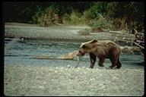 |  |  | Animal bear fish water
Textual 333D |  |  |  |  | 
Euclidean 236D | 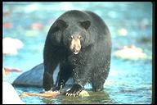 | 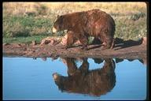 | 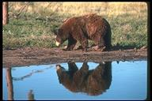 | 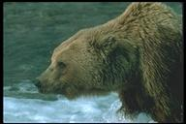 | 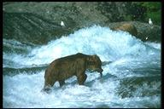
Gaussian 236D |  |  | 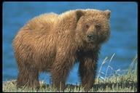 |  | 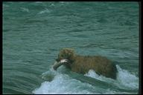
Visual 46D | 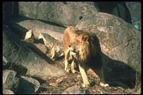 |  |  |  | 
Figure 7. Example retrieval results using six different feature vector models
Recall the retrieval results of Yahoo image search engine in response to the query “bear in water”. This is a good example for demonstrating the shortcomings of purely using collateral textual information for image indexation and retrieval; due to the subjectivity of the textual annotations. Hence, we believe that in realistic scenarios, where the collateral text may contain a lot of noises or may prove to be too subjective, the advantage of the proposed high-level image feature vector model will become more obvious due to its ability of visually re-confirming that the concept does indeed exist in the images.

- CONCLUSIONS
We have proposed a semantically-empowered intermediate image content descriptor model underpinned by a Collaterally Confirmed Labelling (CCL) framework. The CCL image labelling framework can automatically associate the regions of interest of given images with collateral-content confirmed and contextually expanded linguistic labels. The test results using 4 different kinds of high-level image feature vector models were compared with the results obtainable using traditional text-based and content-based image feature models. This showed that the former consistently yield better performance than the latter in terms of satisfying both the perceptual and conceptual needs of the user.
Future work is planned to further exploit the collateral knowledge extracted from the collateral texts of the image data using more sophisticated knowledge representation schemes such as those mediated through ontological networks. We fully expect to explore the potential of CCL in a range of realistic retrieval scenarios e.g. those pertaining to the film post-production industry which could be another challenging proving ground. For all this benchmarking dataset construction is also definitely needed and this is currently in progress.
- ACKNOWLEDGMENTS
The authors wish to thank K. Barnard and P. Duygulu for providing us with their manually labelled Corel image segments. We would also like to thank for the support of the UK Engineering and Physical Sciences Research Council Grant (DREAM Project, DT/E006140/1).

REFERENCES
- Barnard K., Duygulu P., and Forsyth D., "Clustering Art". In IEEE Conf. on Computer Vision and Pattern Recognition, volume 2, pages 434-441, 2001.
- Barnard K., Duygulu P., de Freitas N., Forsyth D., Blei D., and Jordan M.I., "Matching Words and Pictures". Journal of Machine Learning Research, vol 3, pp 1107-1135, 2003.
- Barnard K., Forsyth D., "Learning the Semantics of Words and Pictures". Proceedings of International Conference on Computer Vision, pp. II:408-415, 2001.
- Bimbo, A.D. Visual Information Retrieval, Morgan Kaufmann Publishers, Inc. San Francisco, California, US, 1999.
- Cascia M. L., Sethi S., Sclaroff S., "Combining Textual and Visual Cues for Content-Based Image Retrieval on the World Wide Web". Proceedings of IEEE Workshop on Content-Based Access of Image and Video Libraries, 1998.
- Enser, P.G. "Query analysis in a visual information retrieval context". Journal of Document and Text Management, Vol. 1, pp 25-52, 1993.
- Haralick, R. M., Shanmugam, K., and Dinstein, I., "Texture features for image classification", IEEE Trans. On Sys, Man, and Cyb, SMC-3(6):610-621, 1973.
- Jianbo, S. and Jitendra, M., "Normalized Cuts and Image Segmentation", IEEE Trans. on Pattern Analysis and Machine Intelligence, Volume: 22 Issue: 8, Aug. 2000.
- Keister, L.H. "User types and queries: impact on image access systems", Challenges in indexing electronic text and images. Learned Information, 1994.
- Lew, M. S., "Next-generation web searches for visual content", IEEE Computer, Vol. 33, pp 46-53, 2000.
- Li J., Wang J.Z., "Automatic linguistic indexing of pictures by a statistical modelling approach" IEEE Trans. Pattern Analysis and Machine Intelligence, vol. 25, no. 9, pp. 10751088, 2003.
- Markkula, M., Sormunen, E. "End-user searching challenges indexing practices in the digital newspaper photo archive", Information retrieval, Vol. 1, pp 259-285, 2000.
- Marques, O., Furht, B. Content-Based Image and Video Retrieval, Kluwer Academic Publishers, Norwell, Massachusetts, US, 2002.
- Morris, T. Computer Vision and Image Processing, Palgrave Macmillan Publishers, Ltd. New York, US, 2004.
- Ornager, S. "View a picture: Theoretical image analysis and empirical user studies on indexing and retrieval", Swedis Library Research, Vol. 2 No. 3, pp 31-41, 1996.
- Paek S., Sable C. L., Hatzivassiloglou V., Jaimes A., Schiffman B. H., Chang S.-F., & McKeown K. R., "Integration of visual and text based approaches for the content labelling and classification of Photographs", ACM SIGIR'99 Workshop on Multimedia Indexing and Retrieval, Berkeley, CA, Aug. 19, 1999.
- Rui, Y., Huang, T.S., and Chang, S.F., "Image Retrieval: current techniques, promising directions and open issues", Journal of Visual Communication and Image Representation, 1999.
- Smeulder, A.W.M., Worring, M., Anntini, S., Gupta, A. and Jain, R., "Content-Based Image Retrieval at the End of the Early Years", IEEE Trans. on Pattern Analysis and Machine Intelligence, Vol. 22, No. 12, December 2000.
- Srihari R.K. "Use of Collateral Text in Understanding Photos". Artificial Intelligence Review, special issue on Integrating Language and Vision, Volume 8, pp. 409--430, 1995.
- Srihari, R.K. "Computational Models for Integrating Linguistic and Visual Information: A Survey". Artificial Intelligence Review, special issue on Integrating Language and Vision, Volume 8, pp. 349--369, 1995.
- Westerveld T., "Image Retrieval: Content Versus Context", Proceedings of Content-Based Multimedia Information Access, pp. 276-284, 2000.
- Zhou X.S., Huang S.T., "Image Retrieval: Feature Primitives, Feature Representation, and Relevance Feedback". IEEE Workshop on Content-based Access of Image and Video Libraries ,2000.
- Zhou X.S., Huang S.T., "Unifying Keywords and Visual Contents in Image Retrieval". IEEE Trans Multimedia vol. 9, No. 2, pp. 23-33, 2002.

