AN ONTOLOGICAL APPROACH TO COMPETENCY MANAGEMENT
Karsten Øster Lundqvist, Keith Baker, Shirley Williams
PhD Computer Science, k.o.lundqvist@rdg.ac.uk
keith.baker@rdg.ac.uk, shirley.williams@rdg.ac.uk

Abstract

Competency management is a very important part of a well-functioning organisation. Unfortunately competency descriptions are not uniformly specified nor defined across borders: National, sectorial or organisational, leading to an opaque competency description market with a multitude of competency frameworks and competency benchmarks.
An ontology is a formalised description of a domain, which enables automated reasoning engines to be built which by utilising the interrelations between entities can make “intelligent” choices in different situations within the domain.
Introducing formalised competency ontologies automated tools, such as skill gap analysis, training suggestion generation, job search and recruitment, can be developed, which compare and contrast different competency descriptions on the semantic level.
The major problem with defining a common formalised ontology for competencies is that there are so many viewpoints of competencies and competency frameworks. Work within the TRACE project has focused on finding common trends within different competency frameworks in order to allow an intermediate competency description to be made, which other frameworks can reference. This research has shown that competencies can be divided up into “knowledge”, “skills” and what we call “others”. An ontology has been created based on this with a simple structure of different “kinds” of “knowledges” and “skills” using semantic interrelations to define the basic semantic structure of the ontology.
A prototype tool for analysing a skill gap analysis has been developed.. Personal profiles can be produced using the tool and a skill gap analysis is performed on a desired competency profile by using an ontologically based inference engine, which is able to list closest fit and possible proficiency gaps.

Introduction

Competency management is a very important part of a well-functioning organisation especially when considering individual long-term development planning and organisational learning. Many different stakeholders are addressing this need for competency management. Numerous competency frameworks have been developed both on national levels (e.g. CNCP [1] in France), sectorial level (e.g. SFIA [2] in the IT sector) and even on a Meta level (i.e. EQF [3]). Unfortunately these competency descriptions are not uniformly specified, leading to an opaque competency description market with a multitude of competency frameworks and competency benchmarks.
The members of the Leonardo sponsored project TRACE (TRAnsparent Competence in Europe) were the University of Reading, Menon, EIFEL, Scienter, Scienter España, SkillsNet Europe, HUT Dipoli, BitMedia, Junta de Andalucia and Andras. The aim was to enable transparency between European competency frameworks, to do this it was recognized that an intermediate competency language was needed to provide a platform for comparison between different competency descriptions and profiles, which could provide a way to capture and reference the semantic knowledge contained with the individual competency definitions. This competency language was based on an ontology [4] based competency description which will add semantic value to any description which has references to or bindings with it.
This paper is a description of a comparison tool which was developed within the TRACE project by the author that utilises the first prototype ontology while performing fully automated comparisons of different competency profiles.

Transparency and Automation

Automation and transparency are two important concepts within the TRACE project. The potential of automating competency tasks, such as job search, skill gap analysis and training plan preparation across cultural barriers is enormous, and would be extremely valuable in the European knowledge society. Three levels of transparency have been examined in the context of the automation we are investigating:
- Viewing
- Reading
- Understanding
The first level (viewing) is the level that this project is least concerned with. The Internet is the medium which enables stakeholders to share their information with others and provides a means of automation between computers. Protocols (http, ftp etc.) and standards (html, xml etc.) are well established at this level and these can be used with competency descriptions. Some tools on this level will be needed in the future, such as privacy control; however this is out of the scope of TRACE.
At the reading level the concern is on the syntax of the competency descriptions, so that computers can read the descriptions in a consistent way across different computer platforms and applications. The IEEE has created a standard for defining competencies (Reusable Competency Definition – RCD) in [5] which is intended to enable users to define competencies in a structured and consistent manner. This standard enables applications to share competencies and display the definitions consistently; however the applications do not have any semantic knowledge about what they display, because the definitions are in natural language. Therefore the only automated processes which are possible are transportation and unique identification of different RCDs. However two RCDs with different identifiers can be semantically equivalent, but such a comparison is not possible without semantic understanding.

Another specification (Simple Reusable Competency Mappings – SRCM [6]) has been proposed, which adds logical relationships between different RCDs, this enables different profiles of competency to be created, and does add semantic knowledge to competency profiles (the understanding level), however this proposed standard does not solve the semantic problem at the RCD level, and therefore to ensure, that automation is possible there is a need to develop semantic knowledge about RCDs. This semantic need can be satisfied by ontologies.

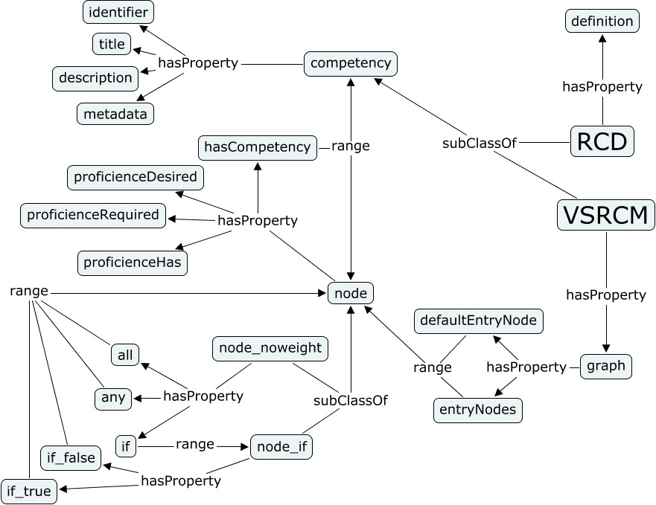
Figure 1: Connection between RCD and VSRCM

Ontology

An ontology is a formal specification of a domain. It defines and specifies the different classes of individuals that form the domain, the actual individuals and the properties (relationships) of the individuals [7] [8]. One of the benefits of developing an ontology is that multiple applications can use the same domain consistently to perform different automated tasks, including tasks that involve reasoning based on the different relationships that are specified.
A prototype competency ontology has been developed in the web ontology language OWL [7], with the aim of becoming the unifying reference point between miscellaneous competency frameworks and descriptions. The prototype ontology defines three groups of competencies:
• Knowledge
• Skill
• Others
These are mainly inspired by the EQF meta-qualification framework [9] and the American occupational framework O*NET [10]. Both of these significant frameworks have Knowledge, Skills and something else as different kinds of competencies. The initial analysis of diverse competency frameworks showed that this is a common trend among competency frameworks. The top level knowledges and skills have been taken from O*NET, as this is a very well established framework, and the 8 level measures [11] from EQF have been incorporated into the system and provides a measurement of proficiency of the different skills and knowledges. The reason for this is that these are well defined and designed to be used in many dissimilar competency frameworks. The semantic relationships that exist between the different competencies are adapted from linguistics, especially with reference to the linguistic ontology WordNet [12], because of the natural language that defines the competencies. These are the relationships that have been used in the implementation:
- Alternates
  - Synonym
Competencies which mean the same; for example different terms used for the same competency across frameworks
  - Antonym
Competencies which mean the opposite; for example the competencies: empathy and impartial. This could be useful for inferences
- Part, either:
  - A has part B (holonym)
That is the relationship that competency A is intrinsically includes B; for instance drive has part that is use of brakes;
  - A part of B (meronym)
That is the relationship that competency A is intrinsically included in B; for instance drive is part of competency to be taxi driver;
- Generality
  - A is more general than B (hypernym)
A includes all the meaning of B, but B includes more detail.
For example driving is more general than driving a lorry.
  - A is more specific than B (hyponym)
B includes all the meaning of A, but B includes less detail.
For example lorry driving is more specific than driving.

Figure 2 is a simple representation of the complete ontology with classes and relationships.
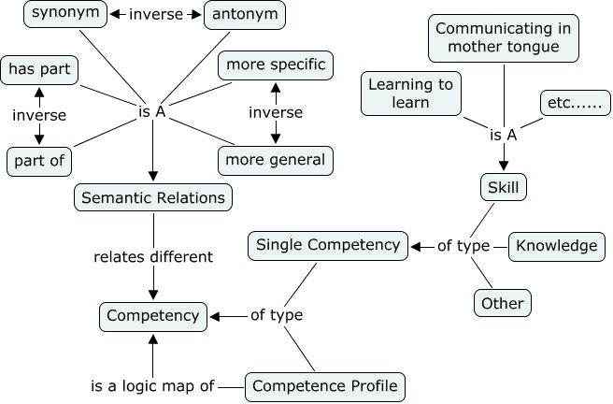
Figure 2: Simple representation of the ontology

By using the specified knowledges and skills from O*NET and the defined semantic relationships it is now possible to extend the complete knowledge base in a consistent manner, which allows for further inferences on the additions across domains and applications. Figure 4 is an example where an ontology engineer has added knowledge’s and skills from a small sample of Computer Science description (in dark blue). Using the predefined semantic relationships, it is possible to define relationships into the pre-defined knowledgebase (light blue in figure 3).
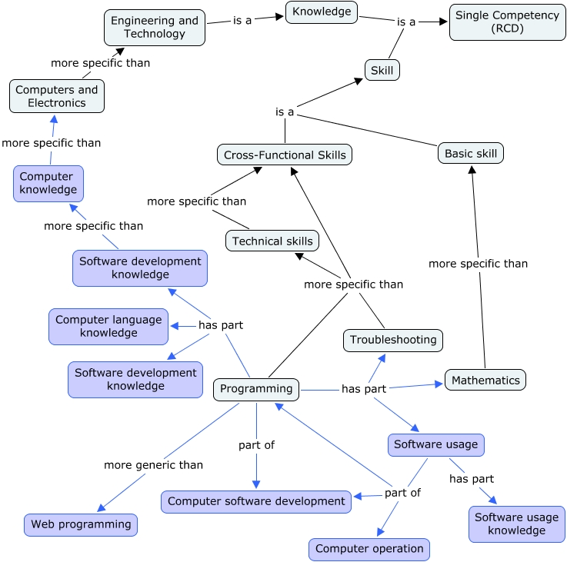
Figure 3: Comparison Grid

Proof of Concept

To show the benefits of ontological reasoning, especially connected to competency maps, it was decided to create a comparison tool between a job profile and a personal profile, where the profiles would be purely described using competency maps. Apart from being a valuable proof of concept exercise comparison is also the basic logical assessment in most logical systems, hence being the natural first step towards many other tools. For instance skill gap analysis tools where many different profiles are matched with a desired profile and the closest matches are specified with their different skill gaps. Training suggestion tools could also be devised that can match profile skill gaps with eLearning material “target” end result competency profiles, hence provide users with training material that could take them from their current competency profile to a desired competency profile.
The comparison tool we have developed as part of this work has been implemented in Java [13] using the semantic web framework Jena [14]. It starts out by loading the prototype ontology described in section 3, thereafter it loads a prototype computer science domain ontology with bindings into the prototype ontology containing additional definitions of knowledge, skills, technologies and techniques and their relationships that exist in the computer domain. Thereafter the desired competency profile is loaded, which is described using a bespoke version of the proposed “Simple Reusable Competency Mapping” (SRCM) called the “Very Simple Reusable Competency Mapping”. The modified version of SRCM is used to increase the readability of the XML for testing purposes and does not change its interpretation significantly. The only significant change made was to tailor the relationship so that a personal profile can contain a proficiency level rather than a required or a desired proficiency level. This is an important relationship when looking at the competency “owners” such as individuals and groups of individuals, but this relationship is not presently included.
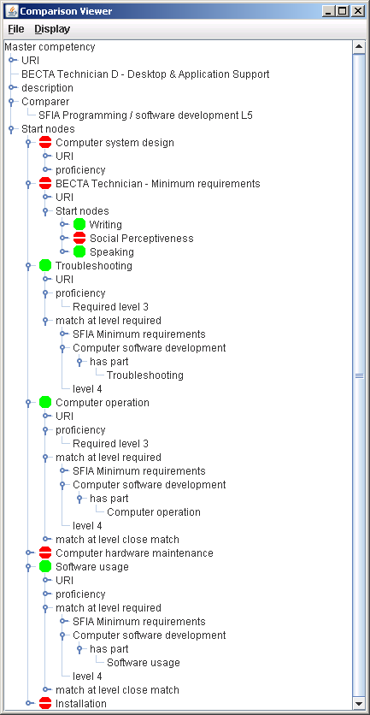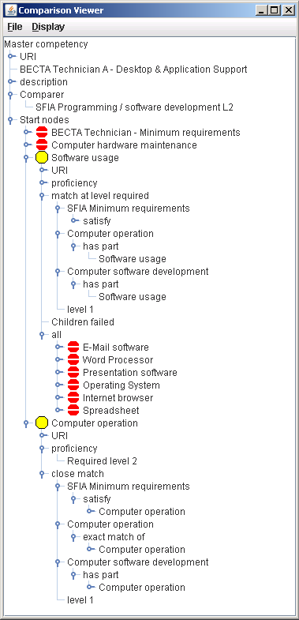
Figure 4: Inference examples

Conclusion and Future work
The work in this paper proves that it is possible to create a comparison tool is possible between different competency mappings and that ontologies can be used to enhance the comparison by utilising ontological semantic inference. This is important because it enables automation of many at present manual tasks in the human resource work field. However a lot of future work is needed to achieve these automated tools. The most immediate tool set that is needed is tools for creation of competency maps with support for easy integration of different competency frameworks. After this further comparison tools could be built for comparison of other kinds of competency maps, for instance enabling comparisons of different levels of two different competency frameworks.
The effectiveness of the inferences is relying on the quality and size of the ontologies, and much work is needed on the creation of ontologies. Although anybody can modify and add to the ontologies depending on their needs, it is obvious that the bigger and extensive the main ontologies are the more value there would be in using them, hence attracting more users of the system, which again would assist refining the ontologies even further.

Many tools, such as skill gap, ePortfolio and training solution tools that would build on the comparison tools can be envisaged, however these are tools which extent the transparency that the TRACE project tools bring and as such lies outside the scope of the TRACE project.

Acknowledgements: Thanks to the members of the Leonardo sponsored TRACE project.

References
- CNCP (Commission Nationale des Certifications Professionnelles), www.cncp.gouv.fr
- SFIA ( Skills Framework for the information age), http://www.sfia.org.uk
- EQF (European Qualification Framework), http://ec.europa.eu/education/policies/educ/eqf/index_en.html
- Nicola Guarino and Pierdaniele Giaretta (1995), Ontologies and Knowledge Bases Towards a Terminological Clarification, Proceedings, Towards Very Large Knowledge Bases: Knowledge Building and Knowledge Sharing, Amsterdam, pp. 25-32.
- IEEE – Work Group 20, Reusable Competency Definitions (P1484.20.1), http://ieeeltsc.org/wg20Comp/
- Claude Ostyn, Draft Standard for Learning Technology - Simple Reusable Competency Map, 2006, Available: http://www.ostyn.com/standardswork/competency/ReusableCompMapProp.pdf
- W3C, OWL Web Ontology Language Guide, Available: http://www.w3.org/TR/owl-guide/
- Matthew Horridge et al, A Practical Guiade To Building OWL Ontologies Using The Protégé-OWL Plugin and CO-ODE Tools, 2004, The University Of Machester, pp 12-15.
- Commission of the European Communities, RECOMMENDATION OF THE EUROPEAN PARLIAMENT AND OF THE COUNCIL - on the establishment of the European Qualifications Framework for lifelong learning, 2006.
- National Center for O*NET Development, Data Dictionary - O*NET  9.0 Database, Employment Security Commission, 2005.
- Commission of the European Communities, RECOMMENDATION OF THE EUROPEAN PARLIAMENT AND OF THE COUNCIL - on the establishment of the European Qualifications Framework for lifelong learning, 2006, pp 18-20.
- Princeton University, WordNet,Available: http://wordnet.princeton.edu/
- Sun Microsystems, Java, Available: http://java.sun.com/
- HP Labs Semantic Web Programme, Jena, Available: http://jena.sourceforge.net

